1st – What is Flutter?

Flutter is Google’s UI toolkit for building beautiful, natively complied applications for mobile, web and desktop from a single codebase.

It can use android, iOS, Web, Desktop, Embedded, MacOS, Linux in currently and then Fuchsia OS in future.

How to work?

* Don’t depend native UI
* Use Sakia Graphics Engine
* Like a game engine
* Native app as a result

Which language used for developing Flutter?

Dart Programming Language

* Developed by Google
* Object Oriented Programming Language
* Simpler with JavaScript, Kotlin

User Interface?

Android =====🡺 IOS

Material UIs ==🡺 Cupertino

IDE?

Android Studio ===============🡺 VS Code

2nd – Installation IntelliJ IDEA dart SDK Lesson

Install IntelliJ, plugin with dart and connect existed dart sdk.

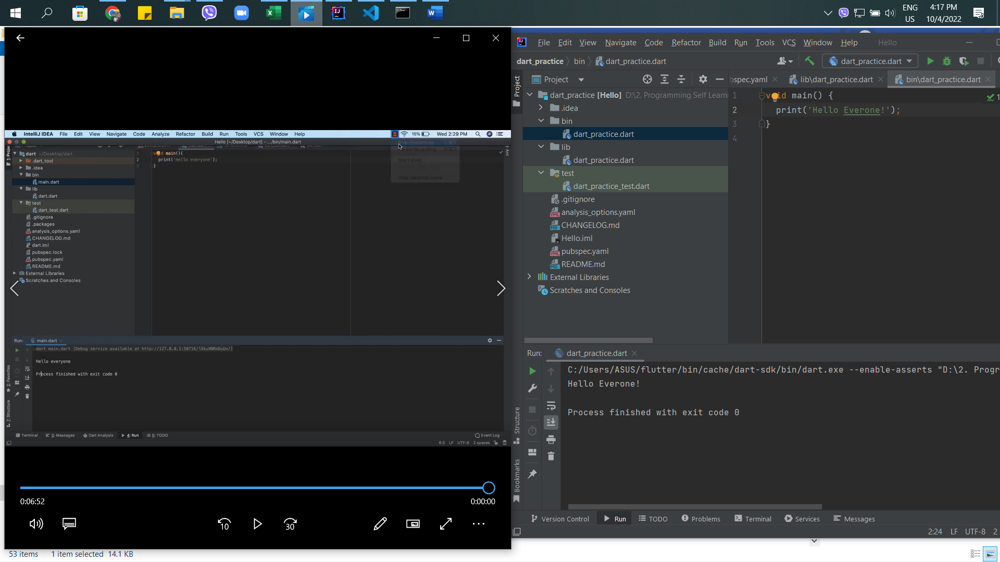

3rd – first program Dart

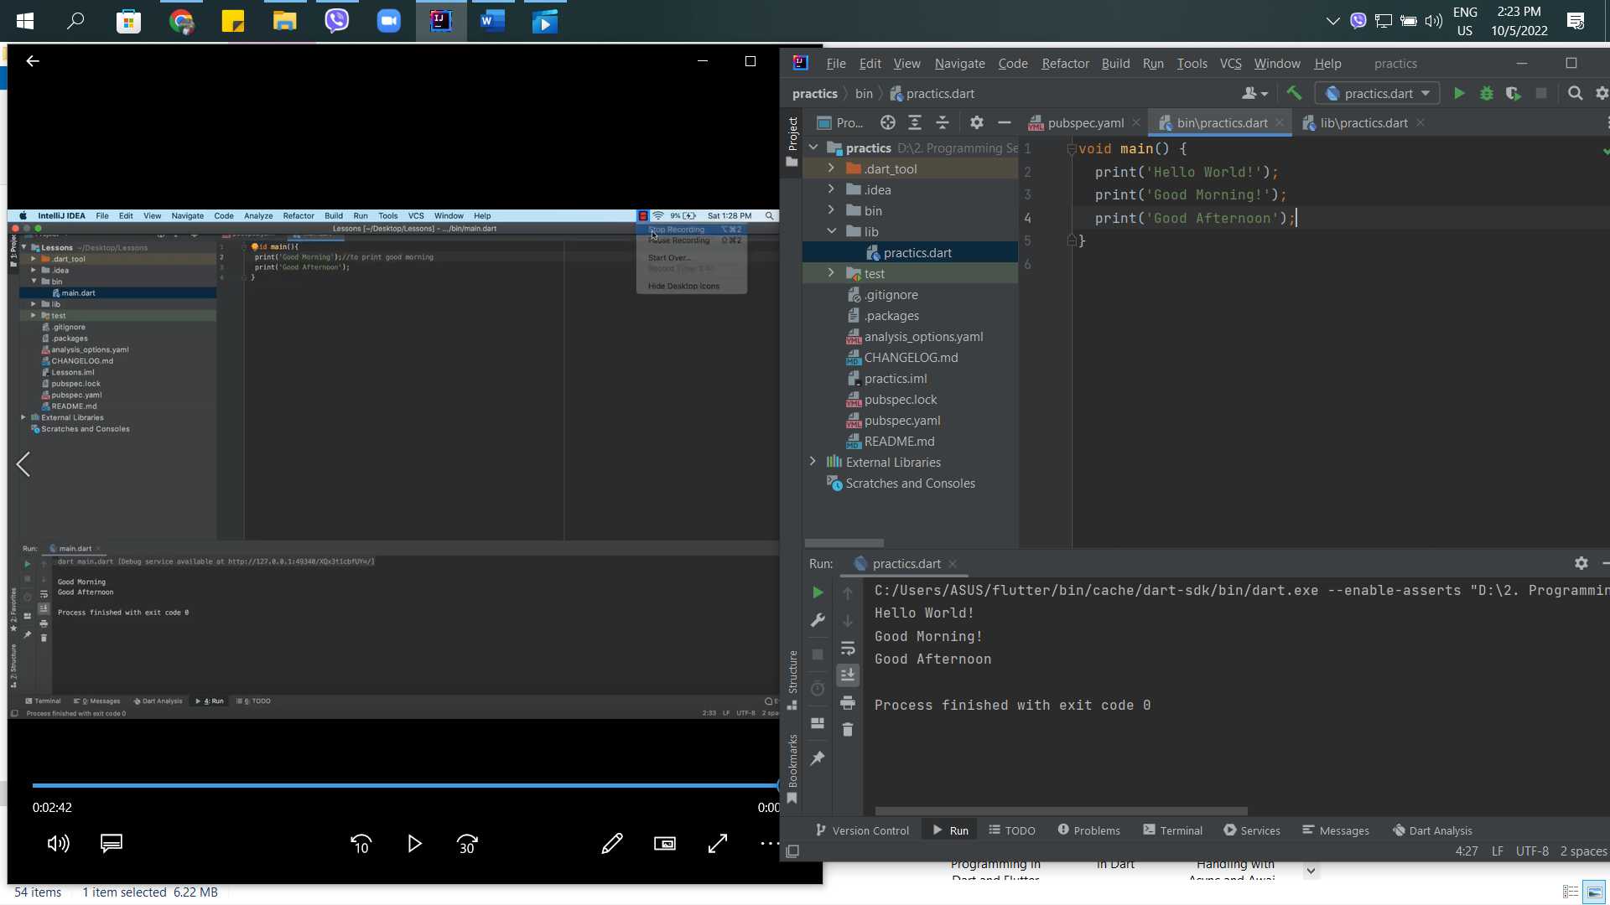

4th – What is Variable and Data Type in Dart

Variable & Data Type in Dart

Variables are used to store information to be referenced and manipulated in a computer program

A = 10

B = 2a

B = 2x10

B = 20

Data Type

Option Type System (Static type, Dynamic type)

* Numbers
* Strings
* Booleans
* Lists
* Maps
* Runes

in

* Var
* Dynamic

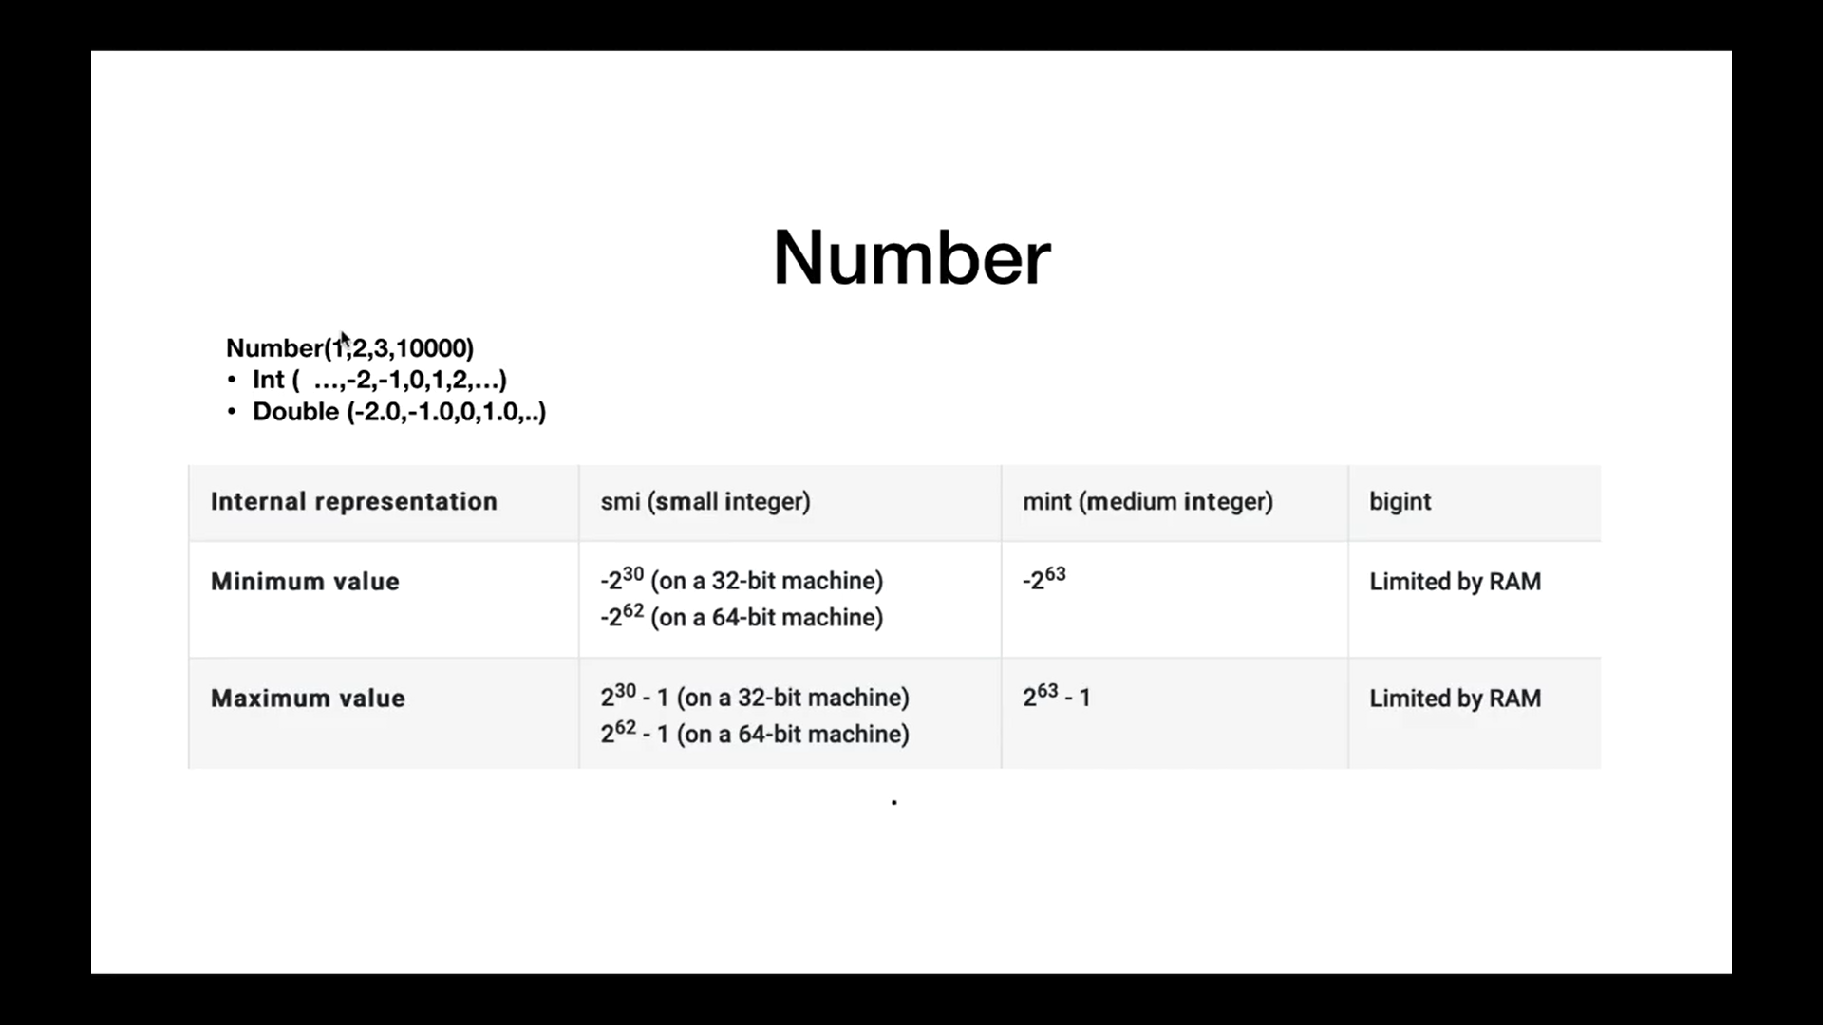

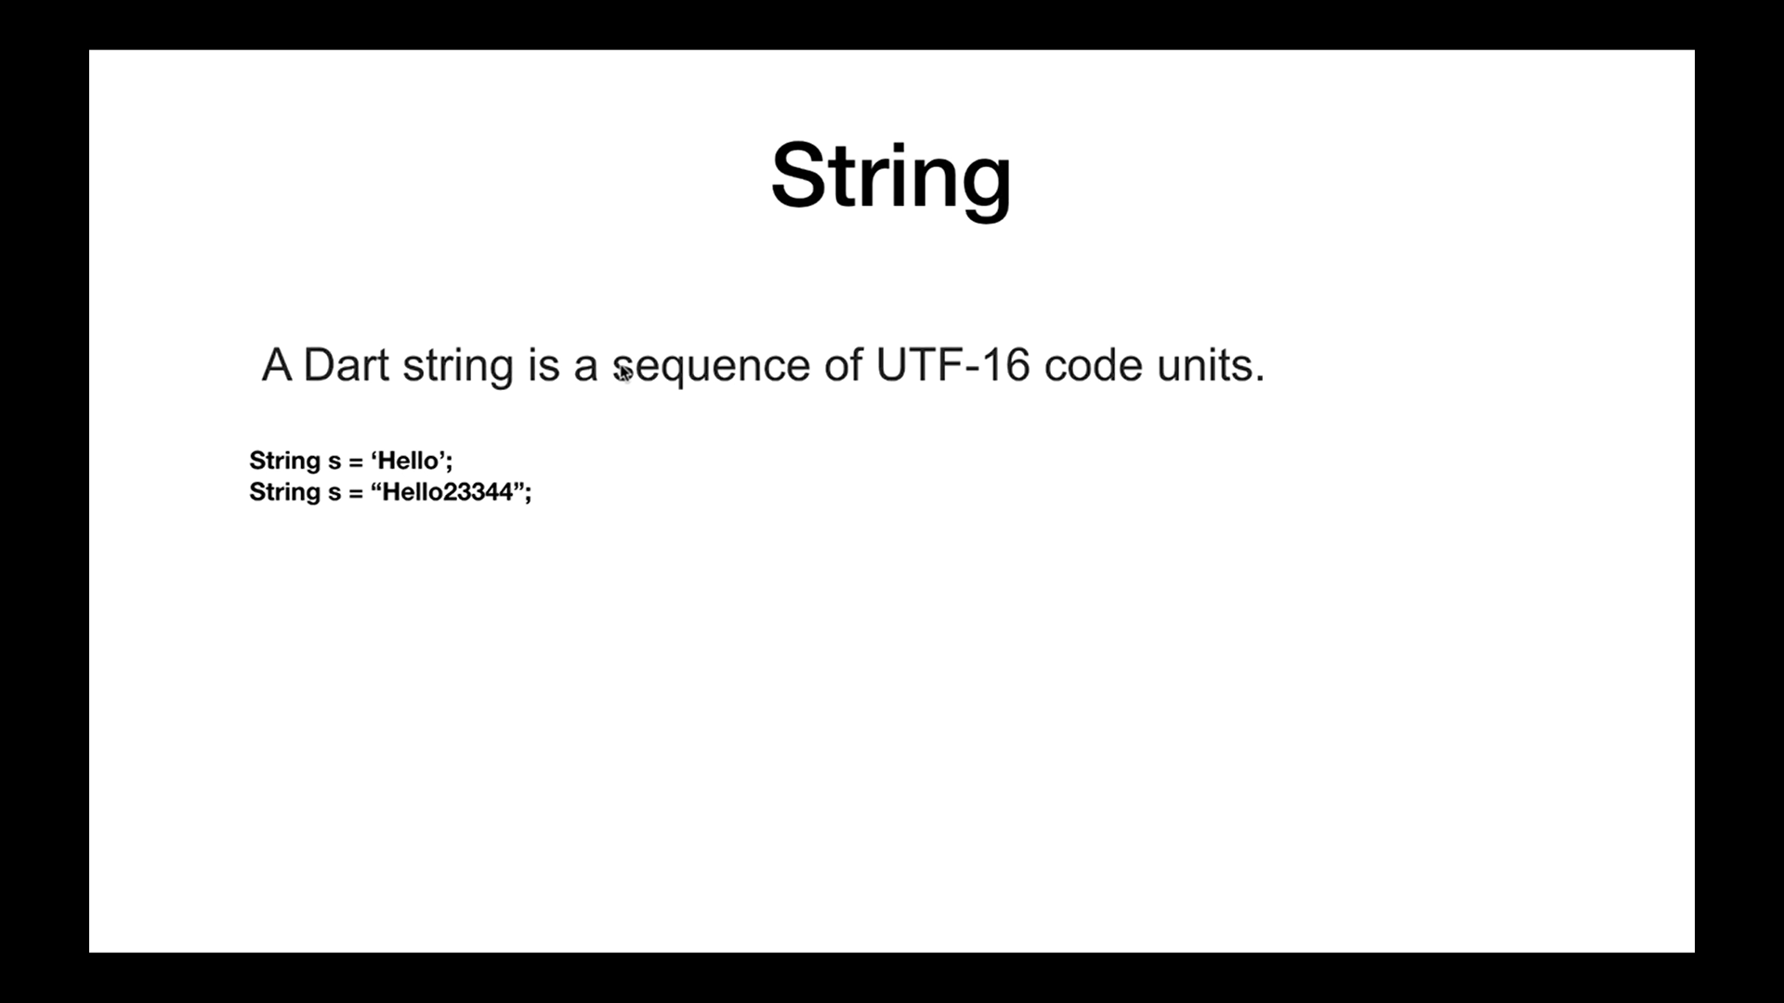

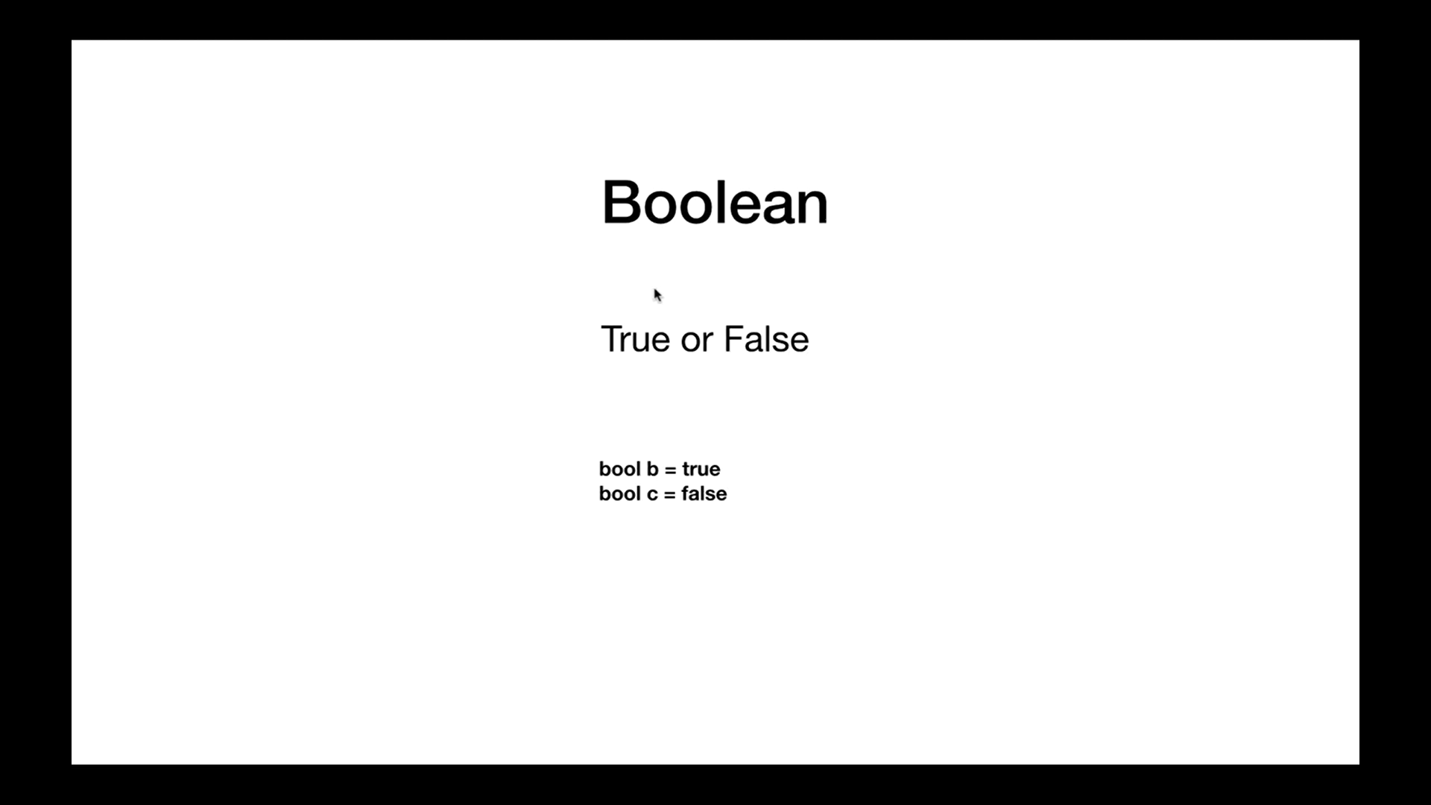

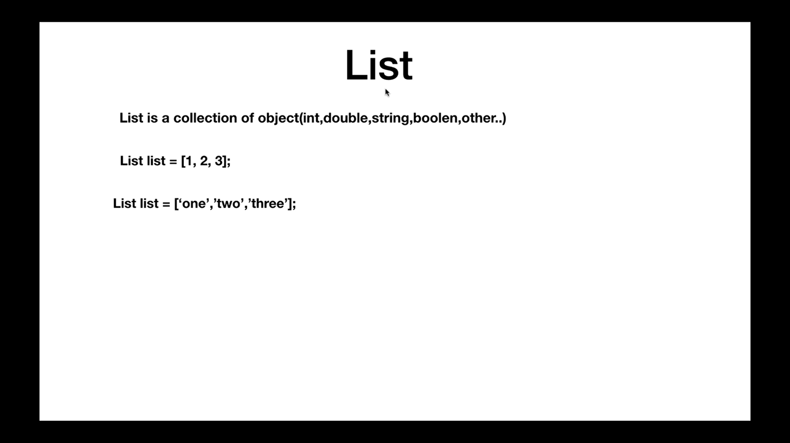

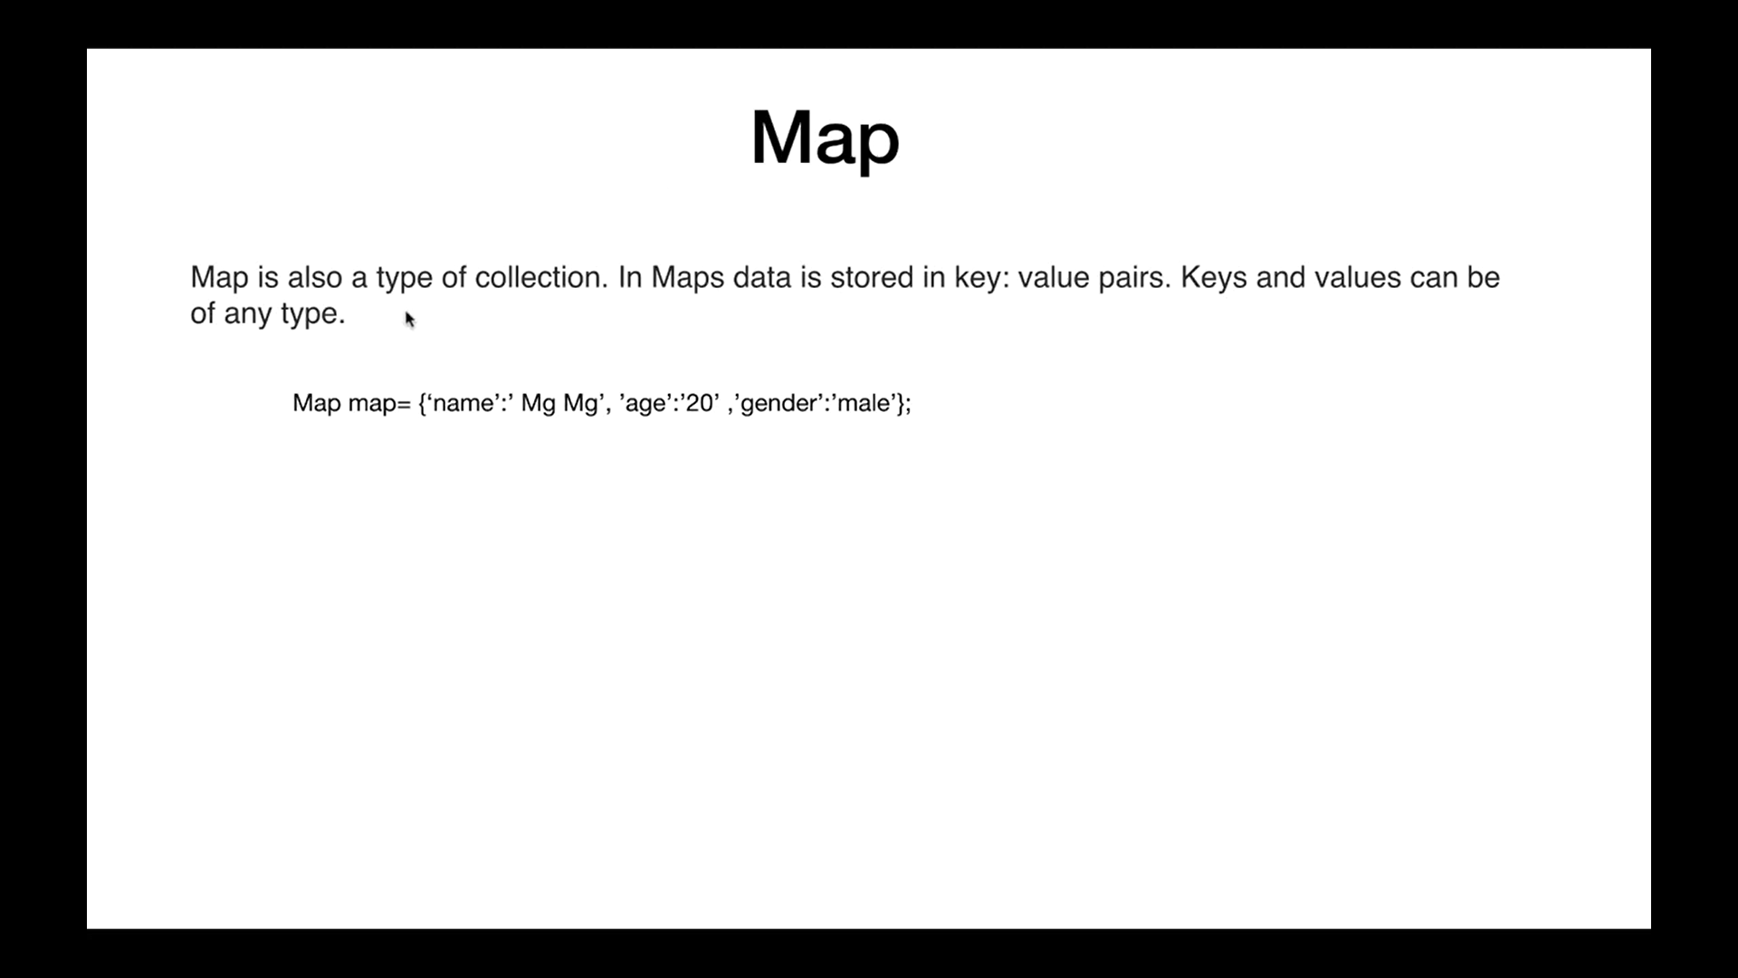

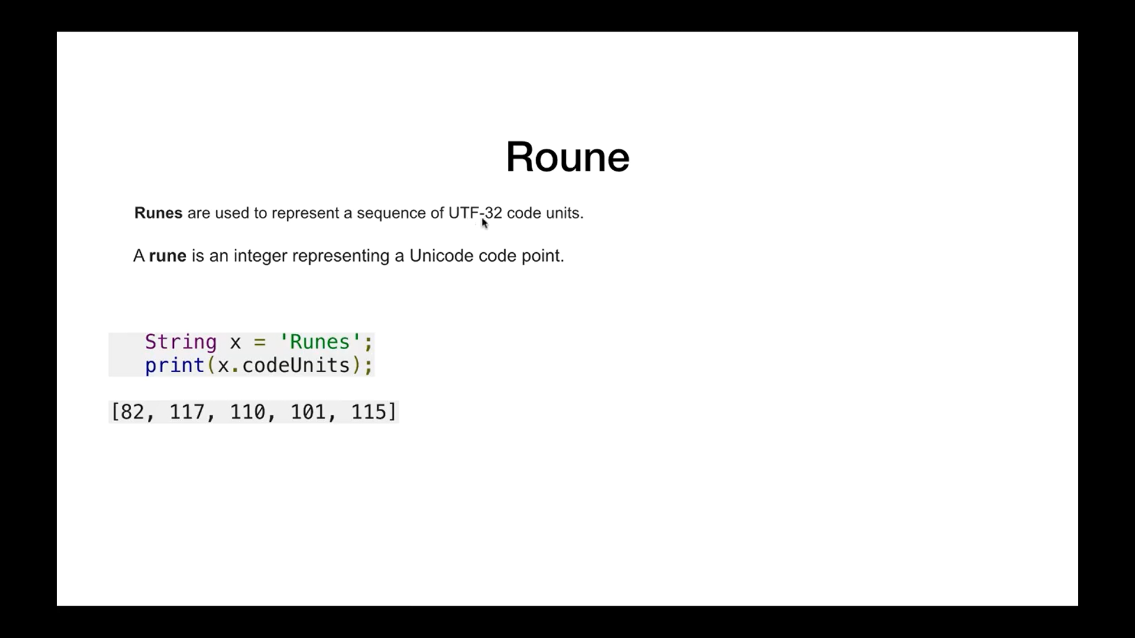

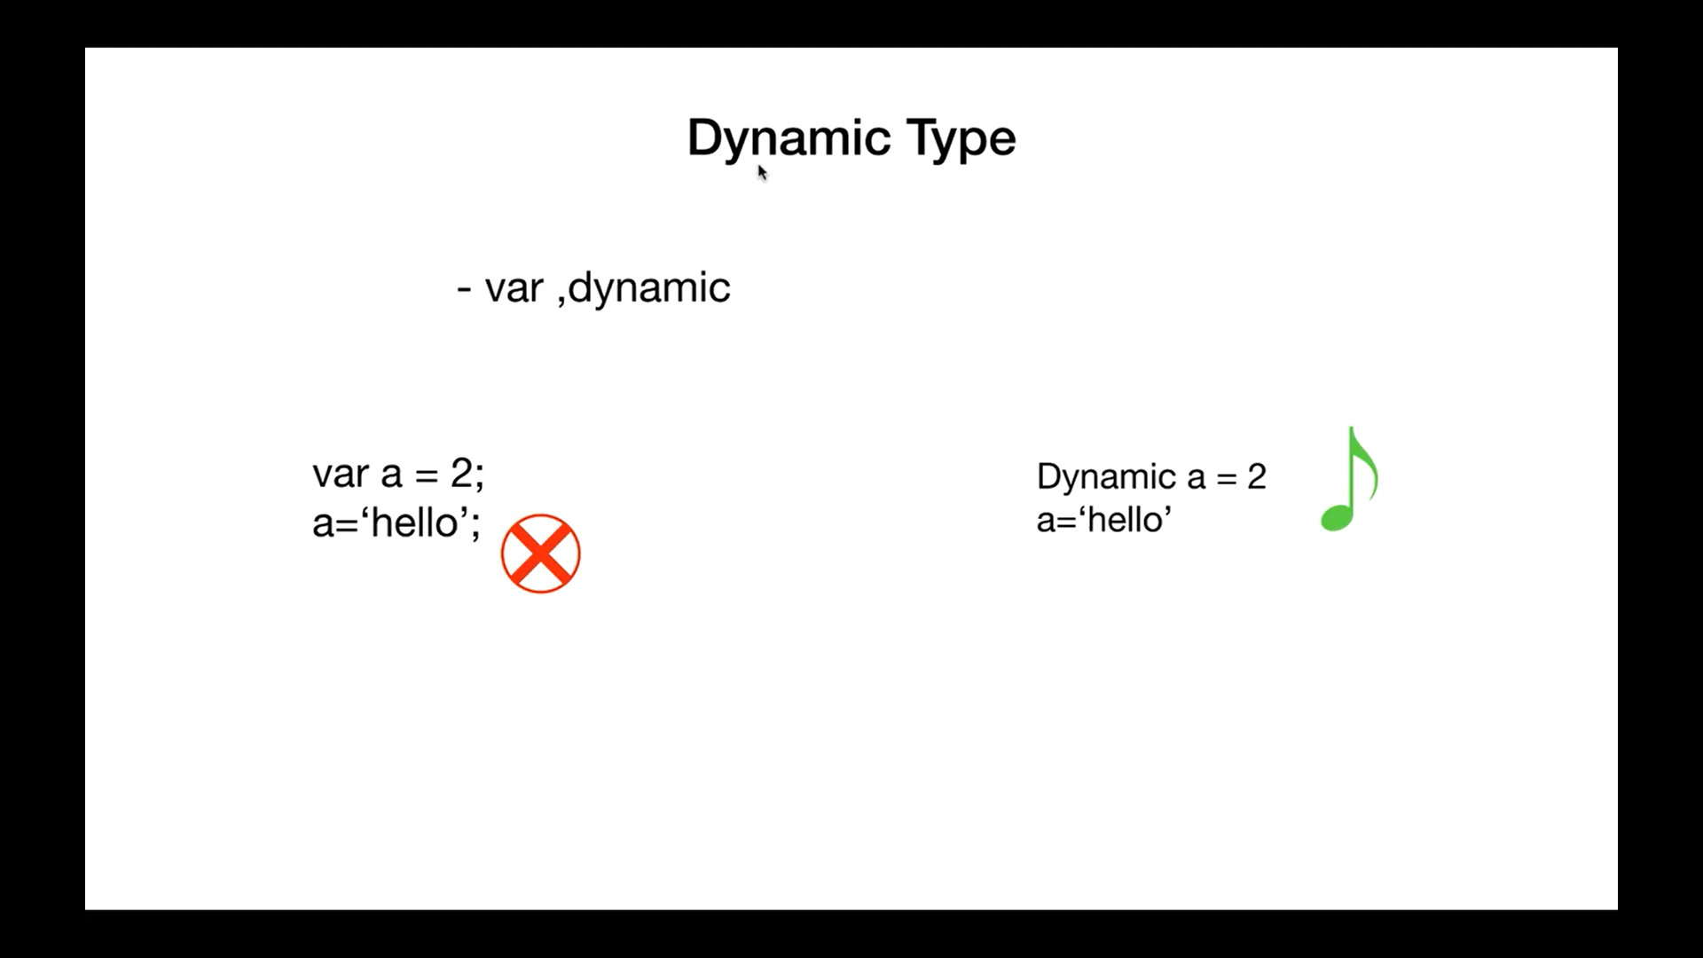

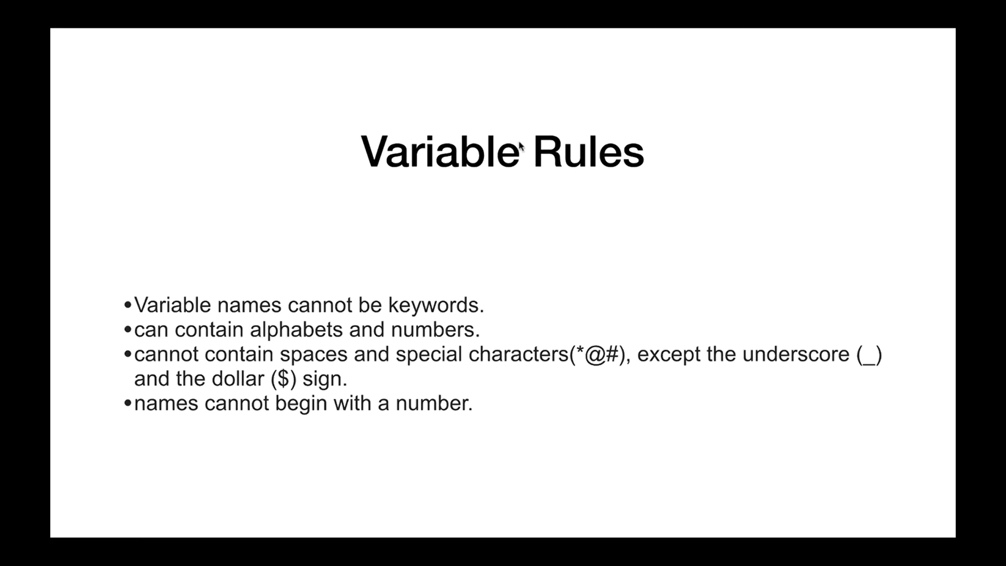

5th – Arithmetic Operator in Dart

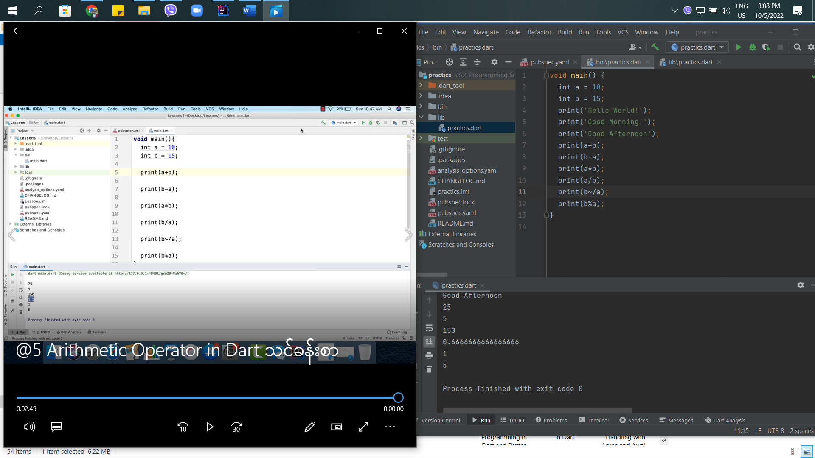

6th – Relation Operator in Dart

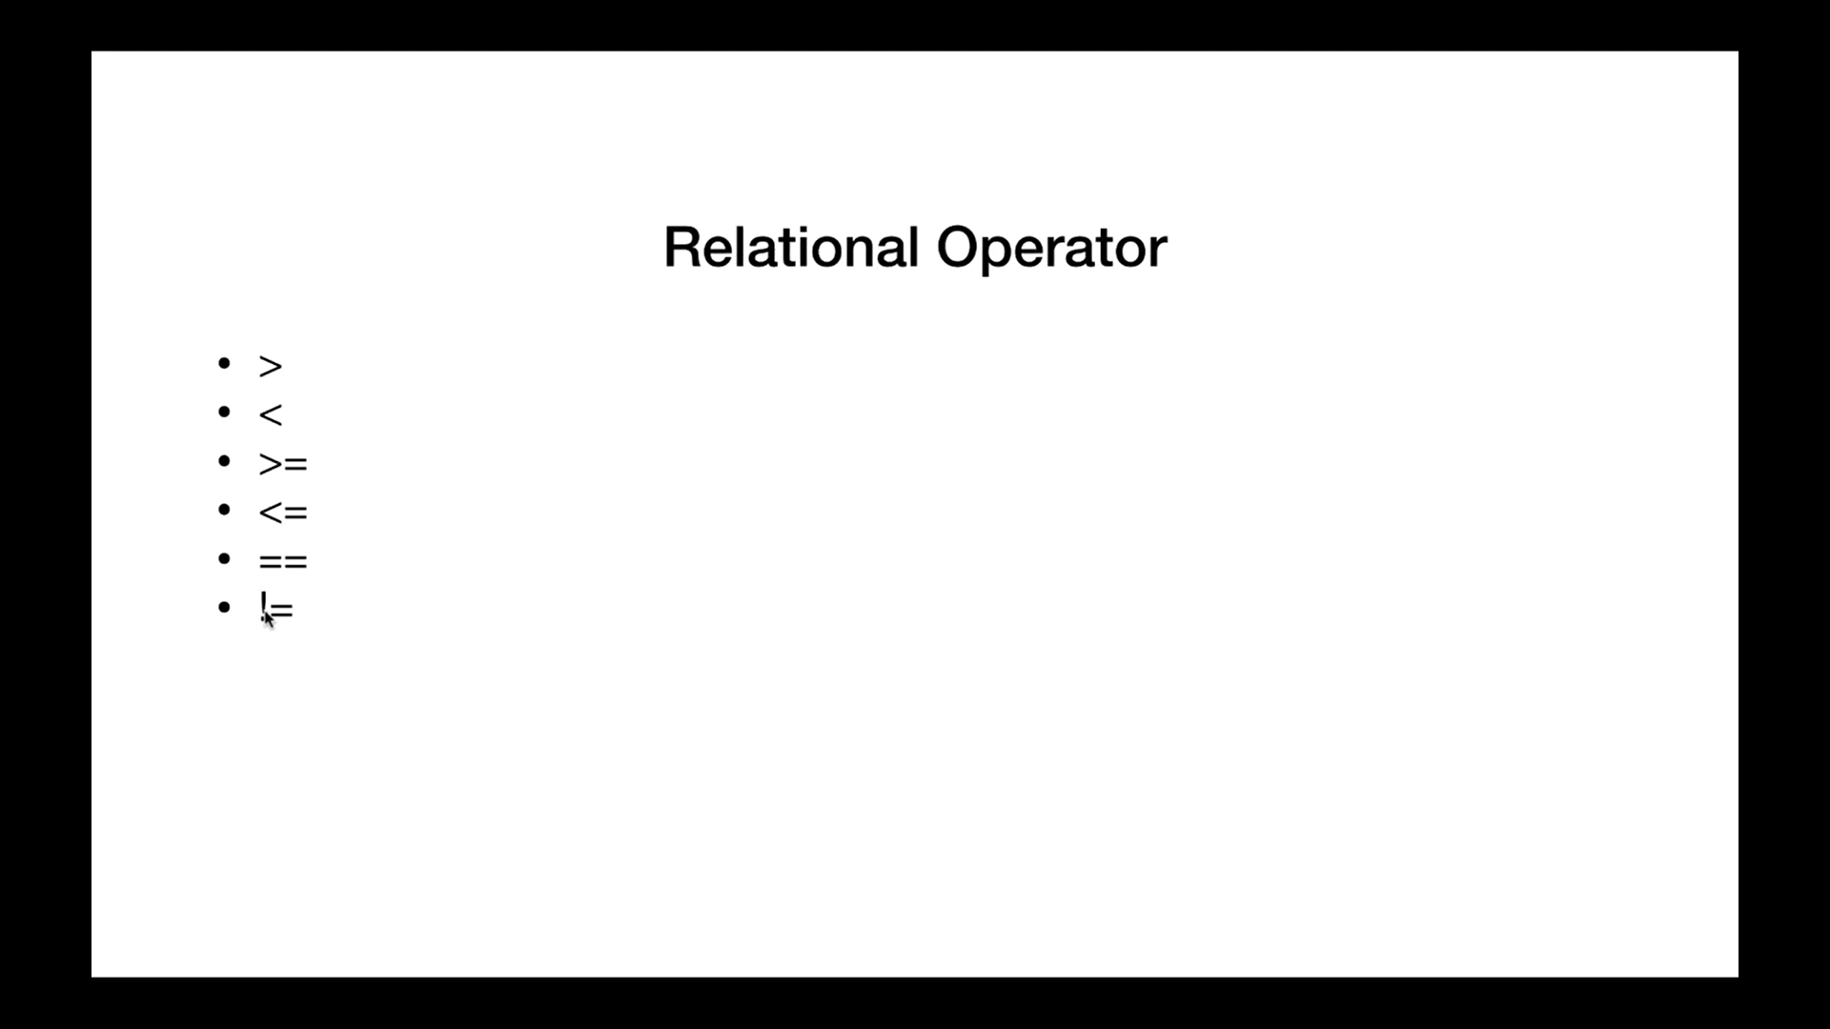

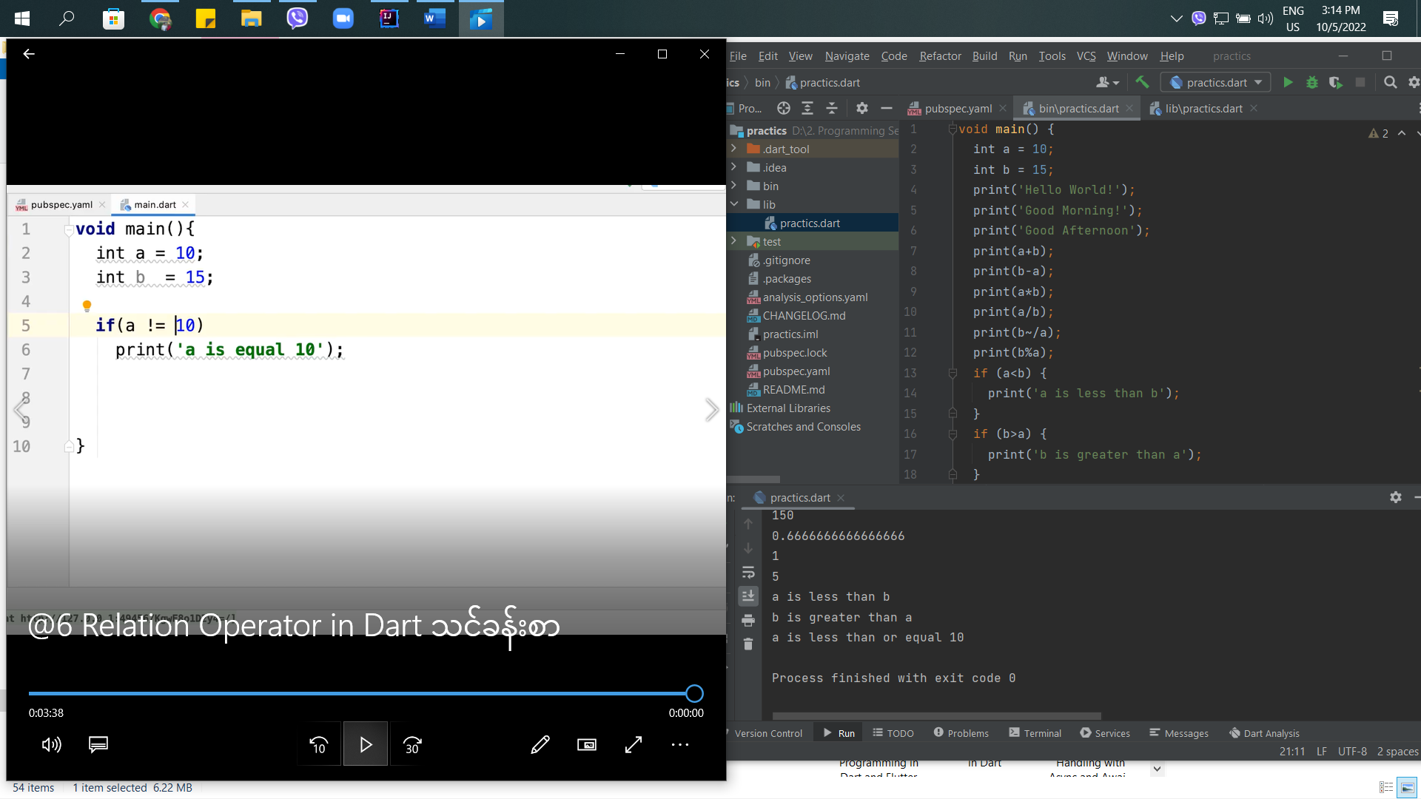

7th – If Statement in Dart Flutter

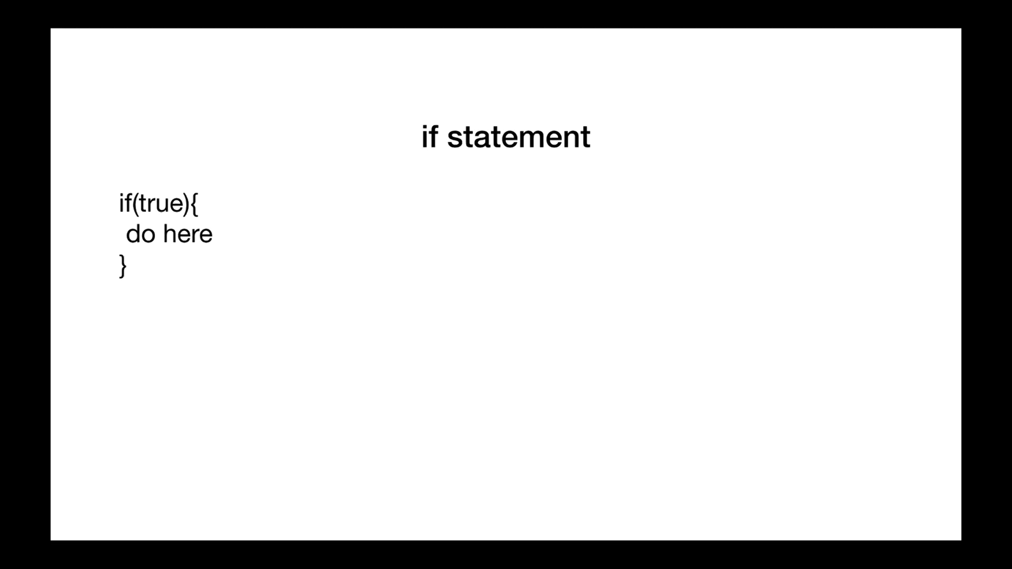

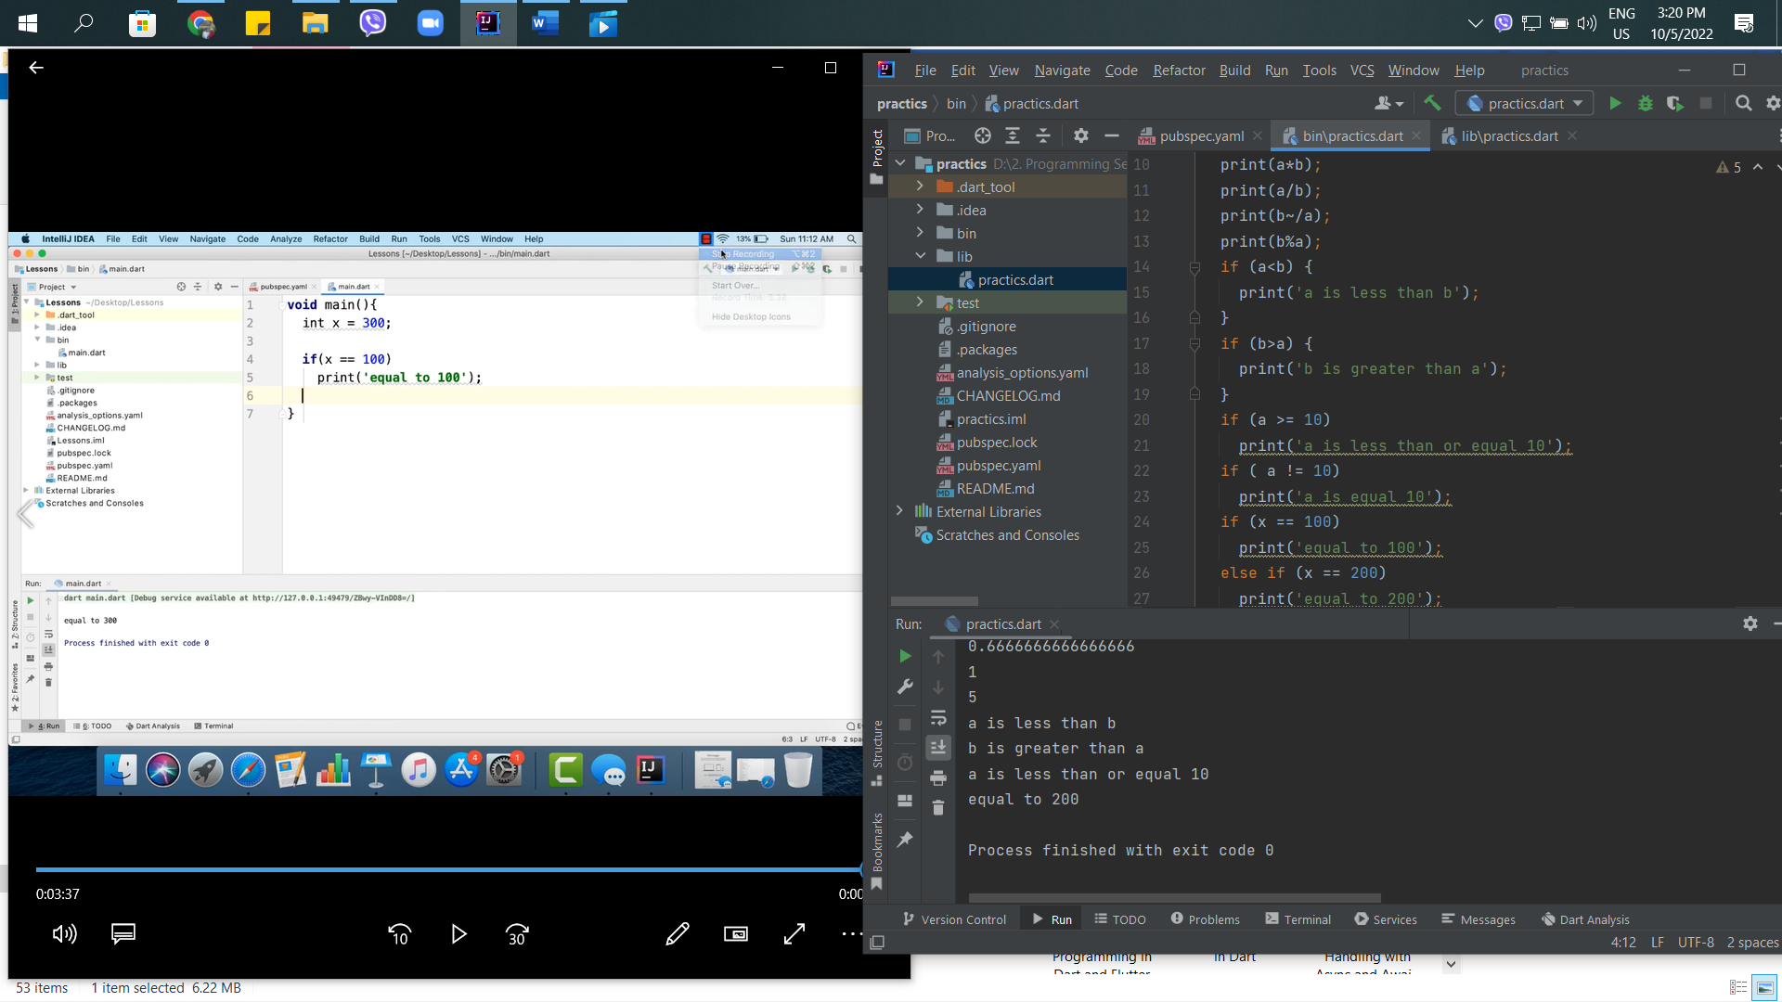

8th – Logic Operation in Dart Flutter

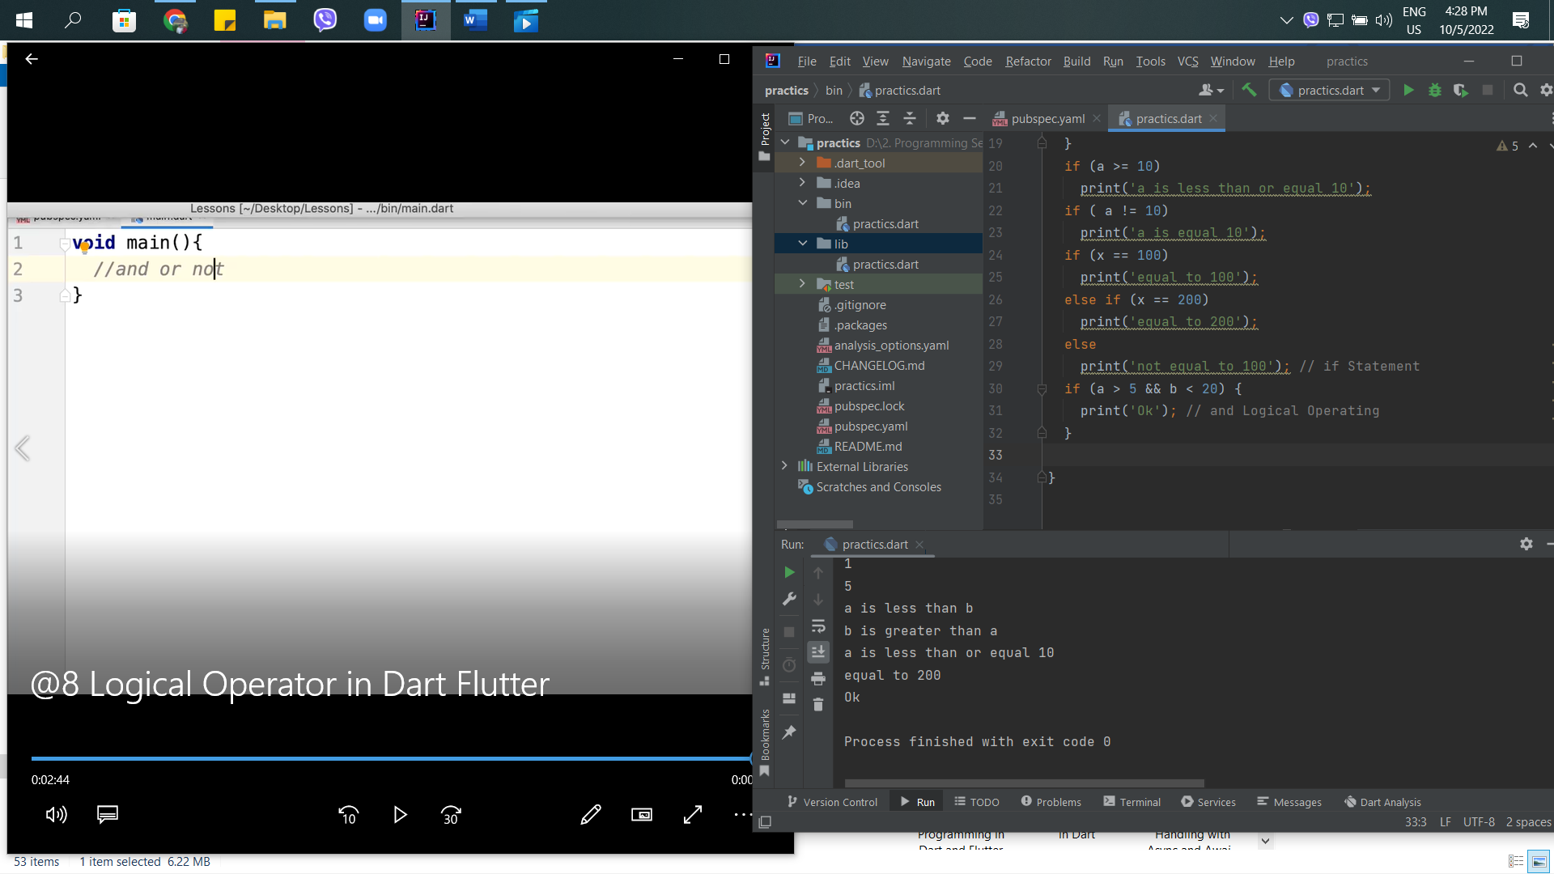

9th – Type test operator in Dart Flutter

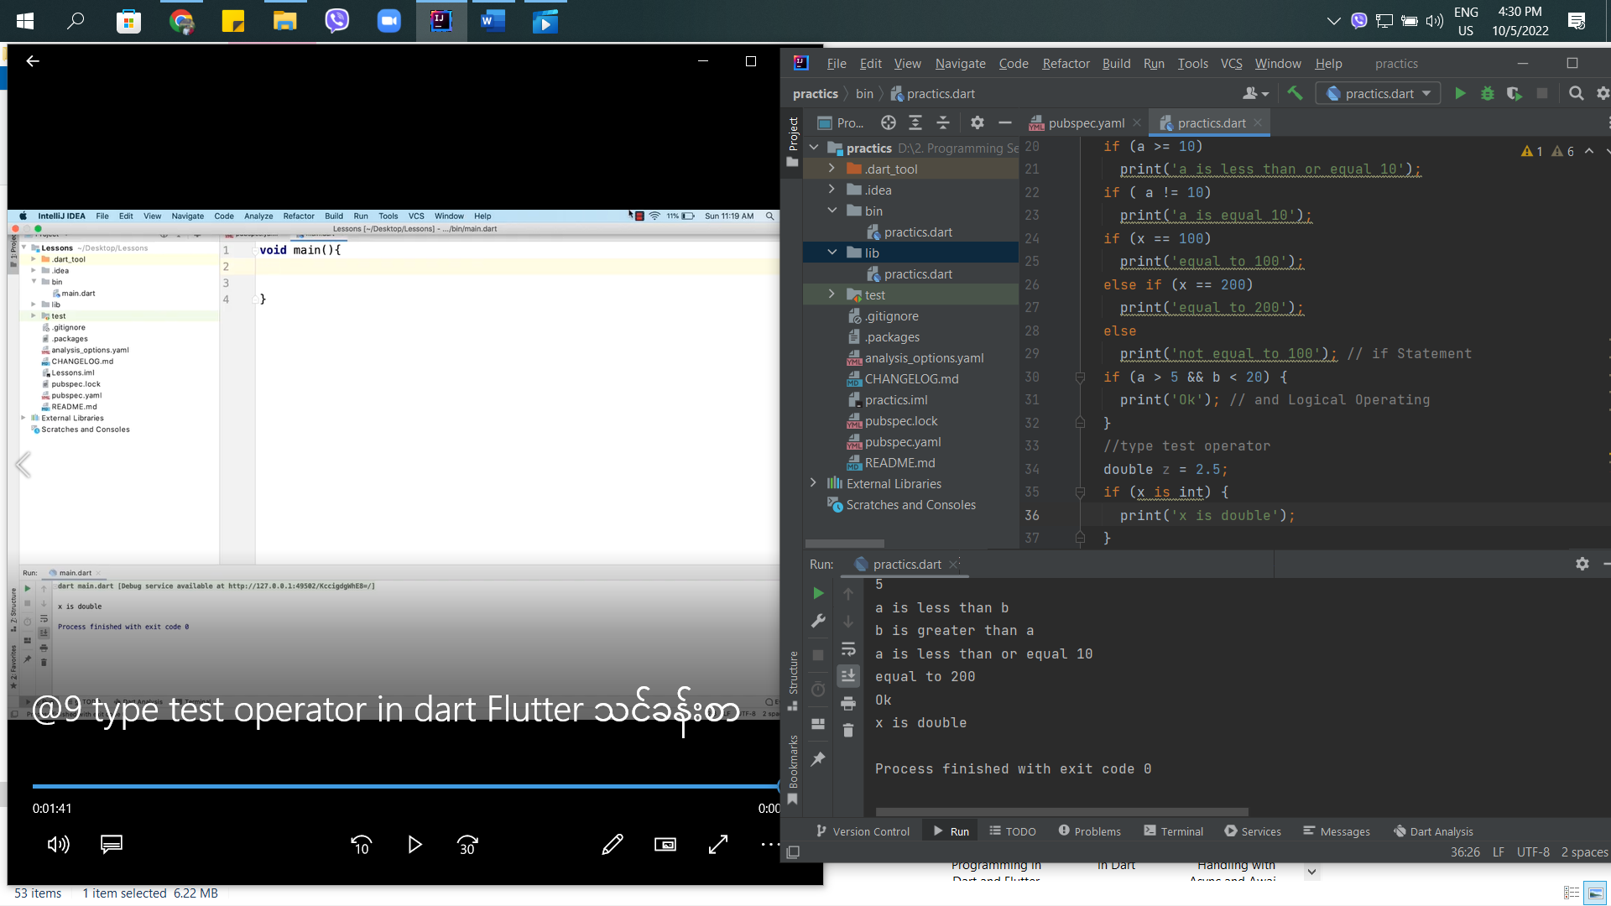

10th – Assignment Operator in Dart Flutter

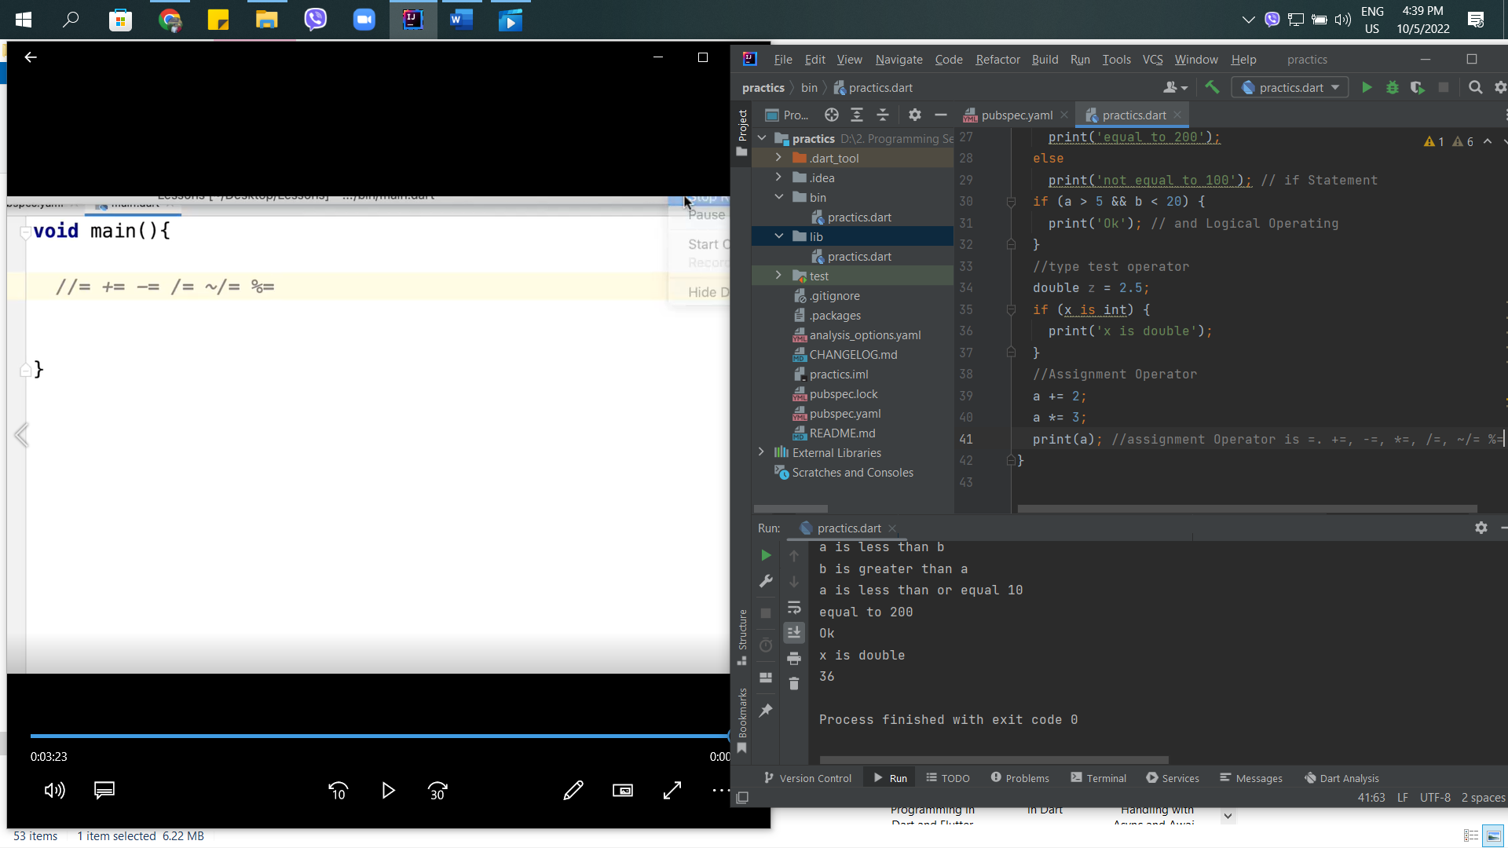

11th – Conditional Operator or ternary Operator

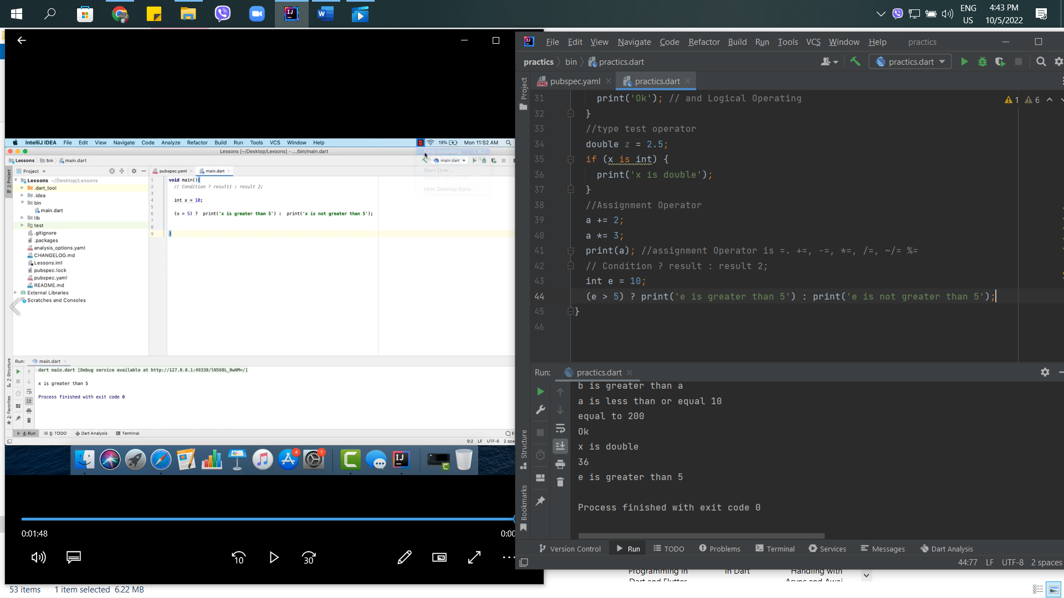

12th – Switch state in Dart Flutter

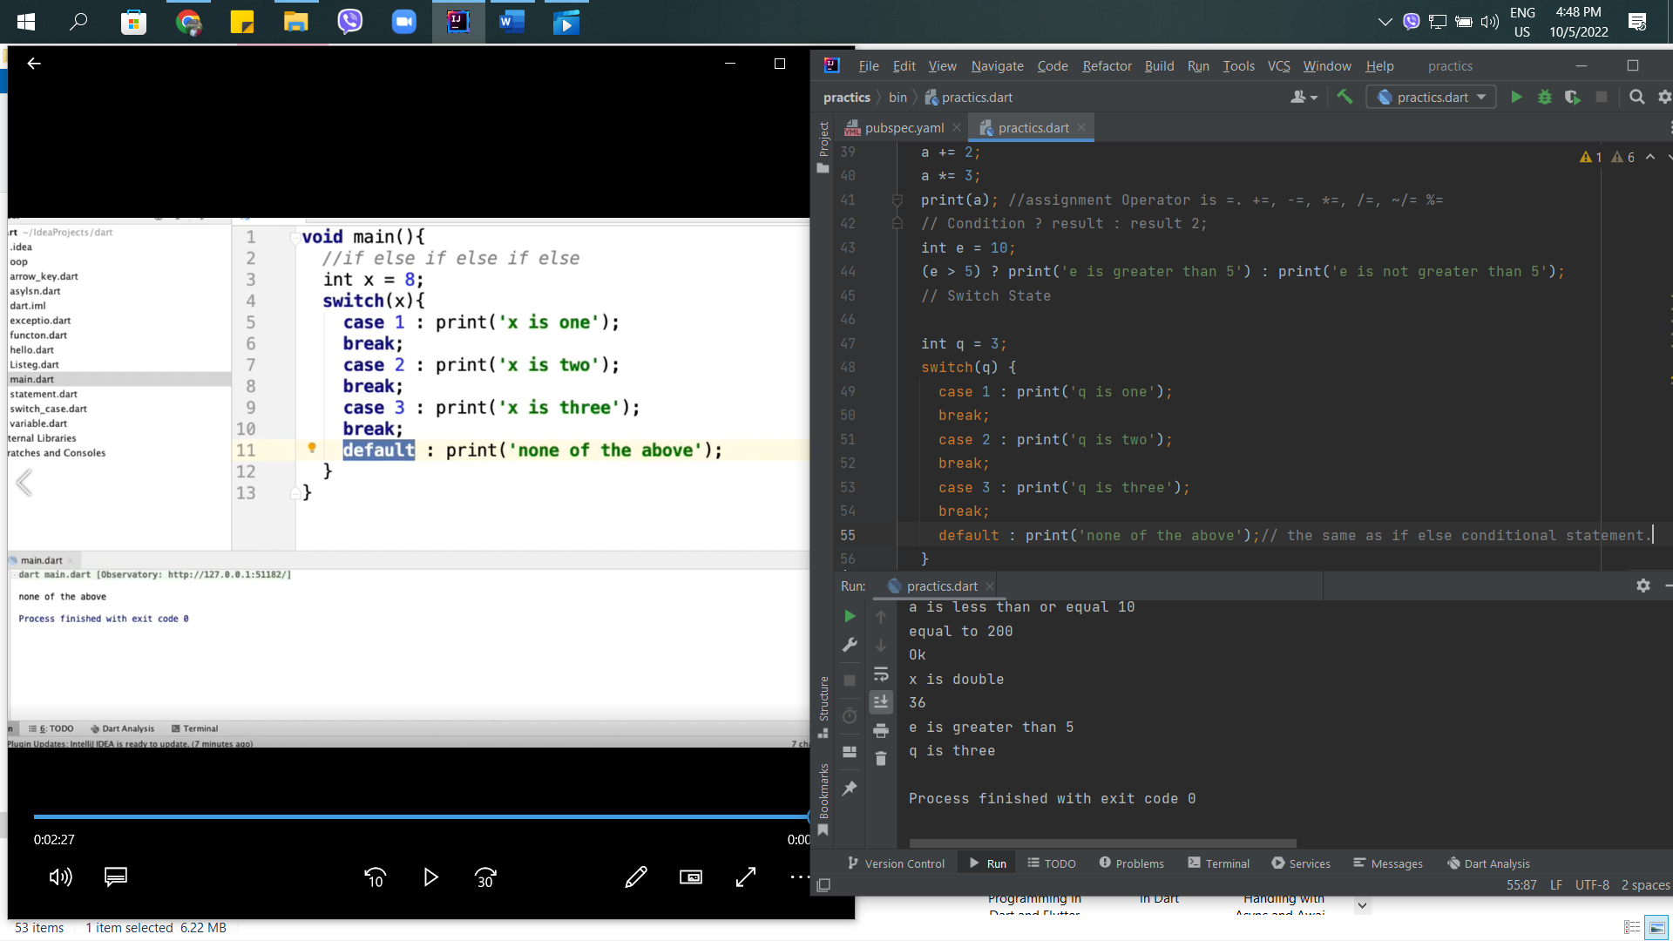

13th – List in Dart Flutter

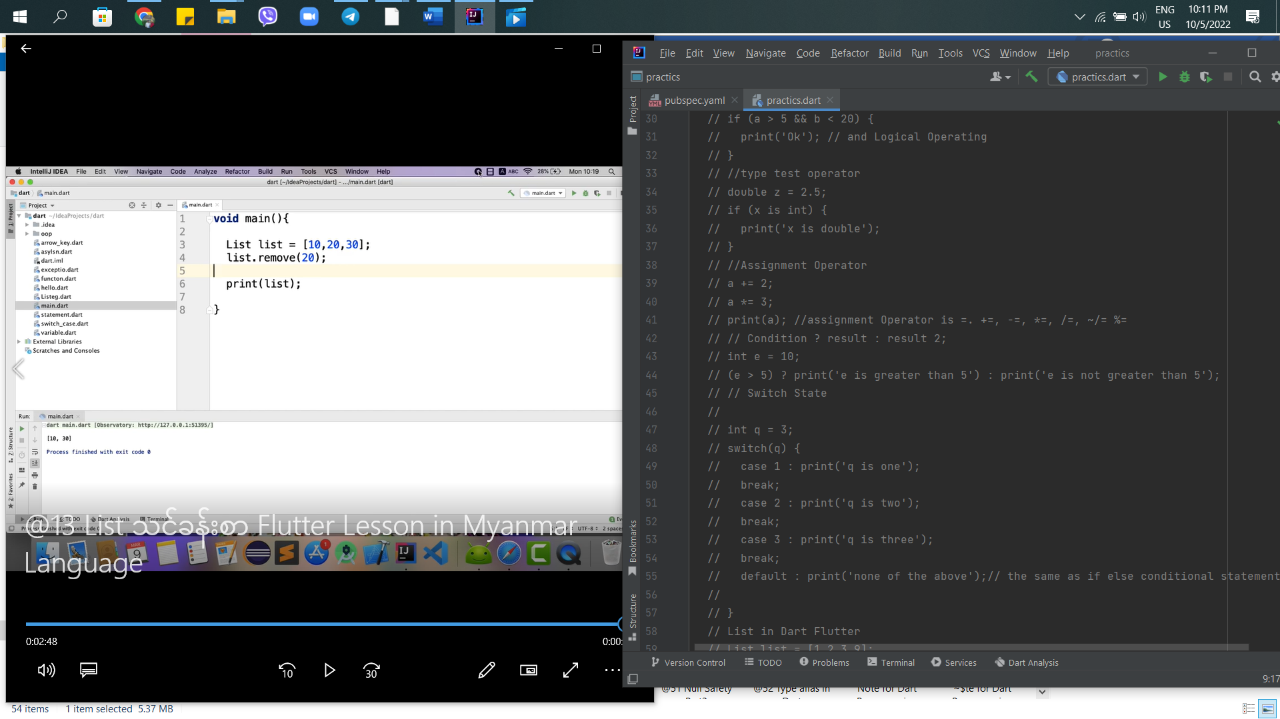

14th – Map in Dart Flutter

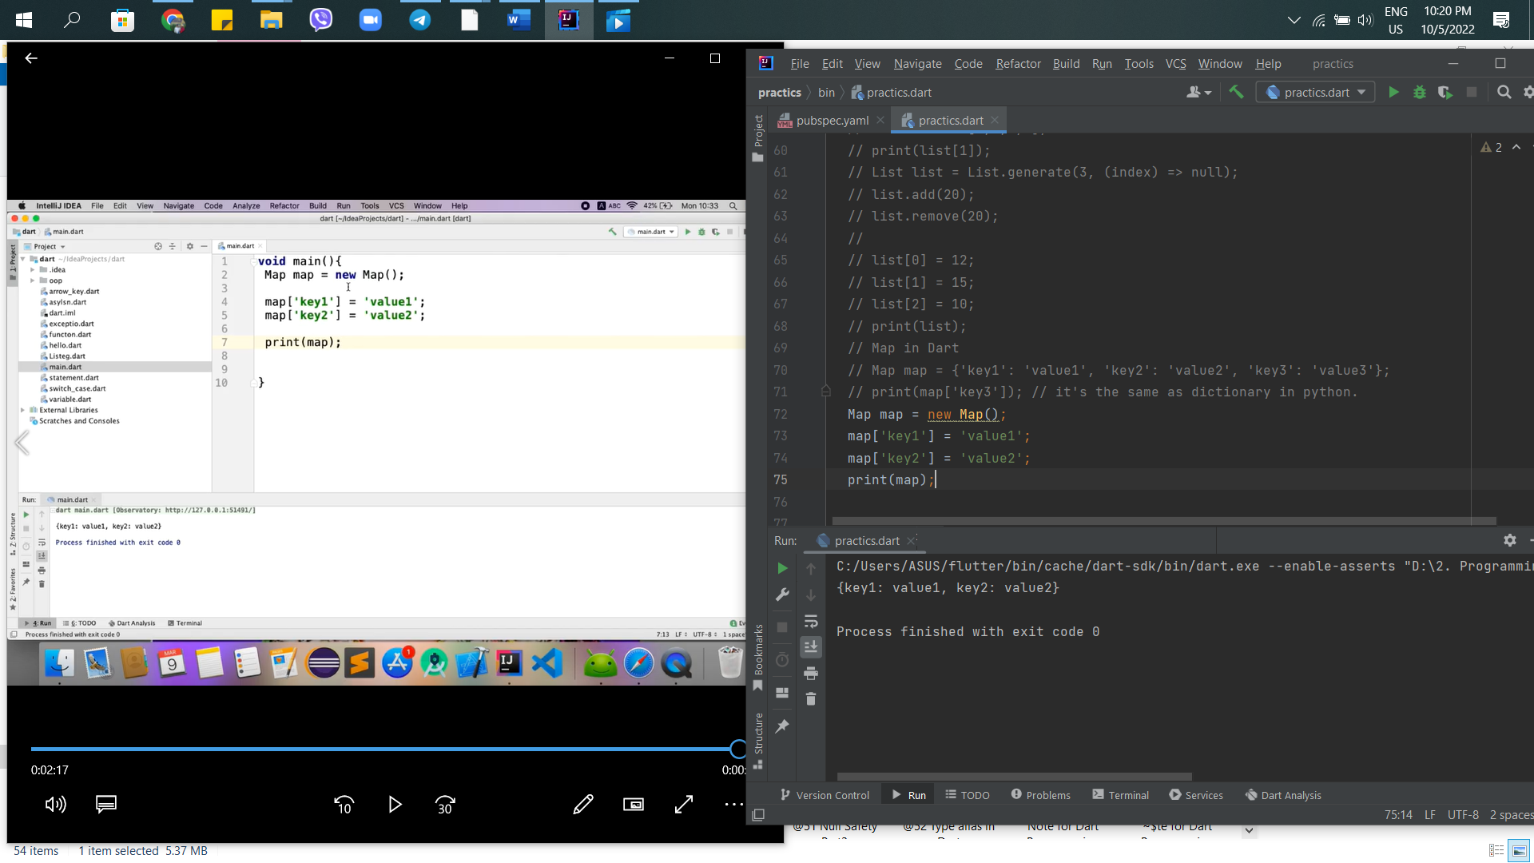

15th – For Loop in Dart Flutter

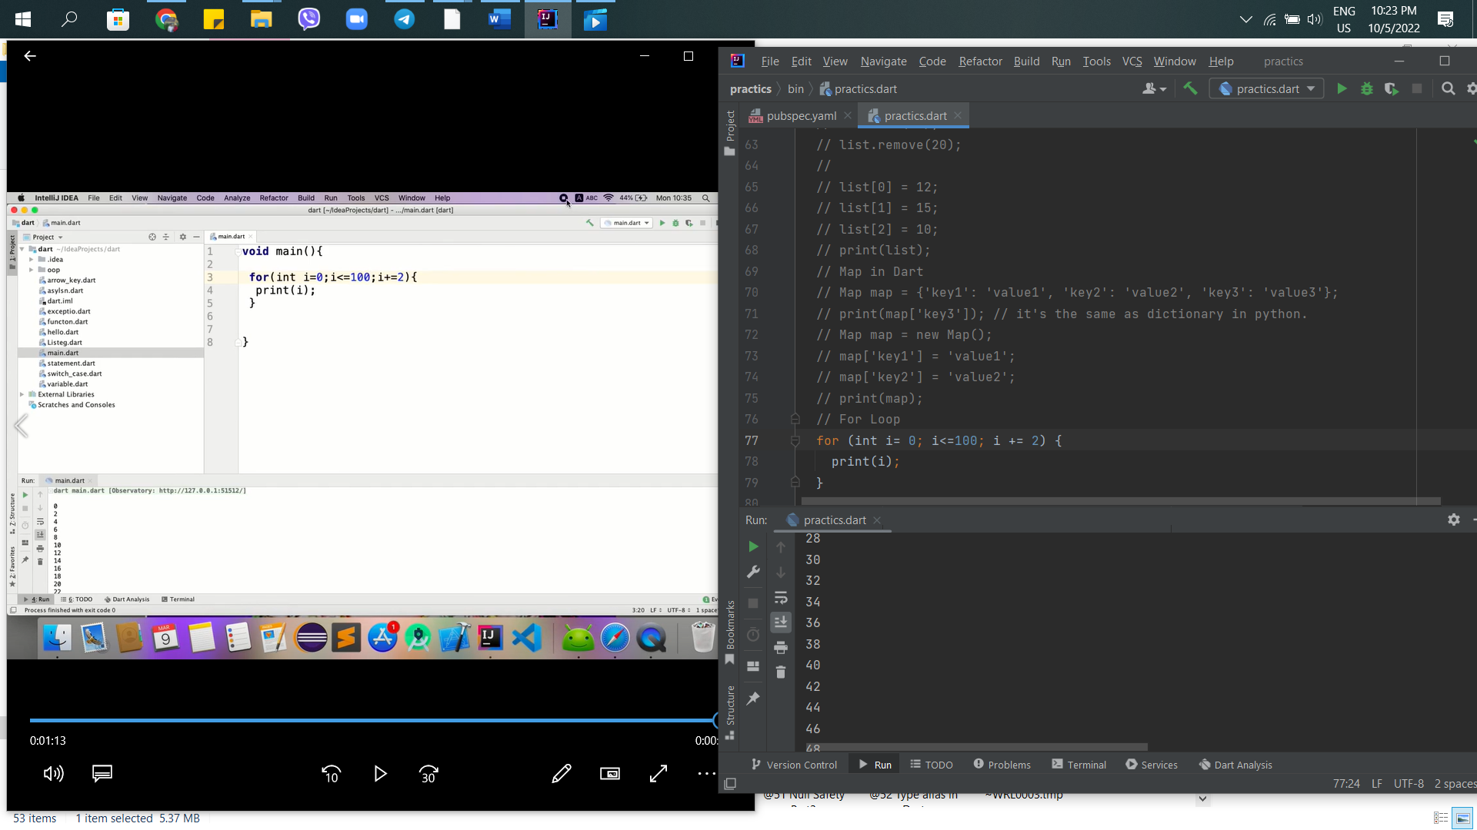

16th – For in Loop in Dart

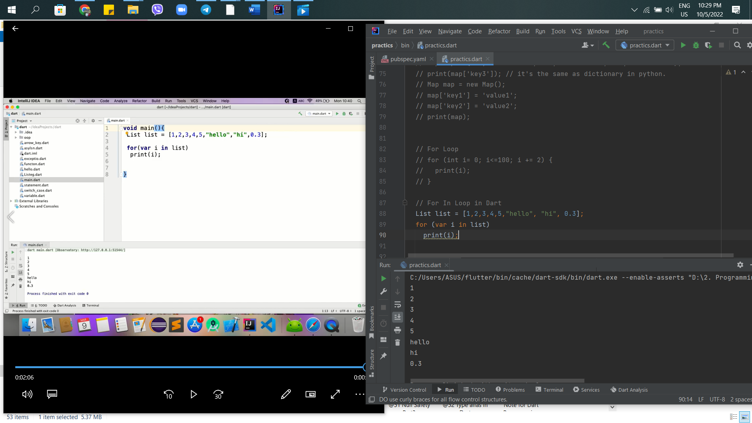

17th – While Loop in Dart

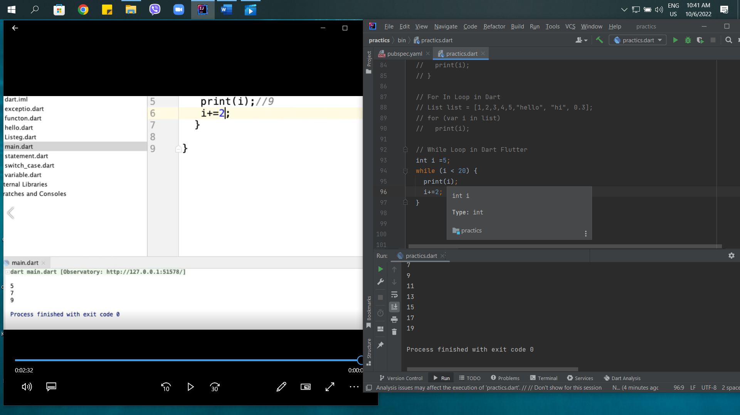

18th – Do While Loop in Dart Flutter

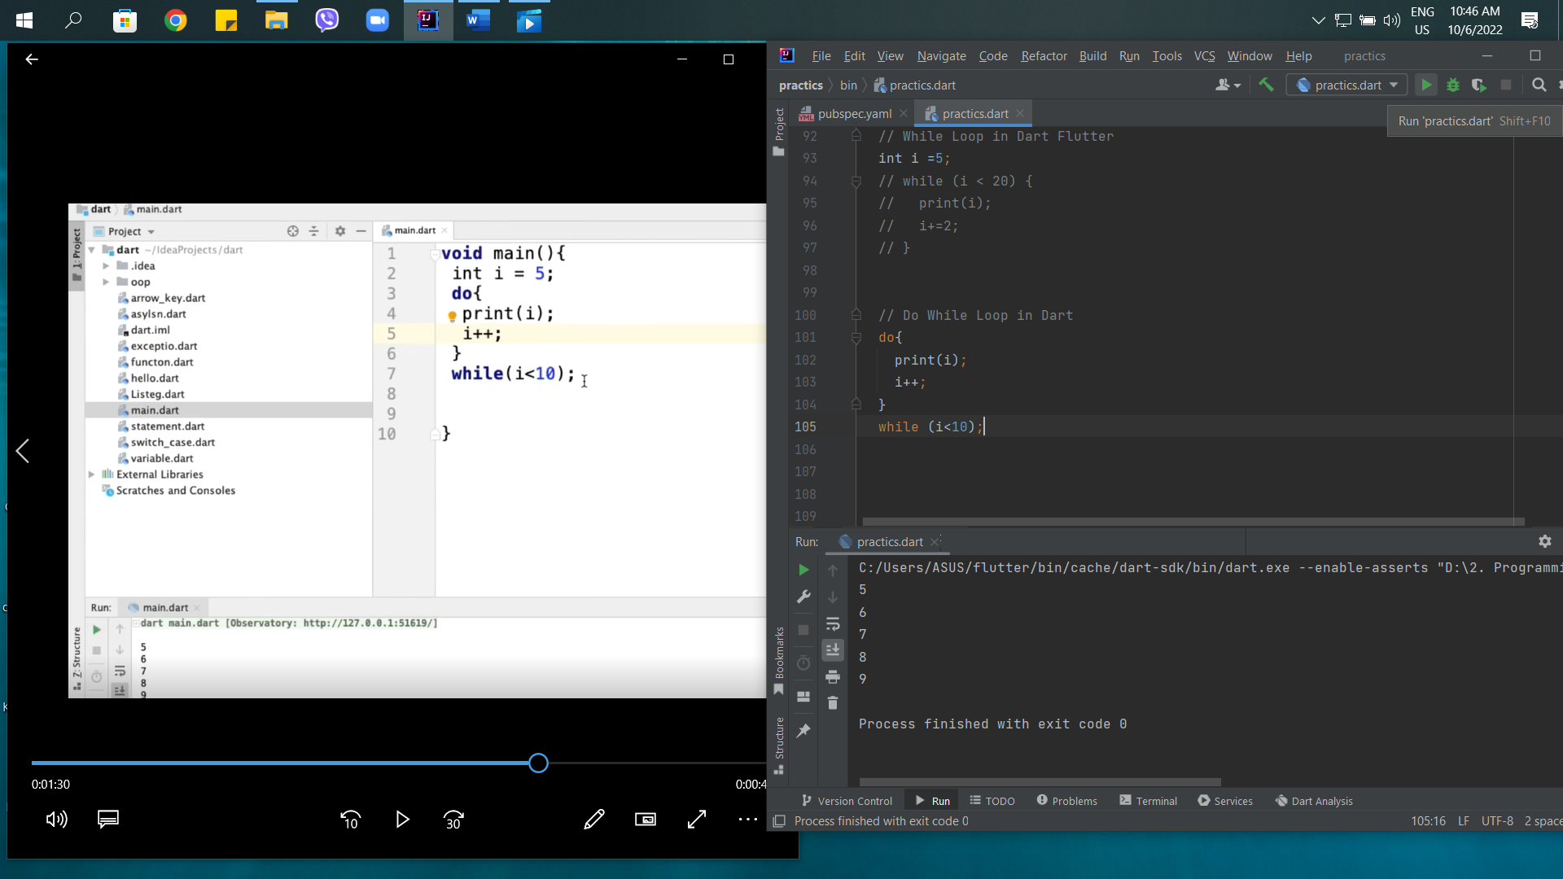

19th – Loop Control Statement in Dart

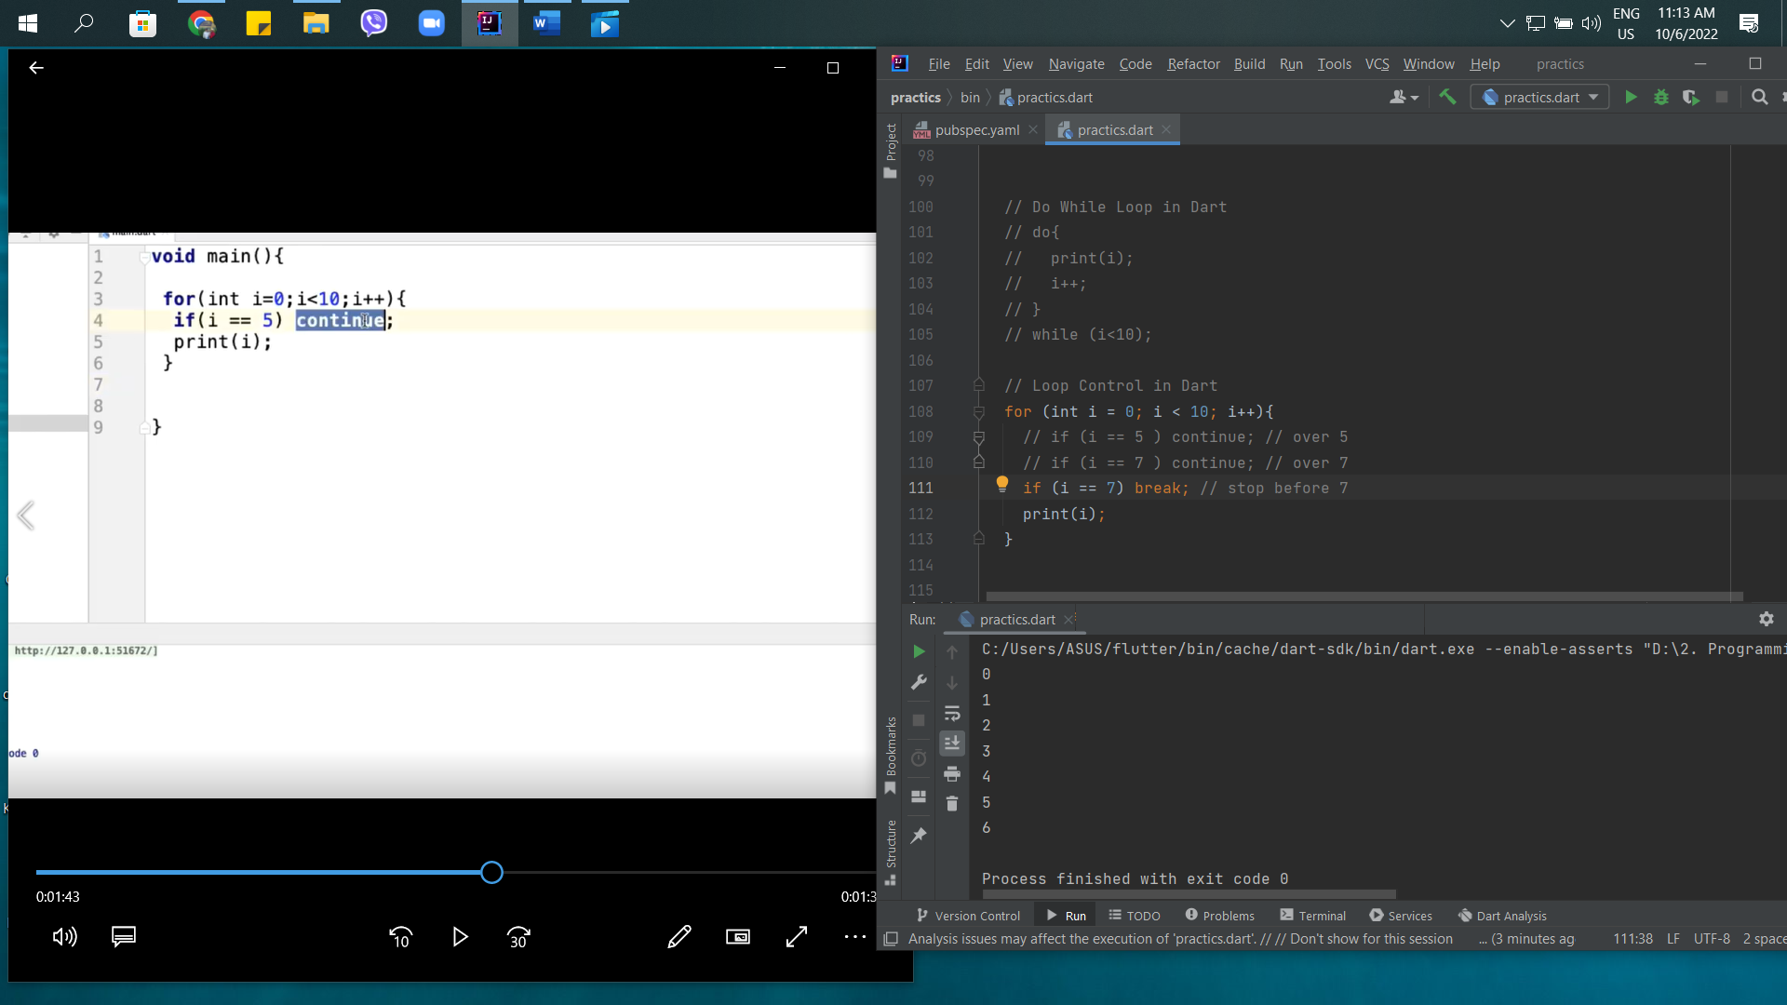

20th – Function in Dart Programming

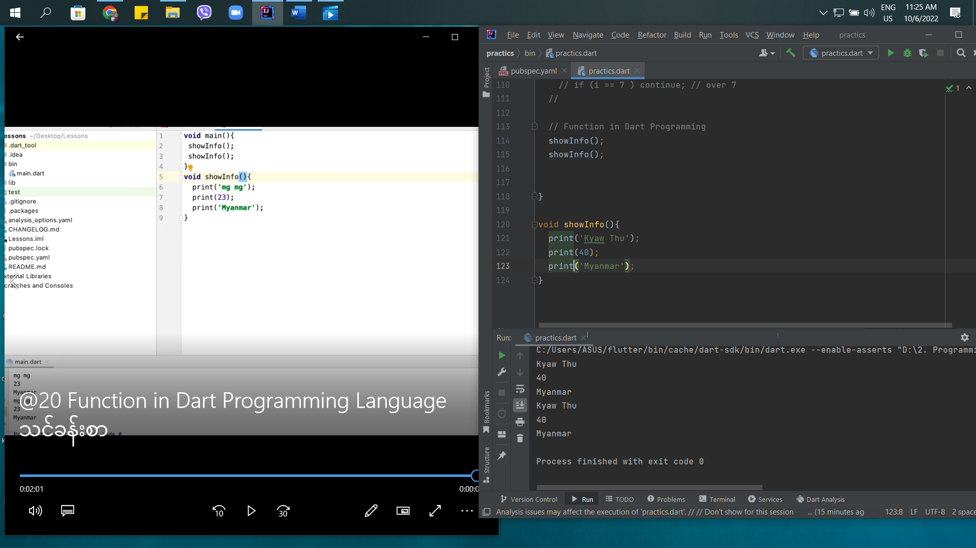

21st – Parameter Function in Dart

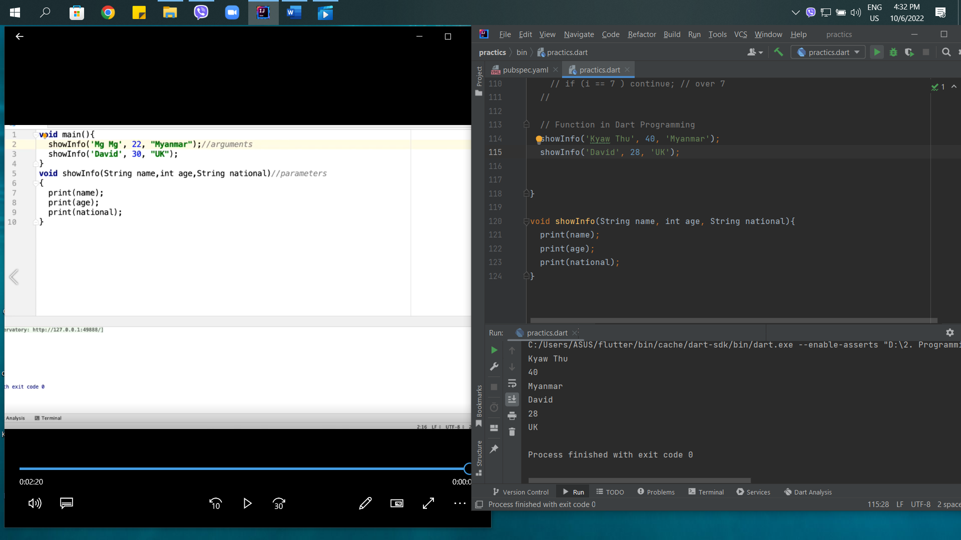

22nd – Function with Return Type in Dart

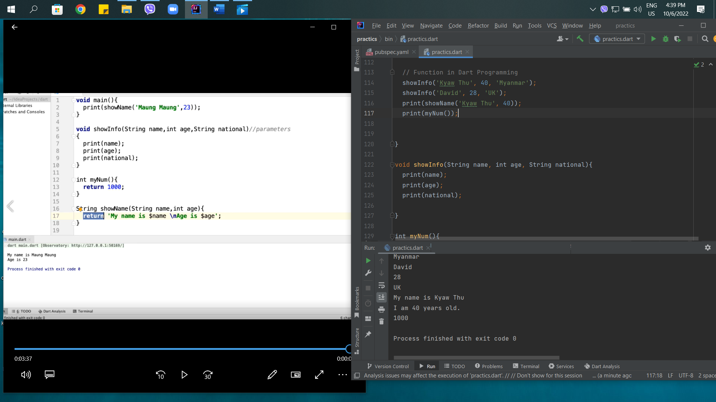

23rd – Type of Parameters in Parameter Function

Type of Parameter in Dart

* Required Parameter
* Positional Optional Parameters
* Optional Default Parameters
* Named Parameters

Required Parameter

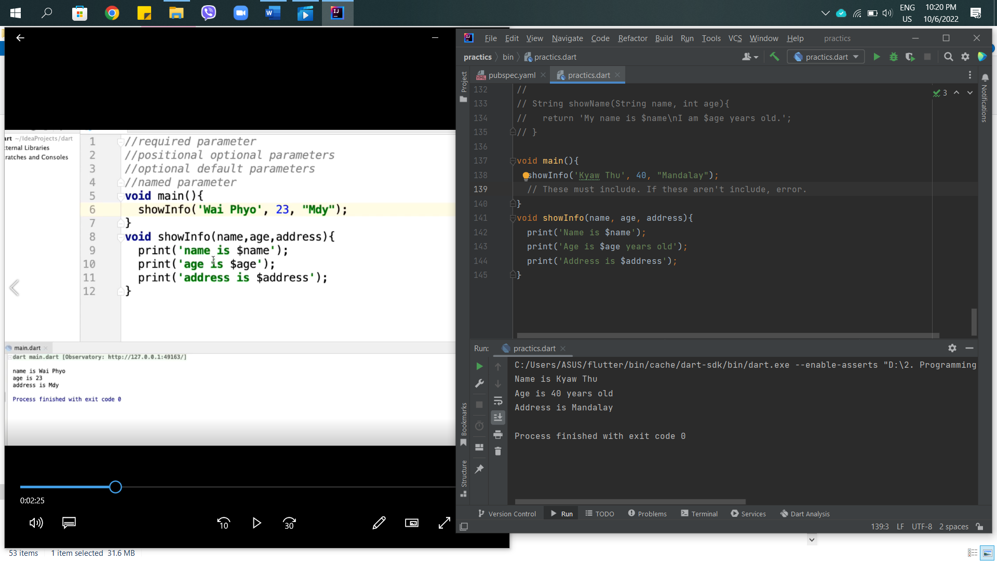

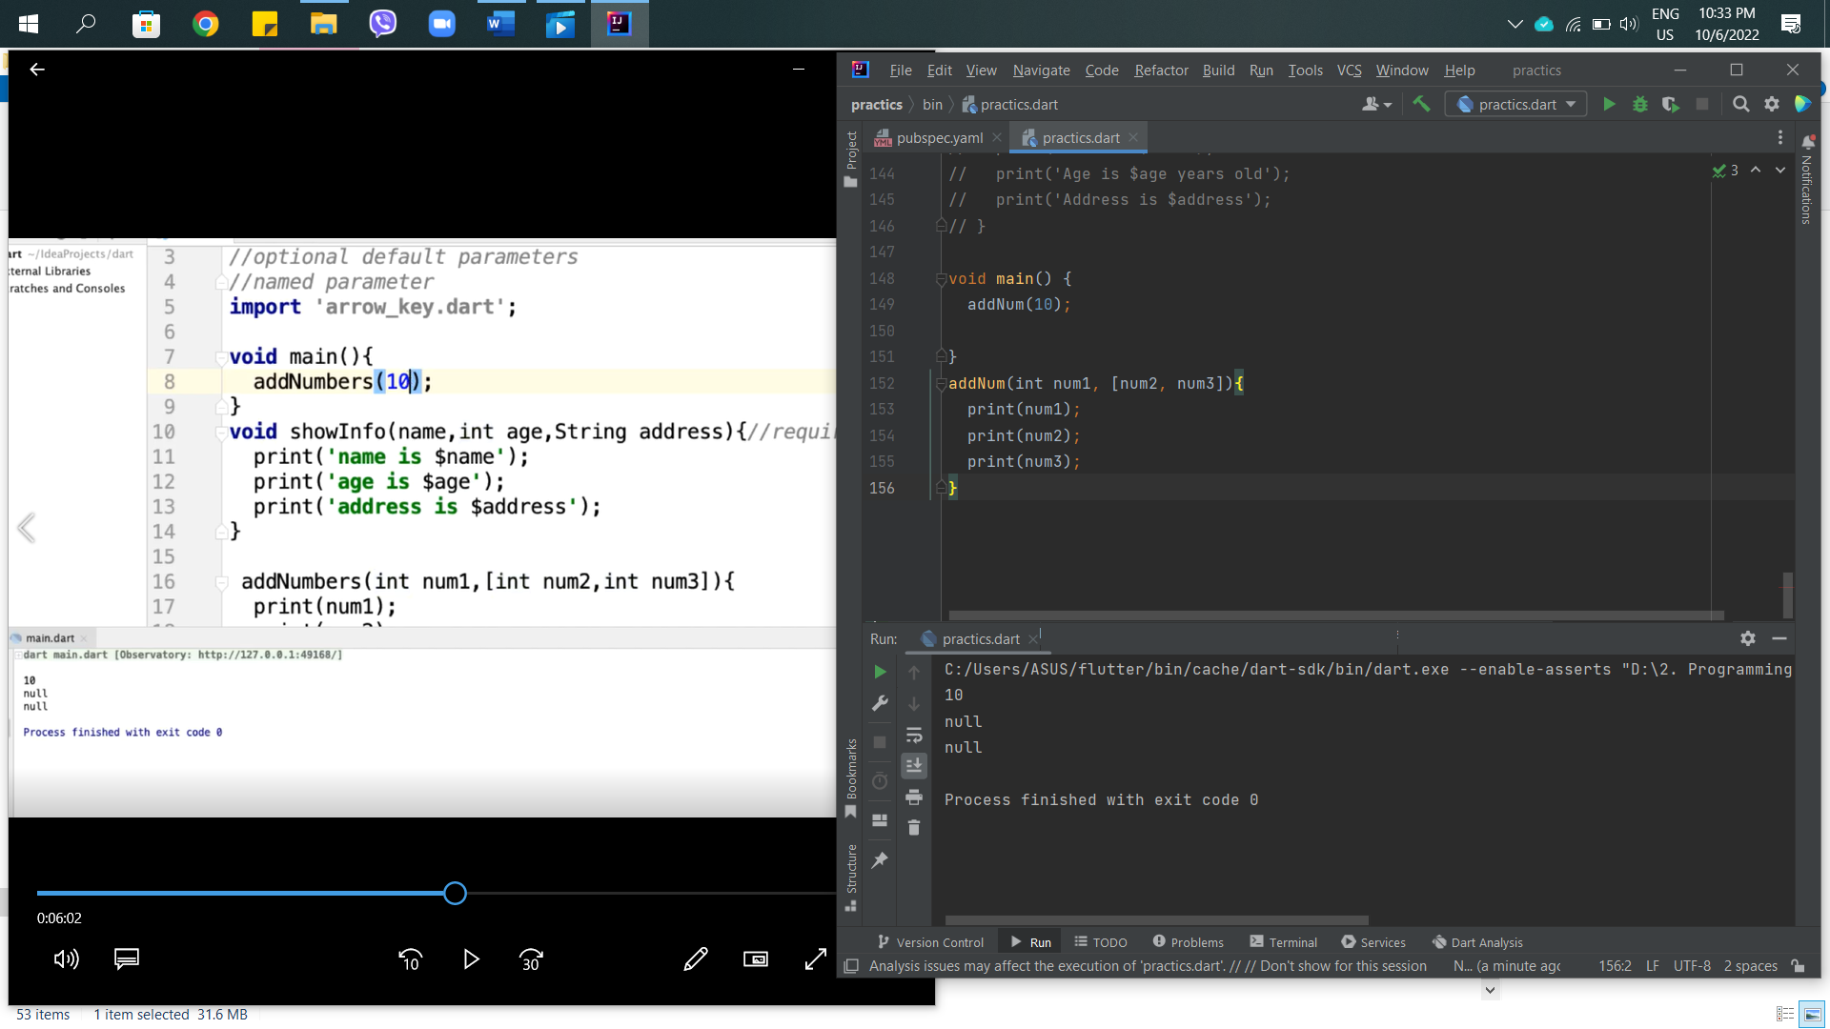

Optional Parameter

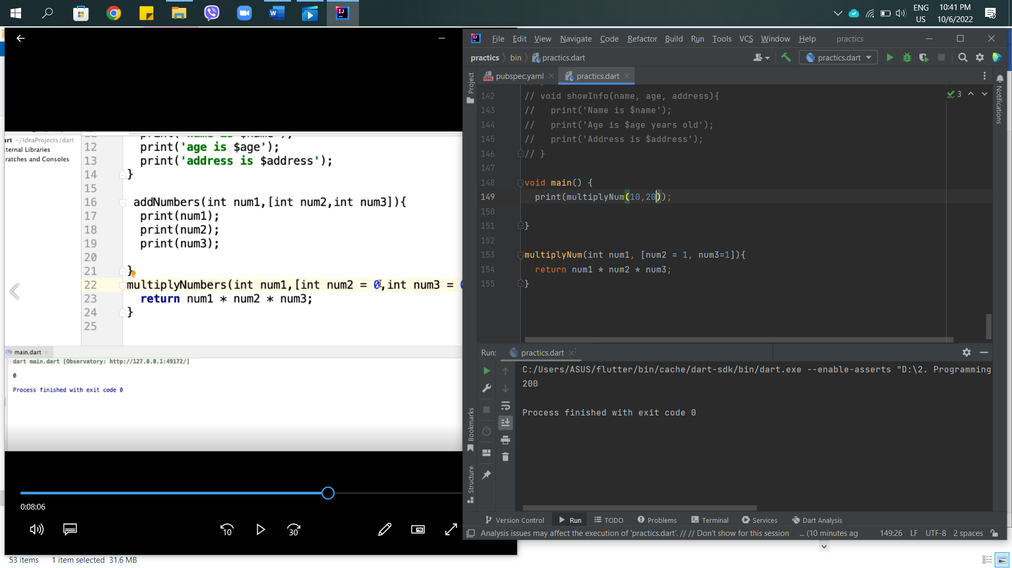

Named Parameter

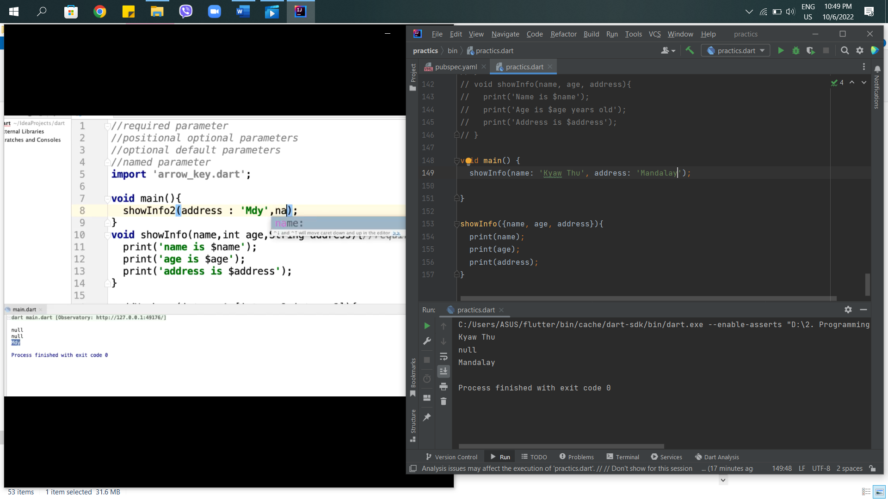

24th – String Interpolation in Dart

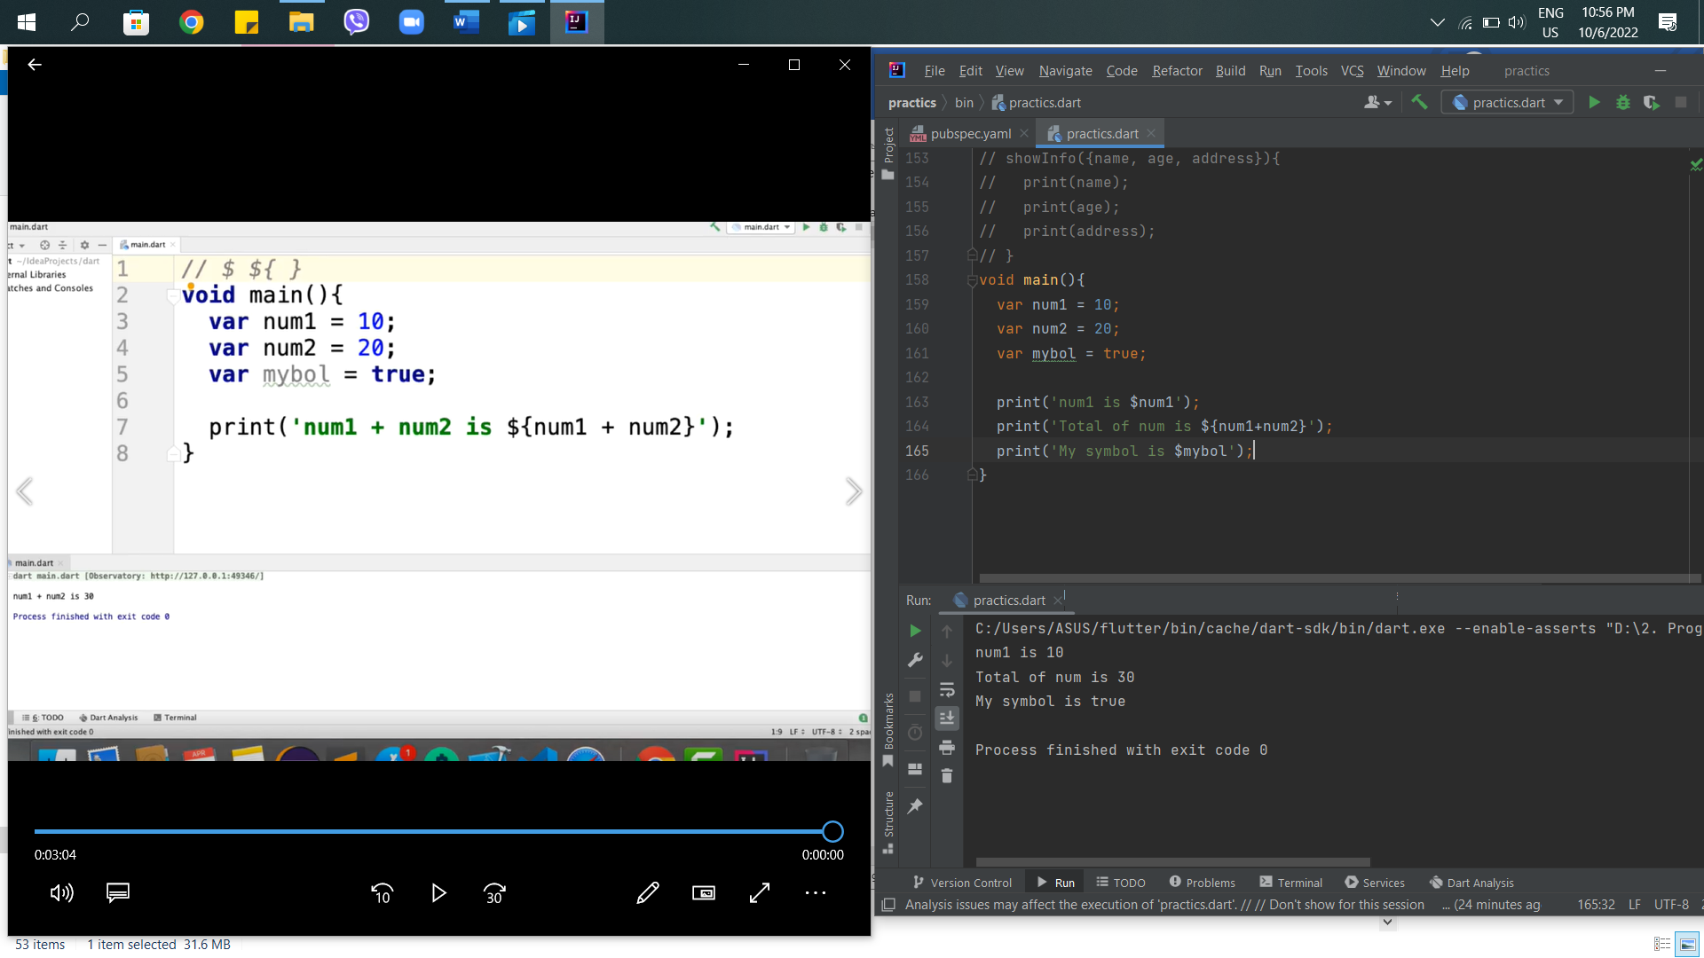

25th – Fat Arrow or Short hand syntax in Dart

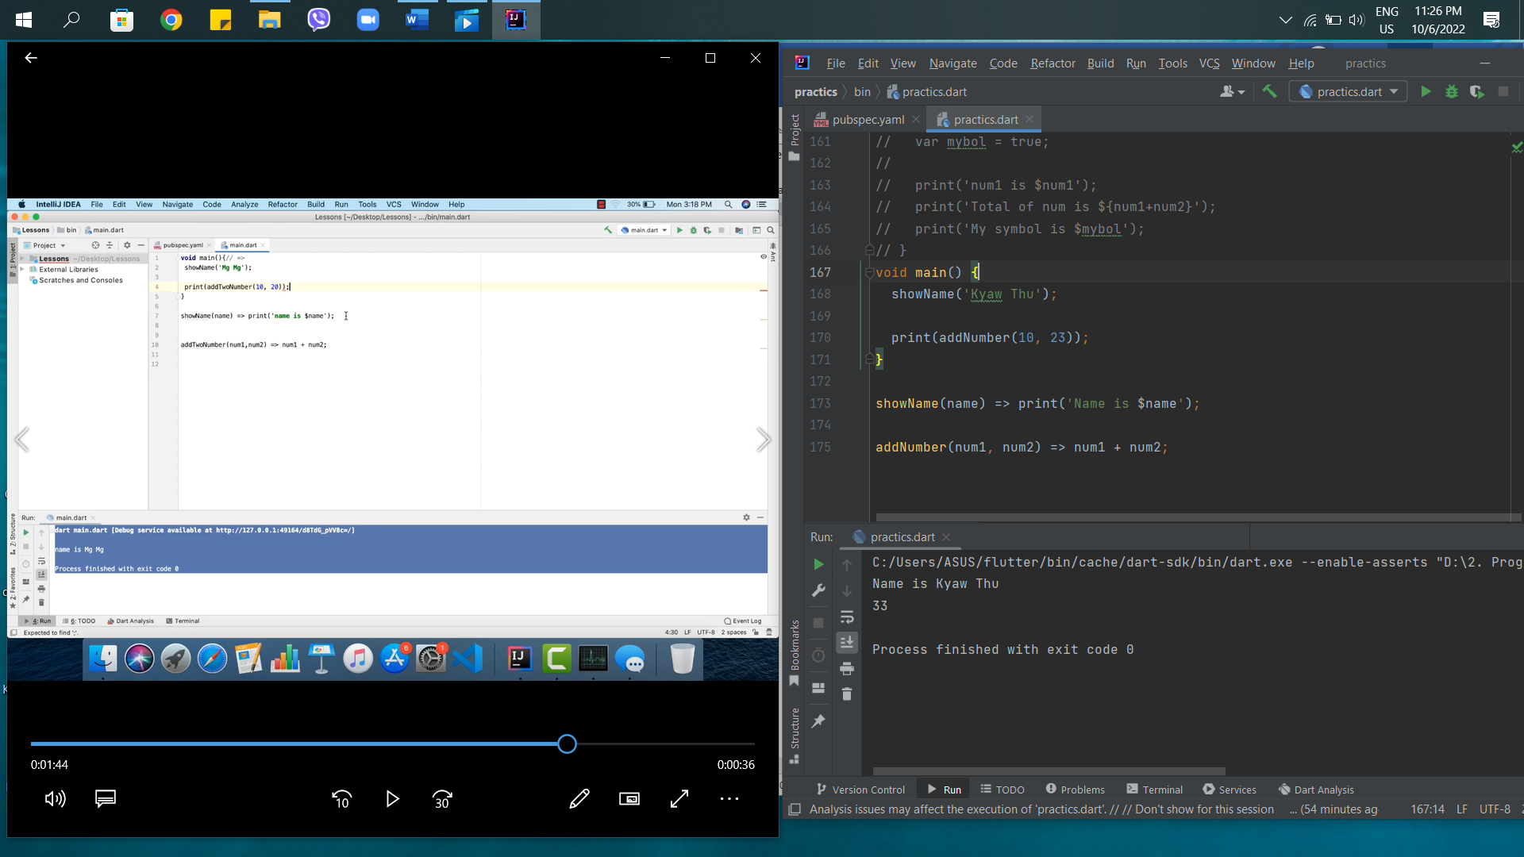

26th – Functional Programming in Dart

Functional Programming in Dart

* Higher Order Function
* Lambda Function
* Closure

Higher Order Function

* Function Parameters can be Function
* Function can be return a Function
* And both

Lambda Function also known as anonymous function arrow function

* Lambda function are function with on name
* Anonymous
* Nameless function

Closure

* Inner Function can across variable parent scope or outside of scope even the parent scope is closed
* Can access parent function parameter
* A function object that accesses in its lexical scope
* Call outer function and return inner function that access parameter

27th – Higher Order Function in Dart

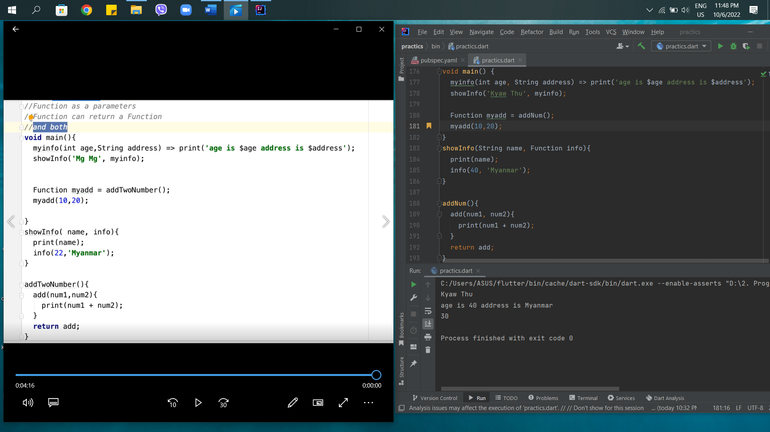

28th – Lambda Function in Dart

* Lambda Functions are function with no name
* Anonymous
* Nameless Function

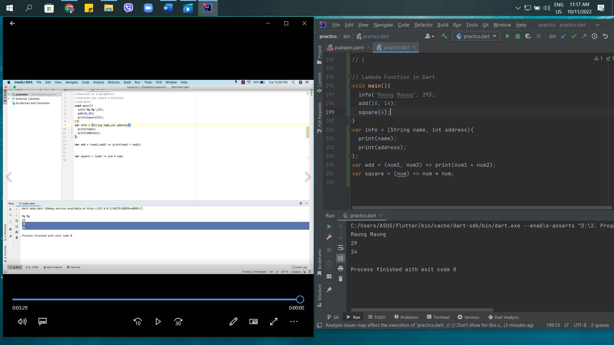

29th – Closure in Dart

It can accept outside of the child. But, it can’t accept inside the child.

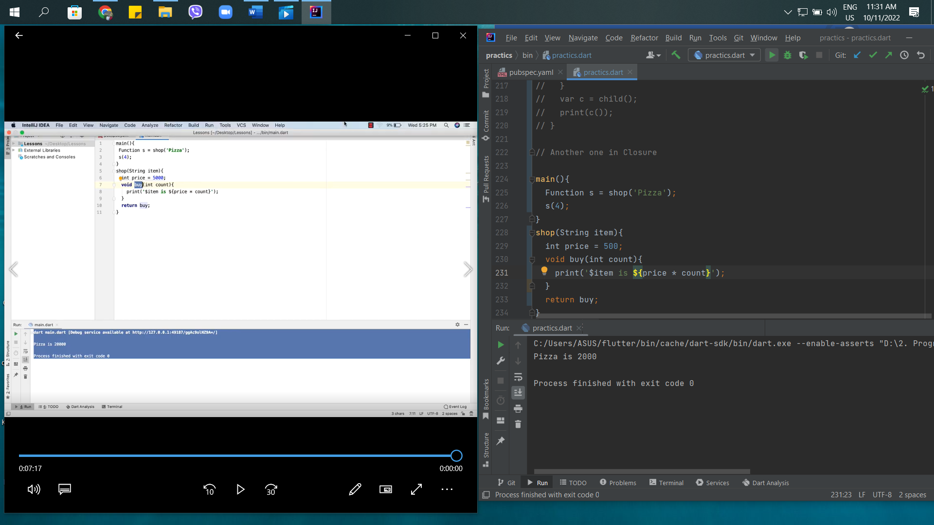

30th – OOP Class and Object in Dart

Object Oriented Programming in Dart (OOP)

1. Class, abstract, interface, mixins, etc.,
2. Inheritance
3. Polymorphism
4. Encapsulation, etc.,

Class and Object

Object – a real-world entity an entity which has state and behavior. (eg. – A cat is an object color is white, knowns as state and cat is useful to catch mice, it is behavior)

Class – Prototype, Structure and Blueprint of Object which encapsulate the behavior and state Object.

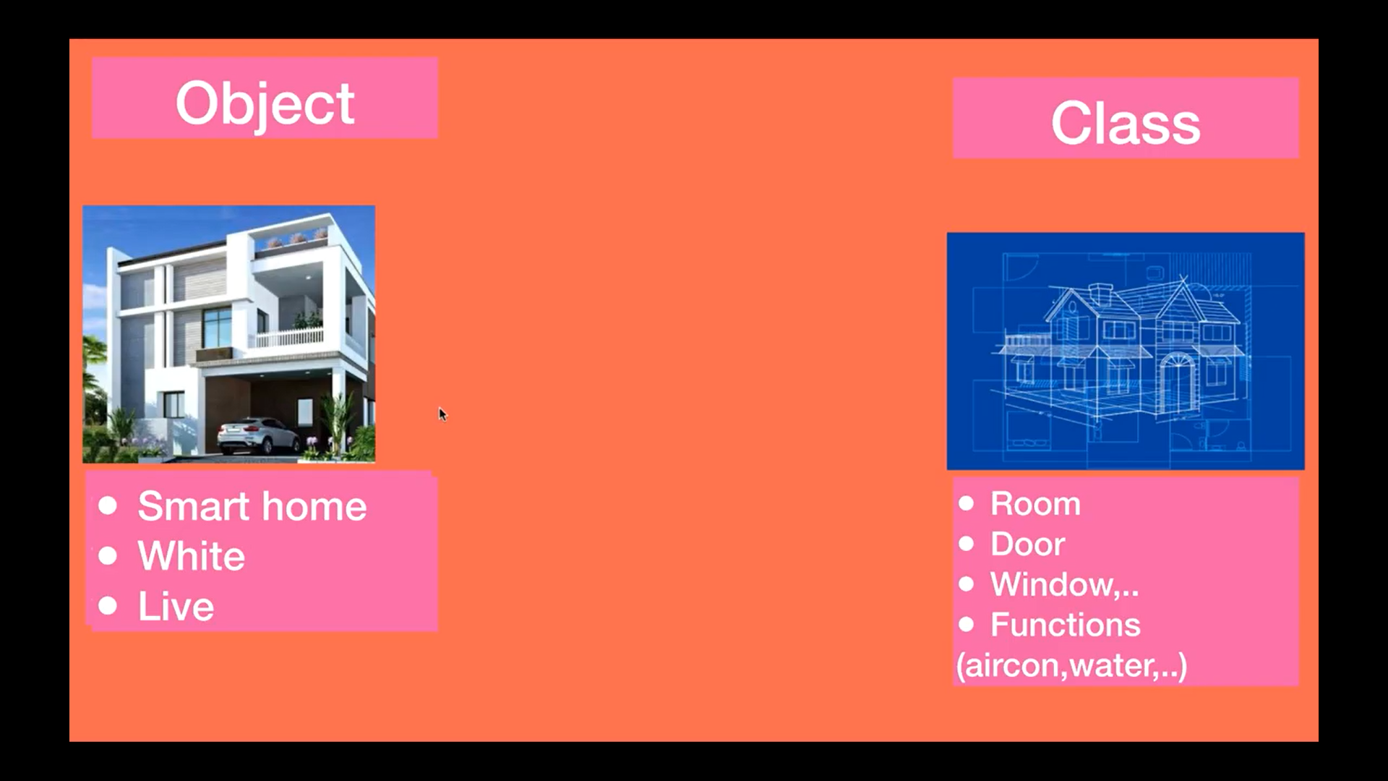

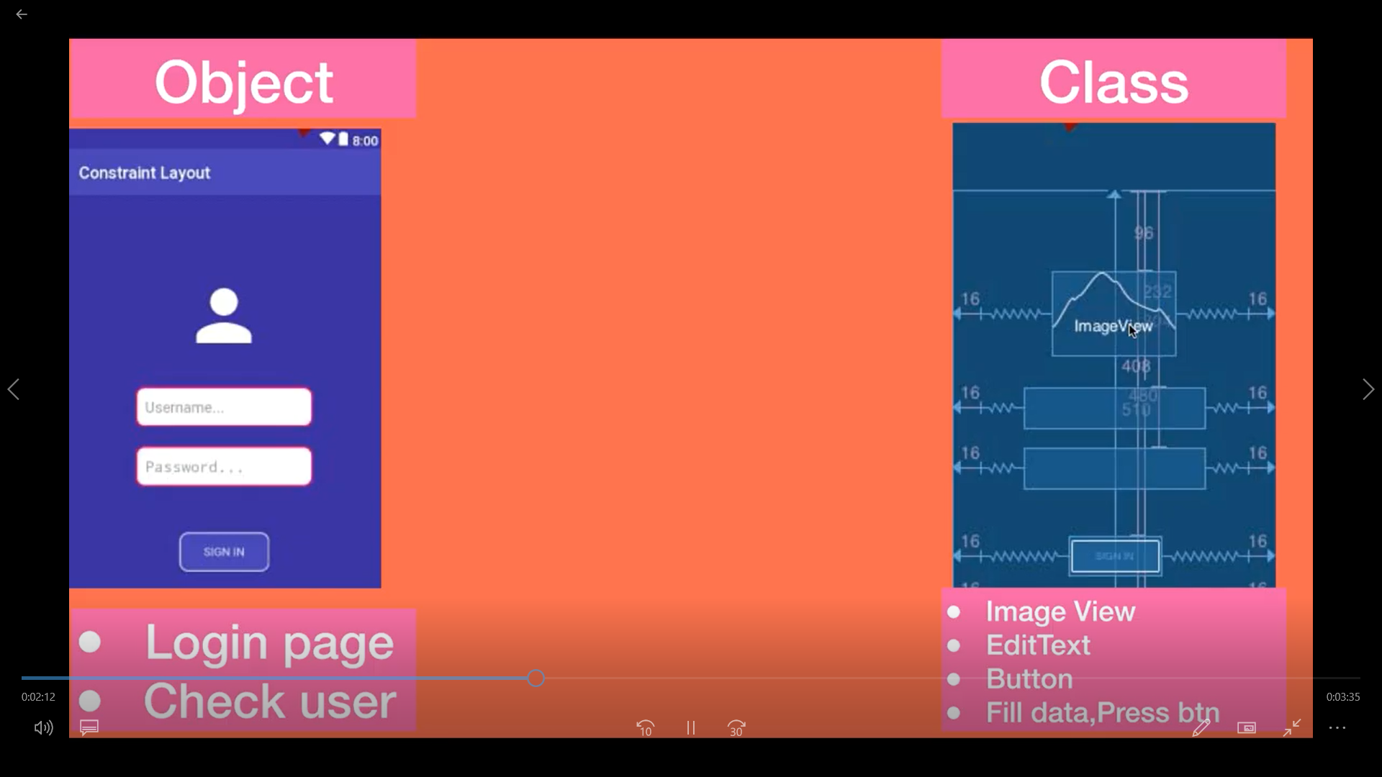

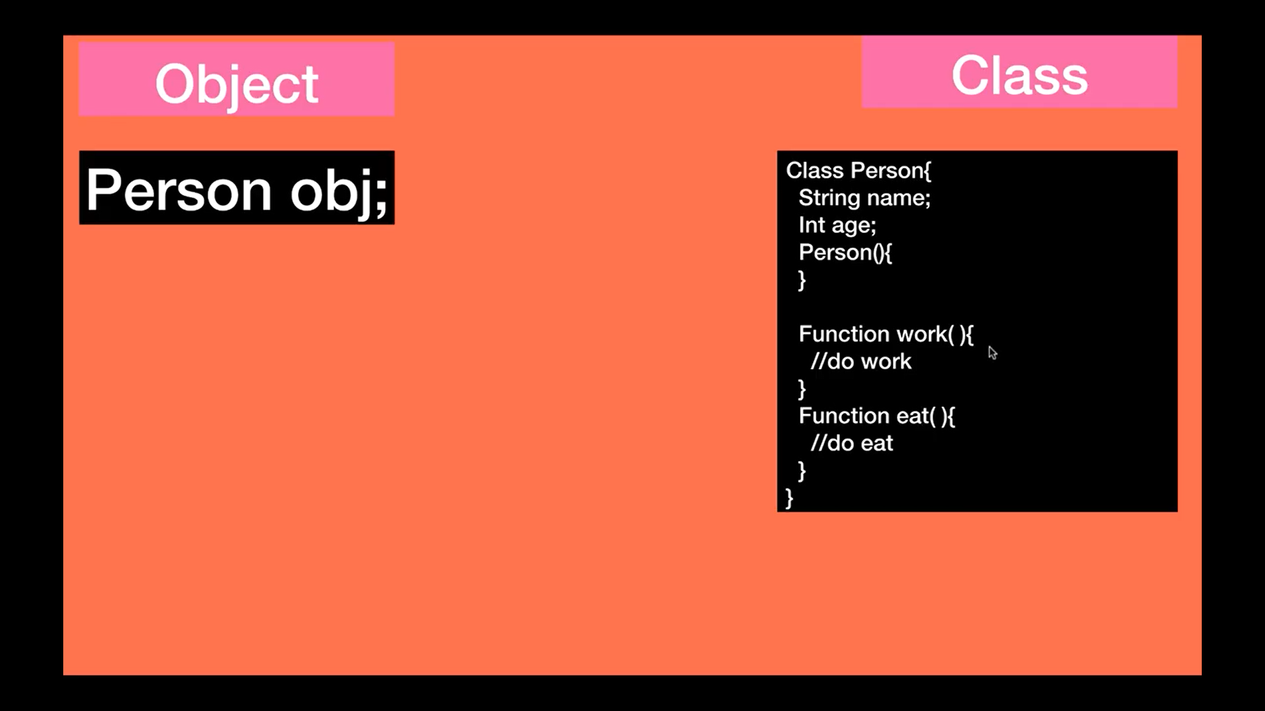

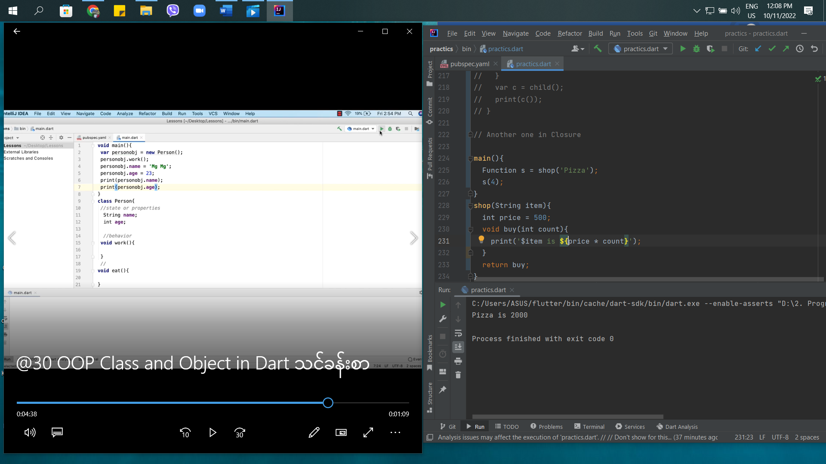

Error code

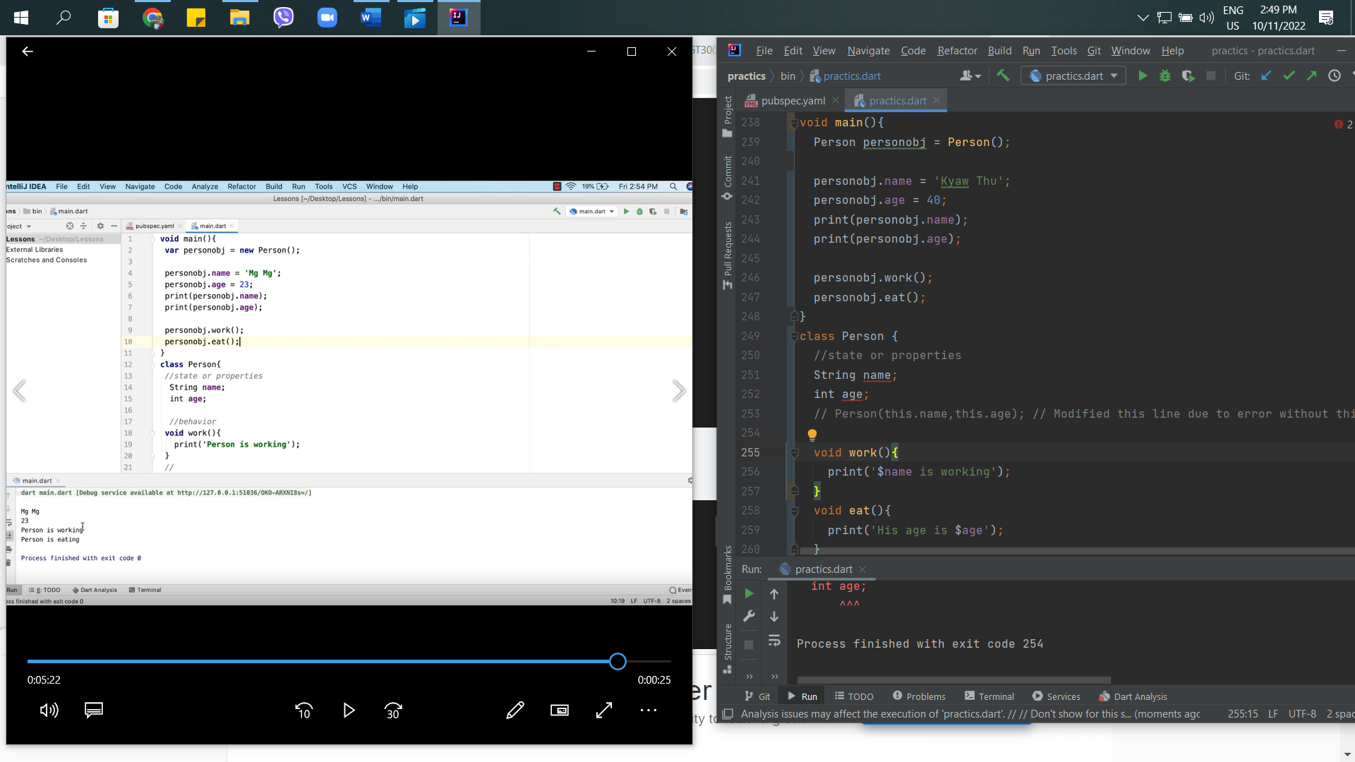

Run code

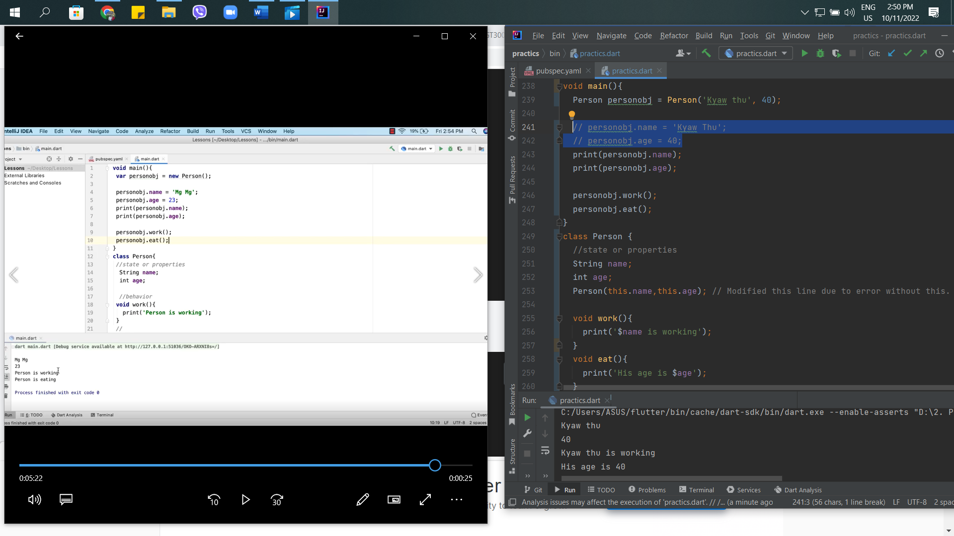

31st - Class Object Instance and reference variable in Dart

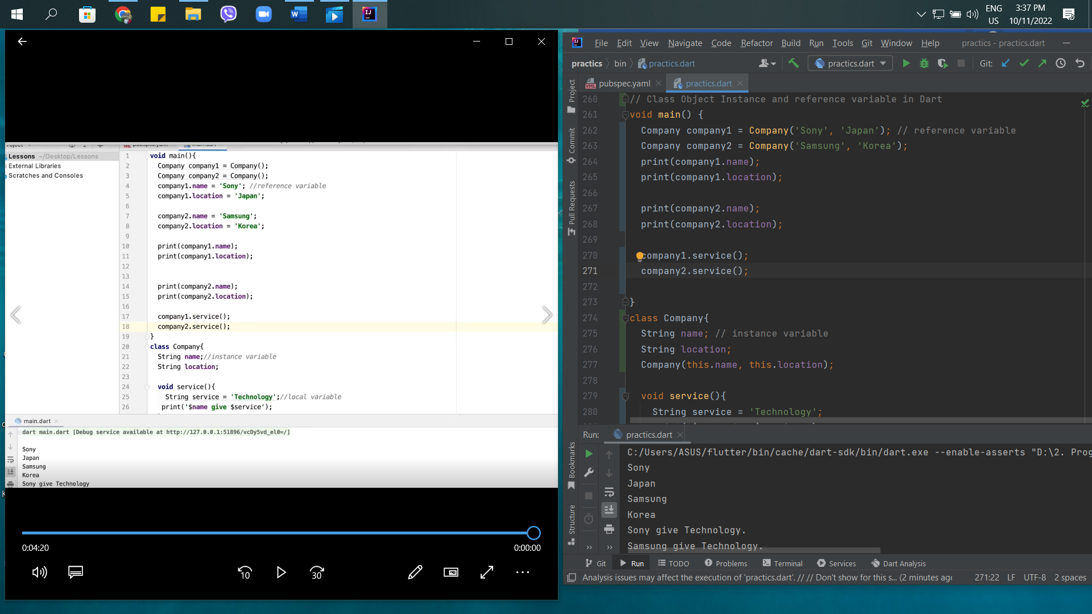

\*\*\* I’m Ok with $ in class variable. \*\*\*

32nd – Constructors (Default Constructor Name Constructor factory Constructor) in Dart

There are 3 type of constructor. These are

* Default Constructor
* Name Constructor
* Factory Constructor

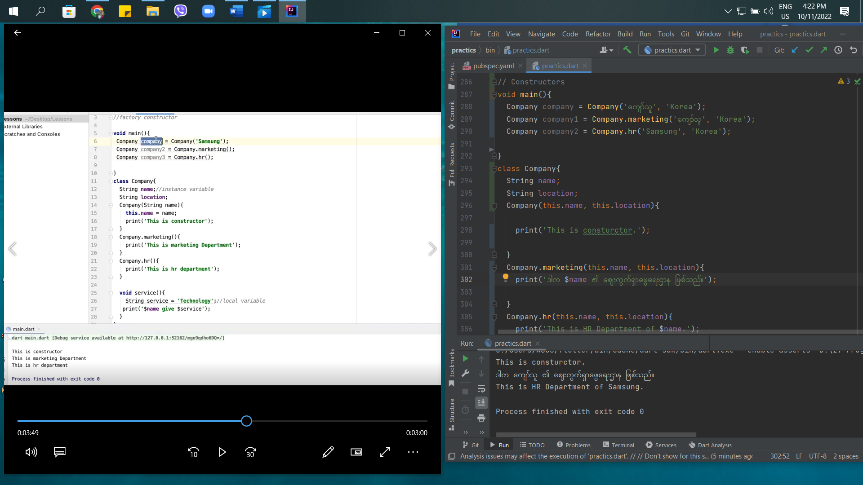

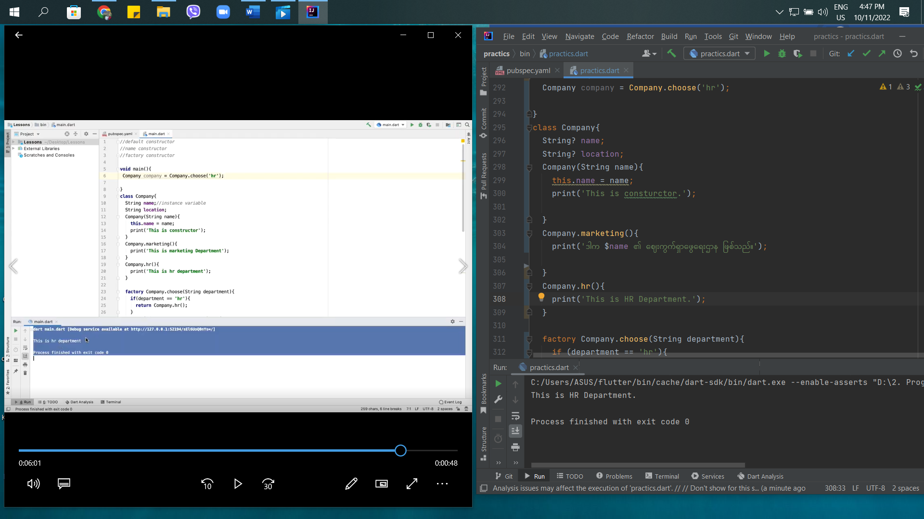

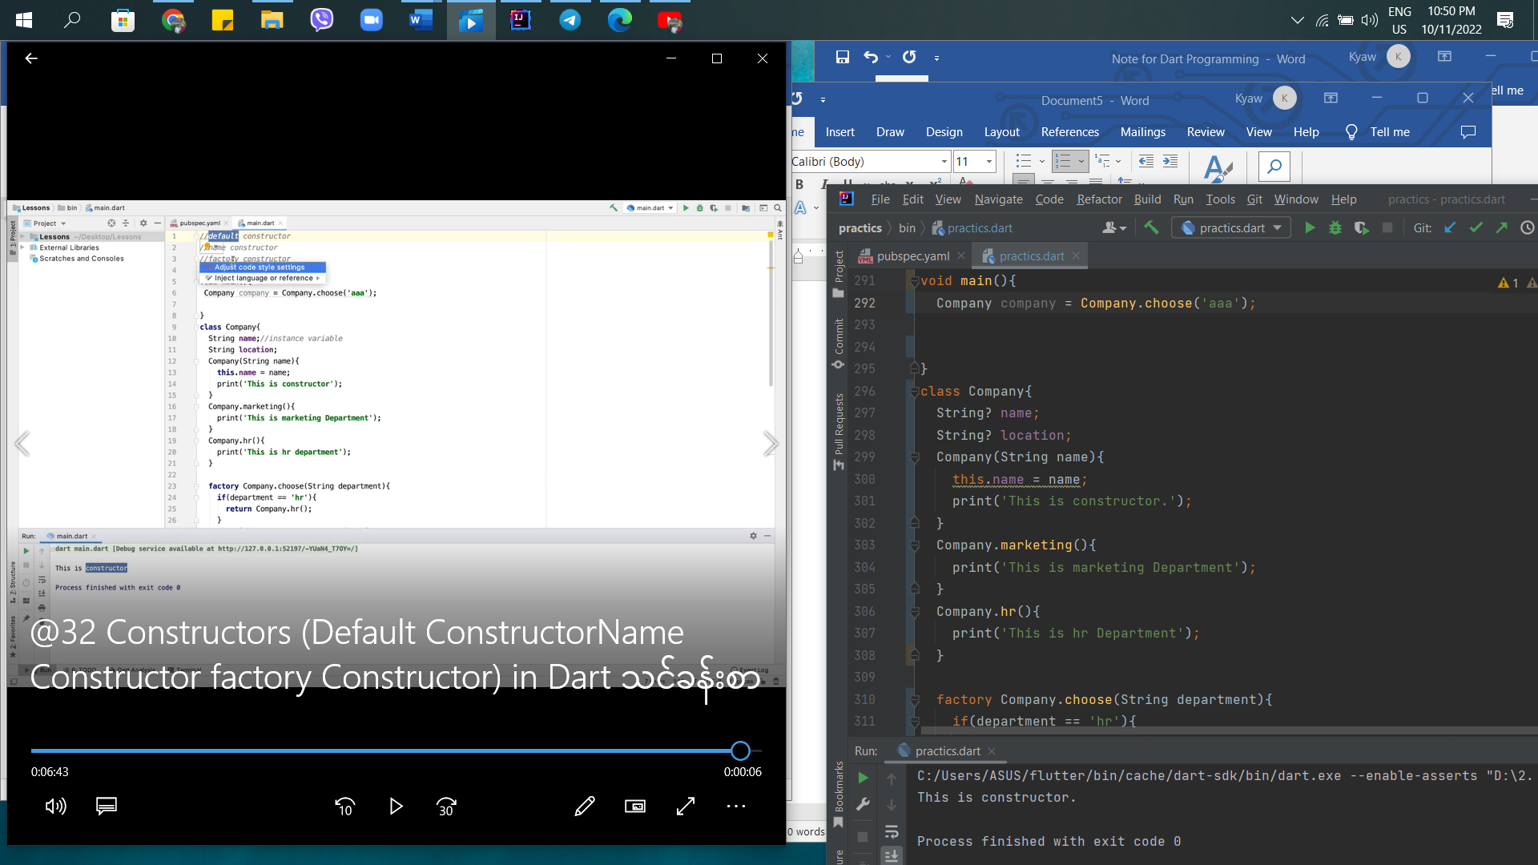

33rd – Inheritance introduction in Dart

Inheritance is the main feature of Object Oriented Programming in Dart.

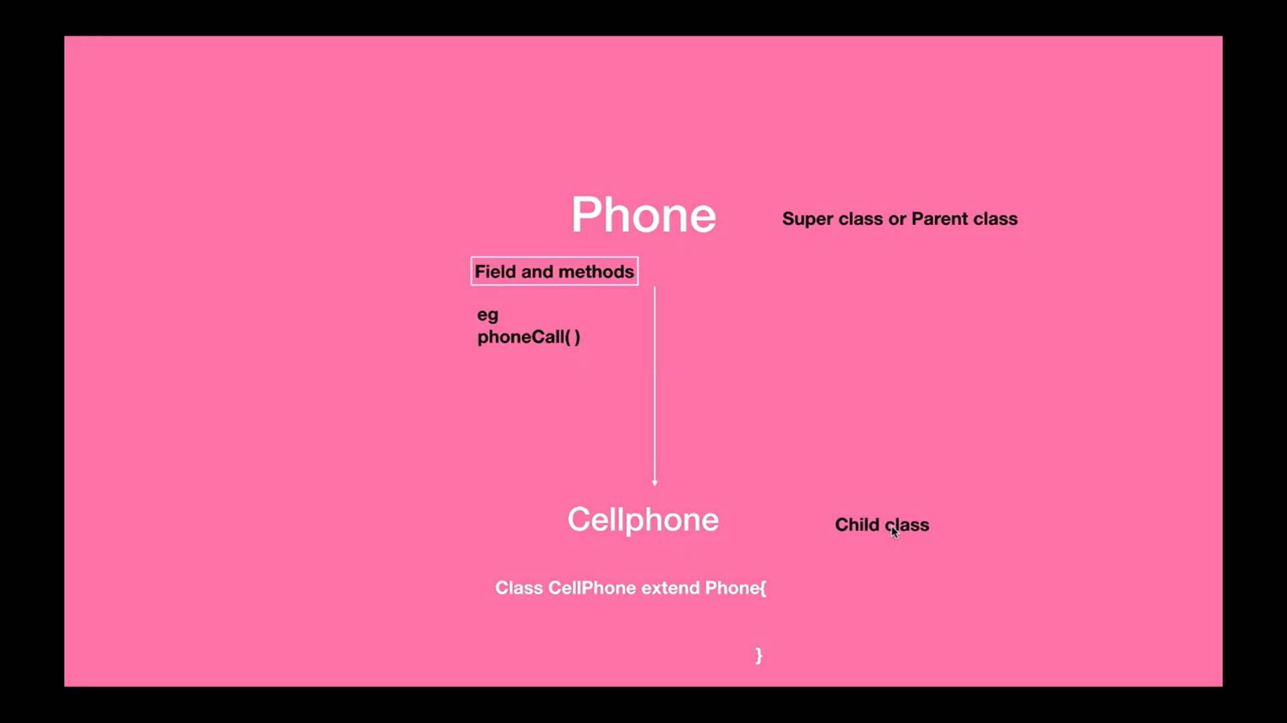

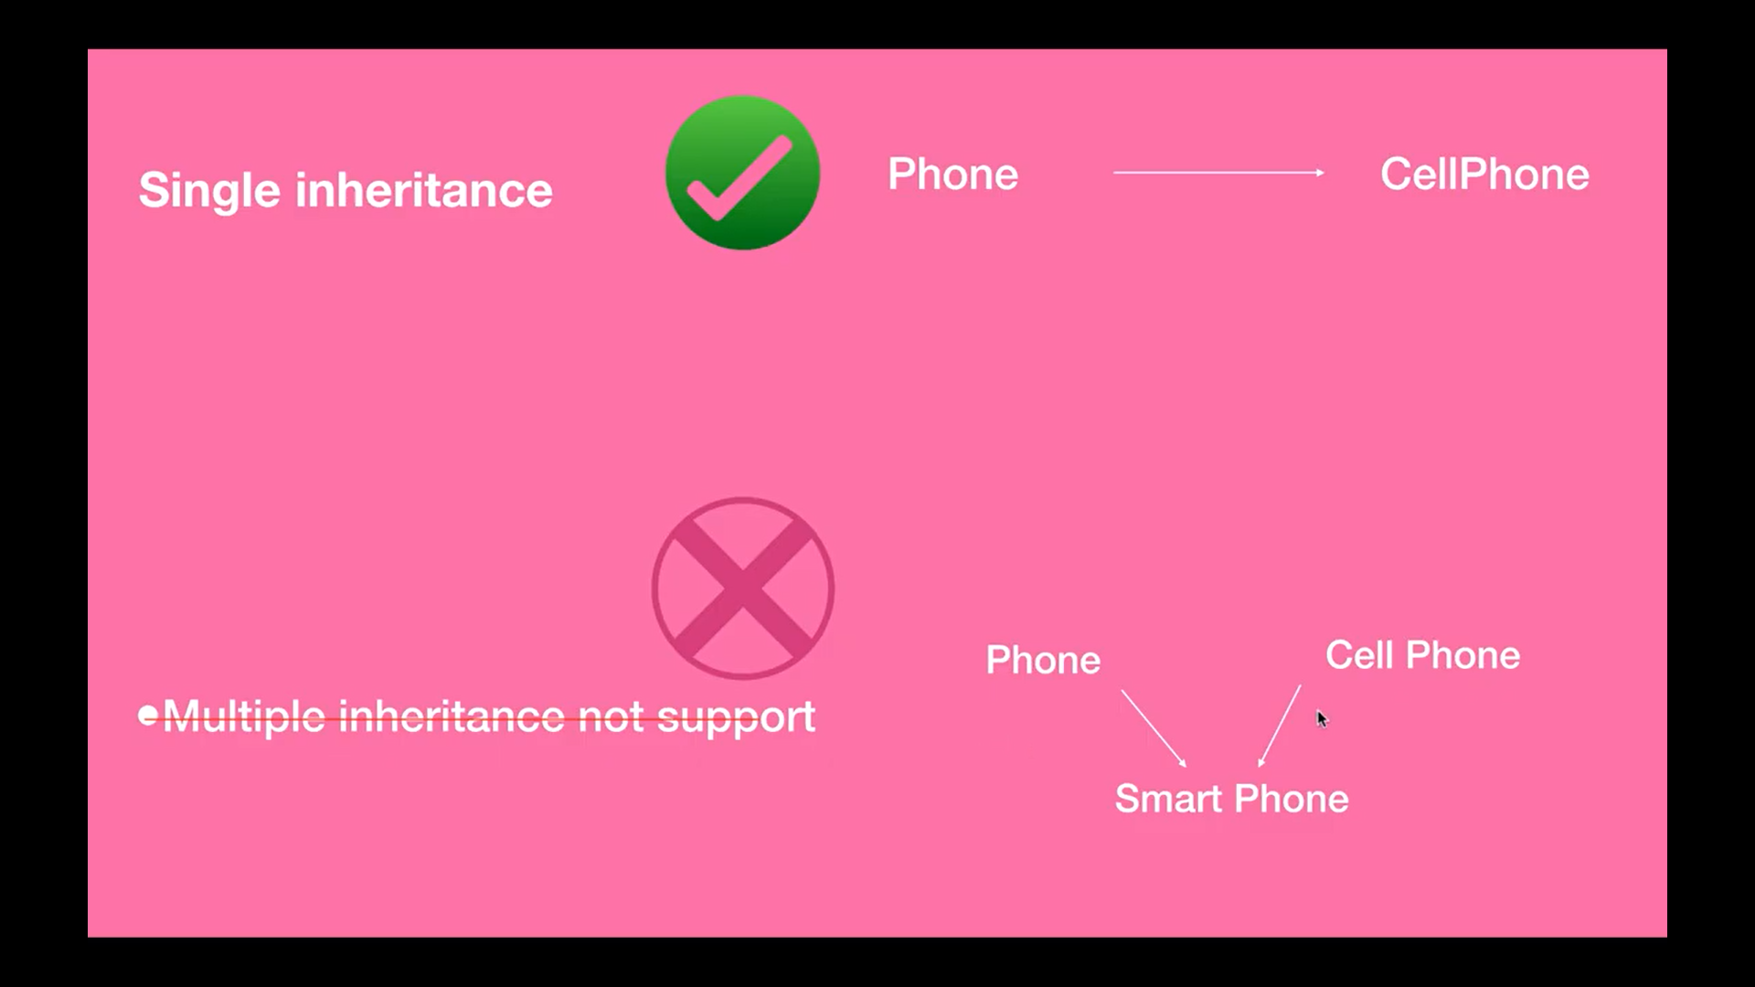

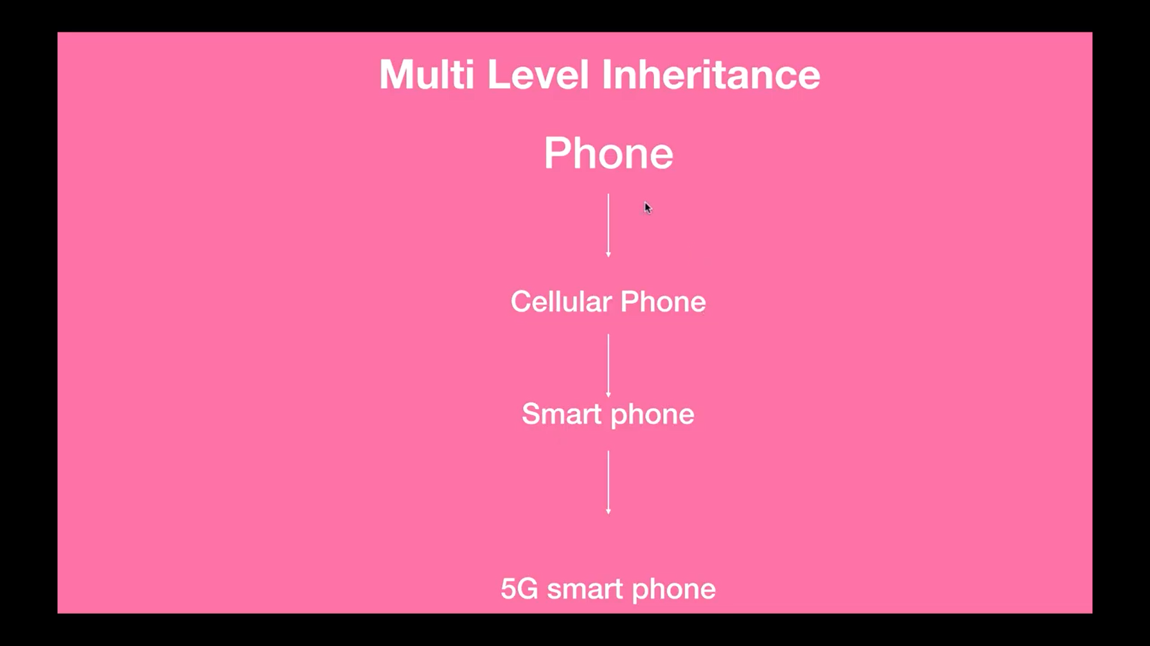

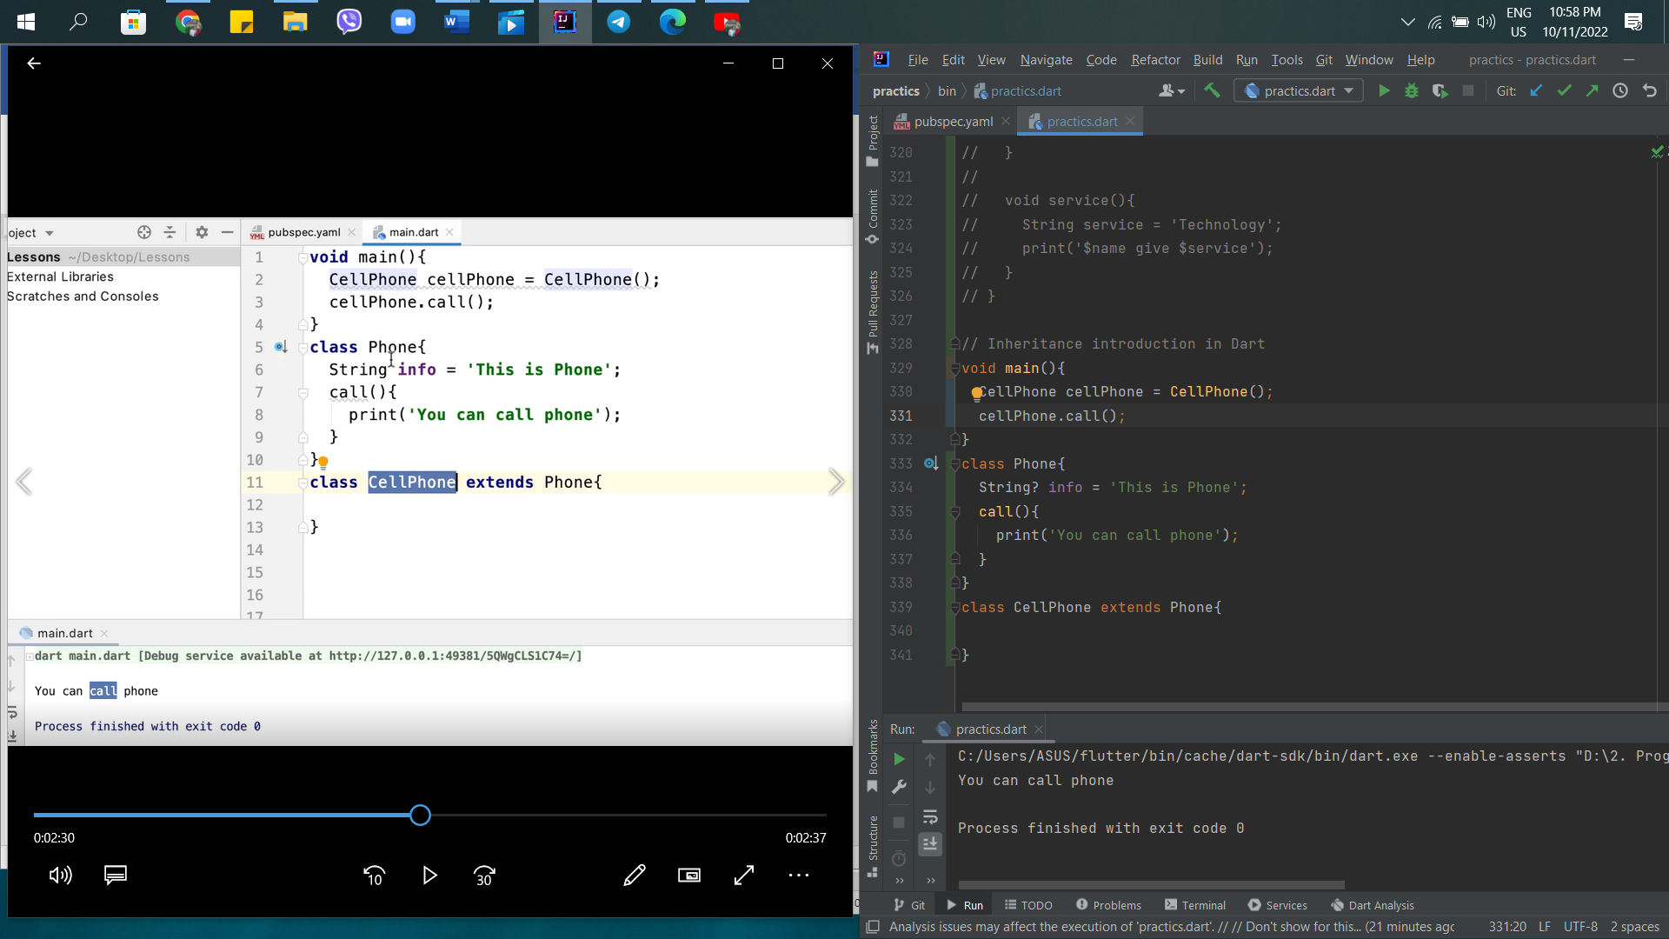

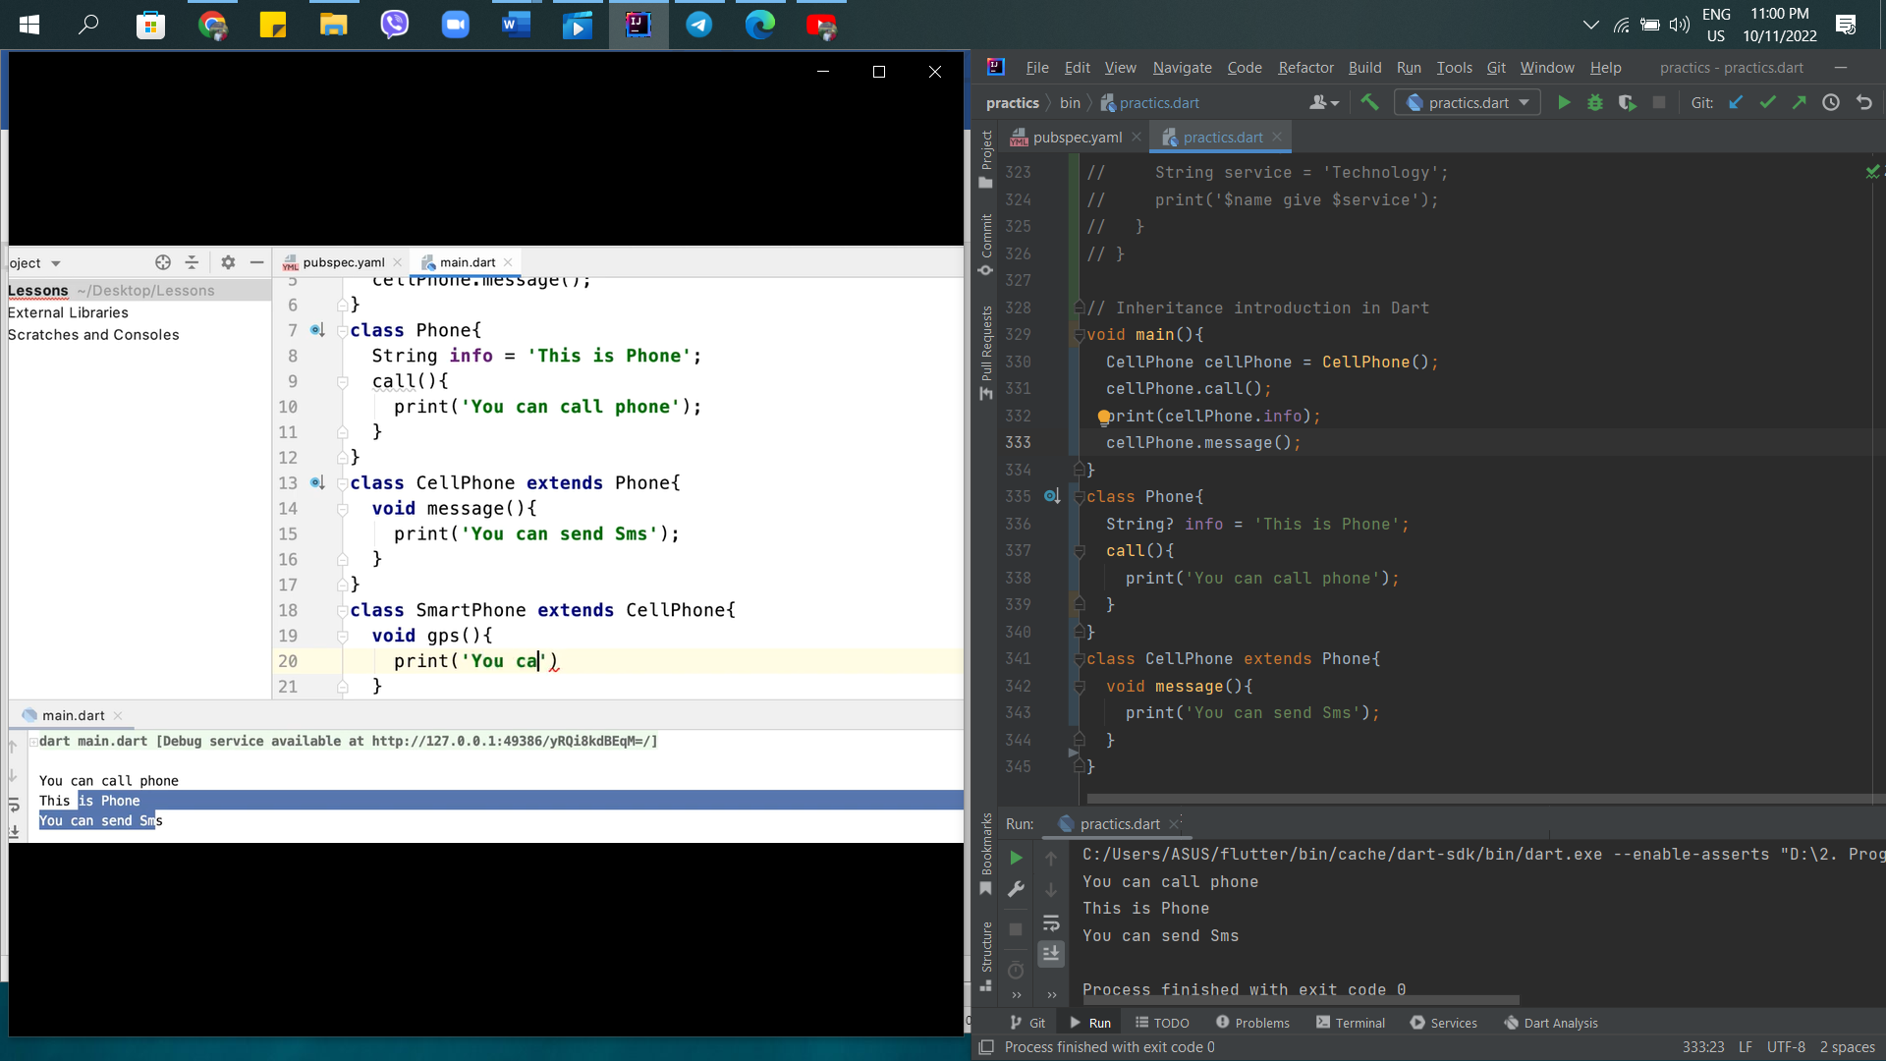

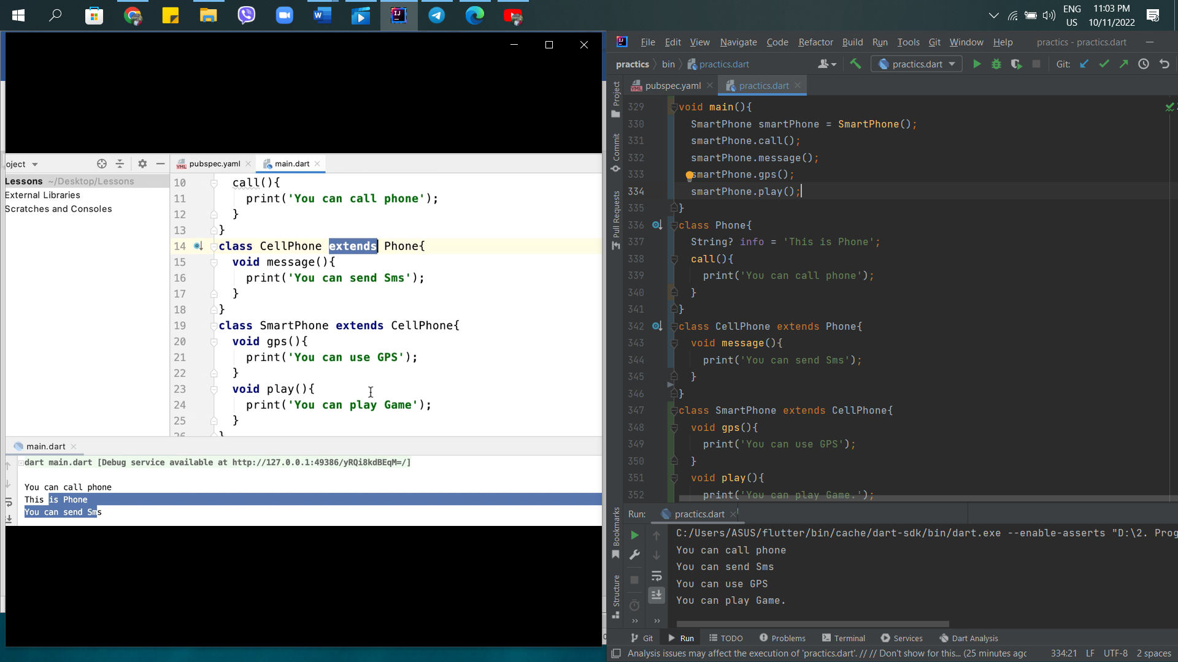

34th – Inheritance Part 2

There are two methods. These are method override or polymorphism and super this.

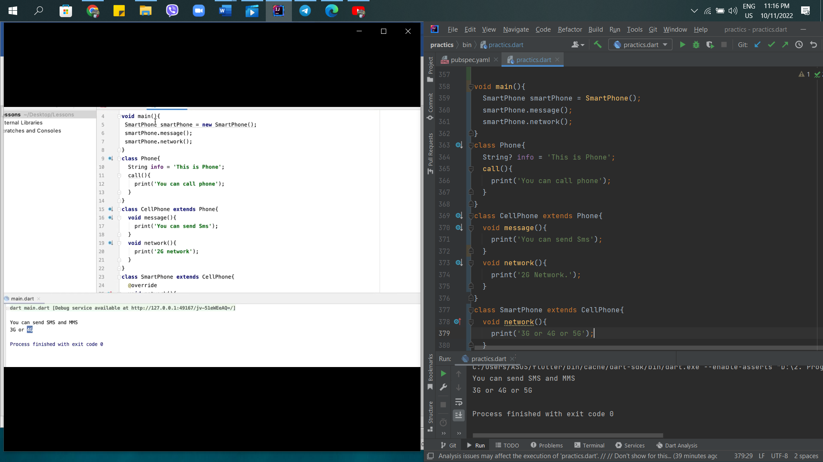

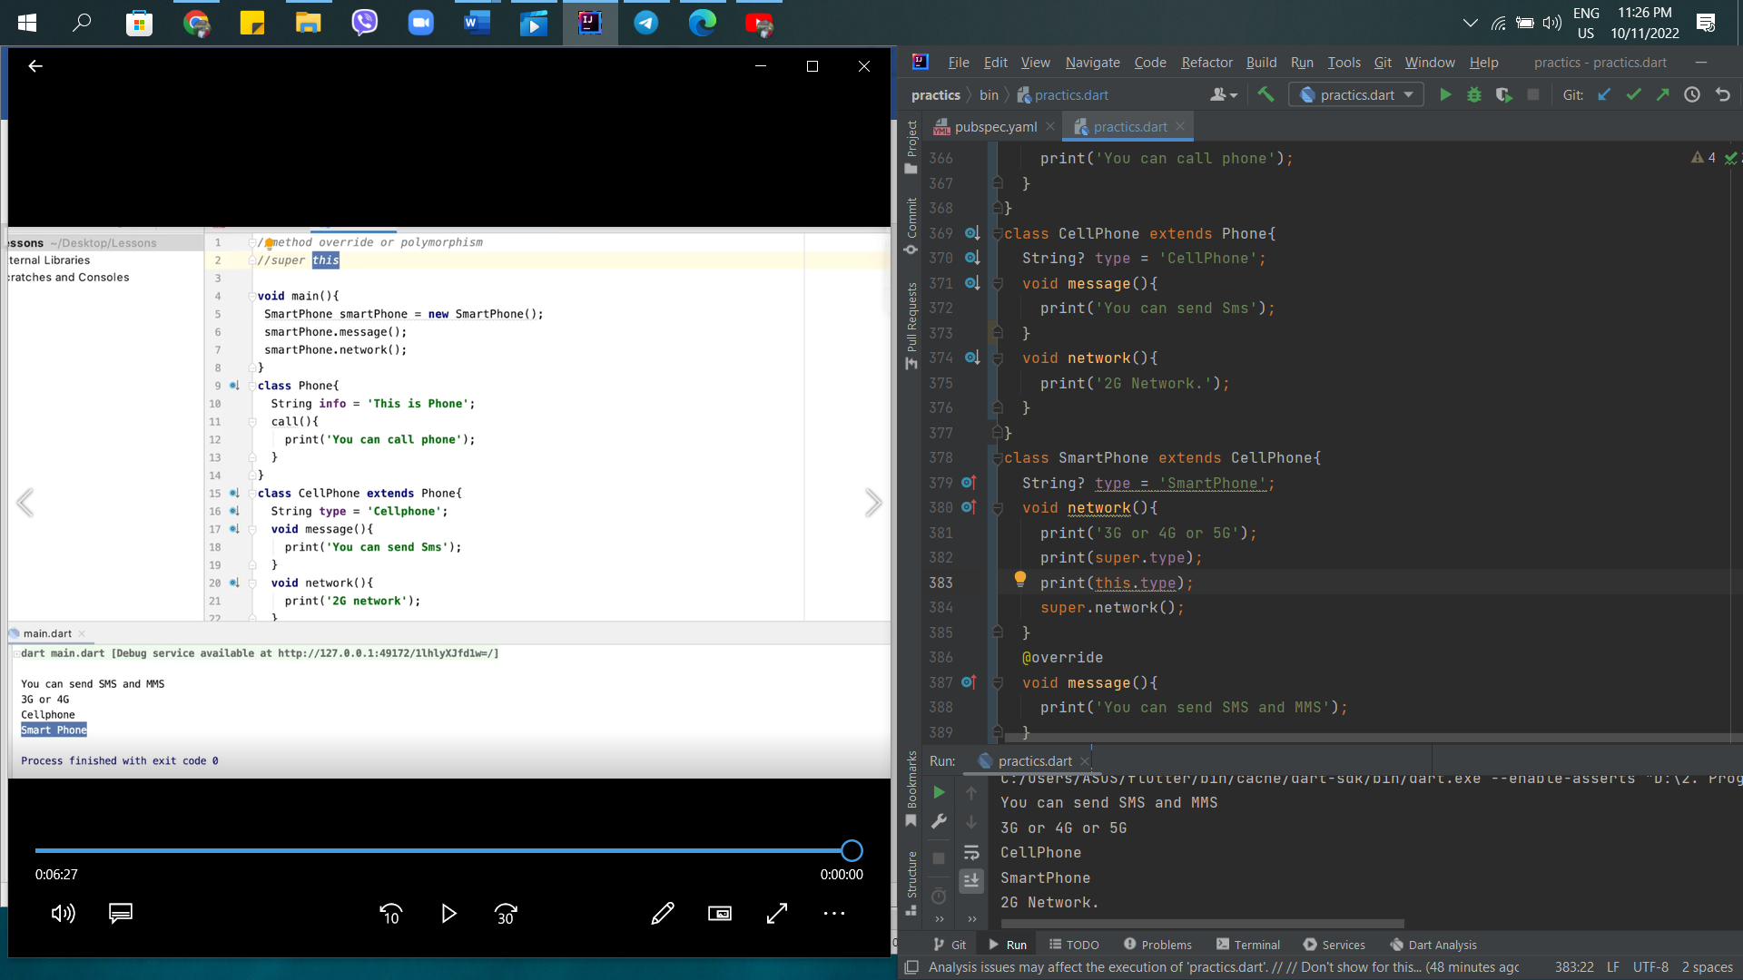

35th – Inheritance Part 3 in Dart

Learning Super constructor and cascade notation constructor.

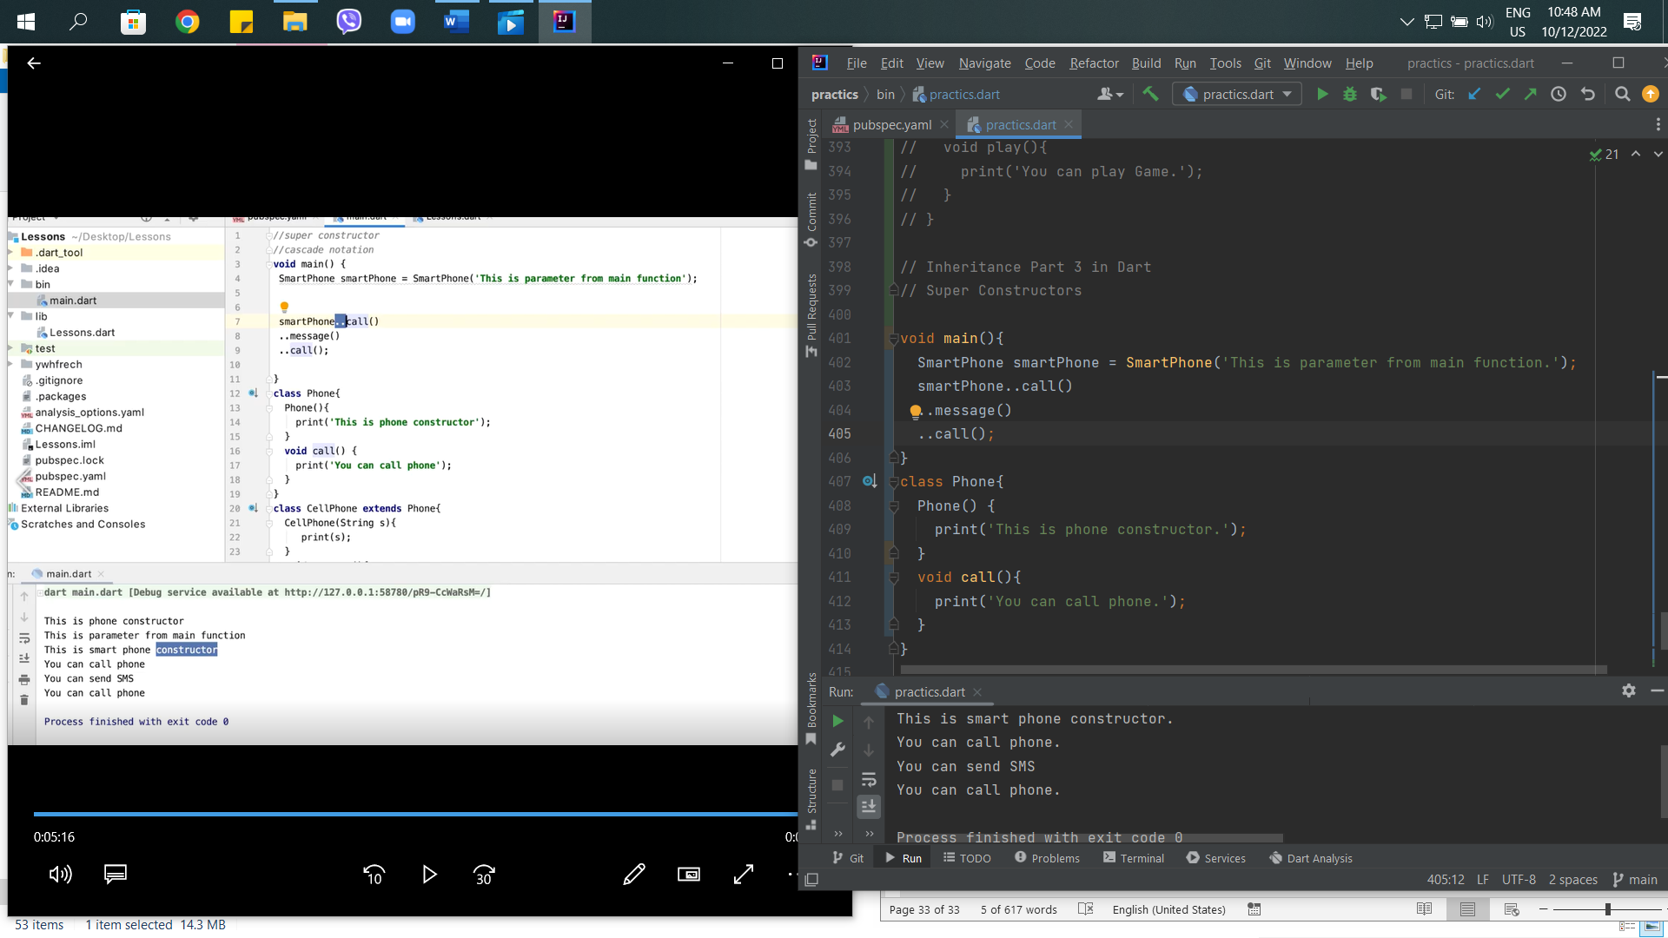

36th – Static Keyword (Static Variable and Static Method) in Dart

Learn Static variable and Static method

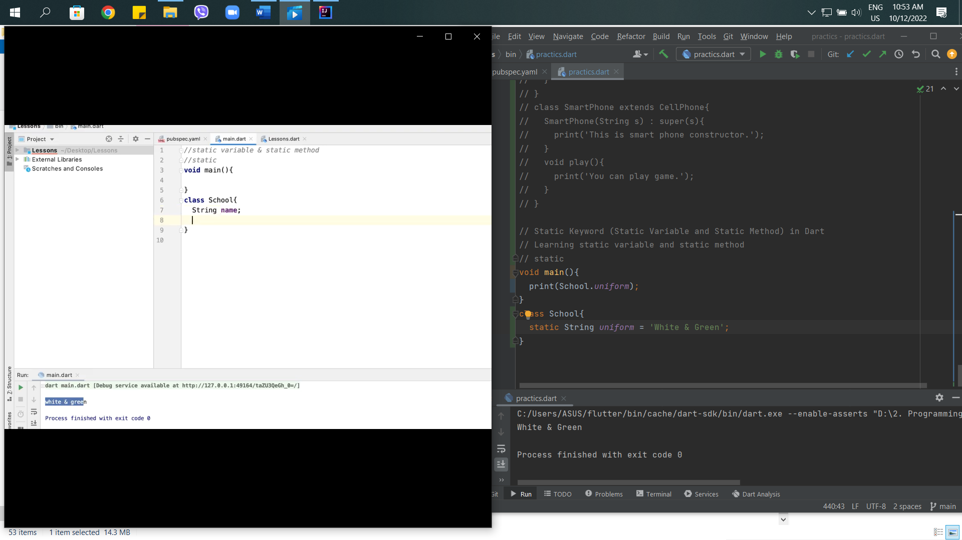

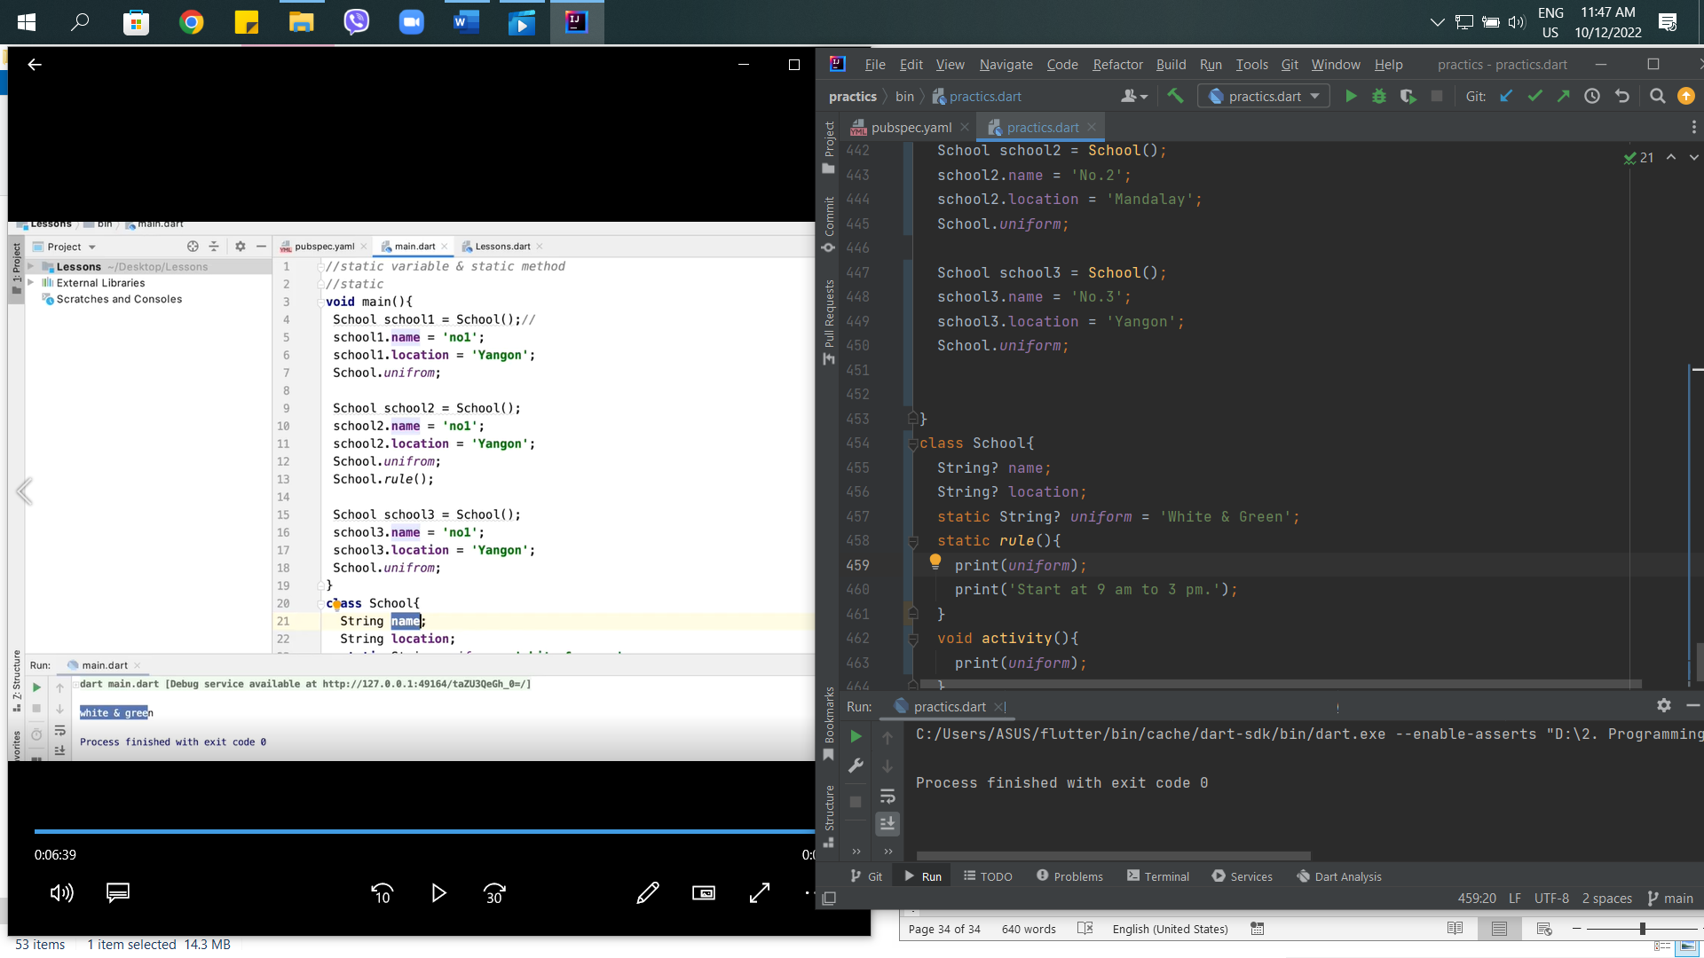

37th – Access Modifier in Dart

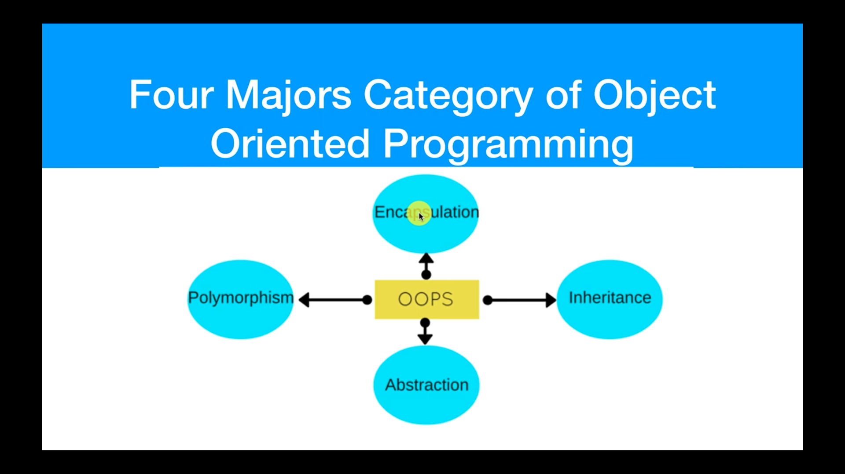

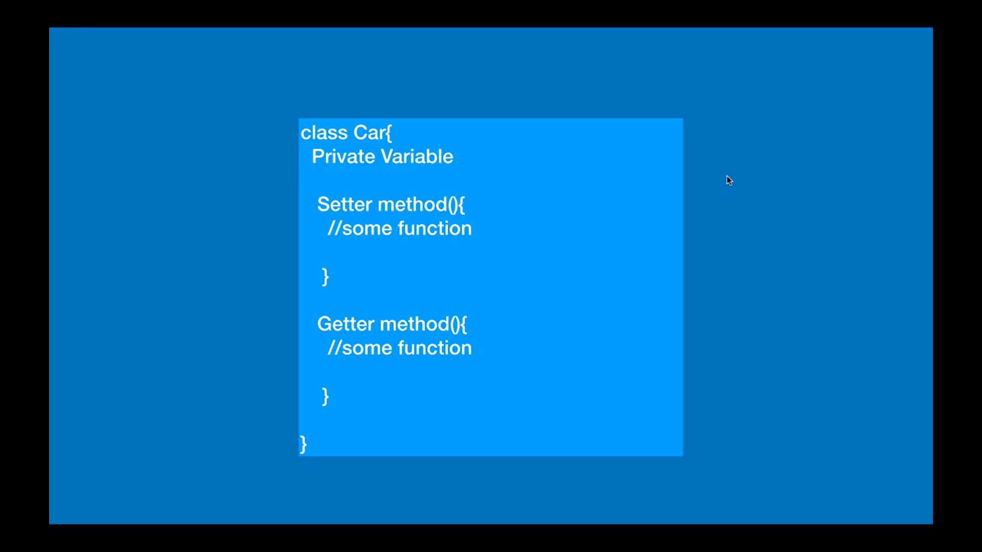

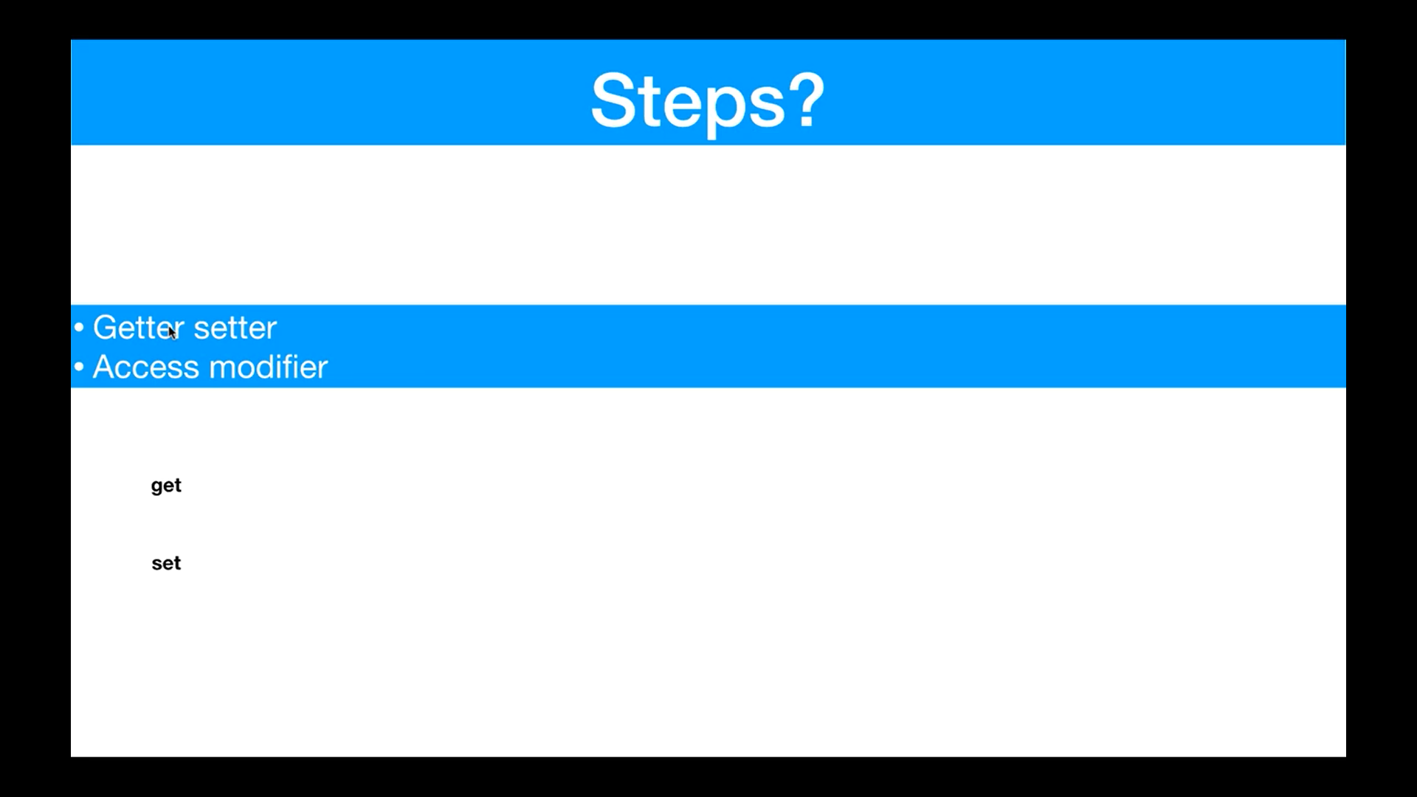

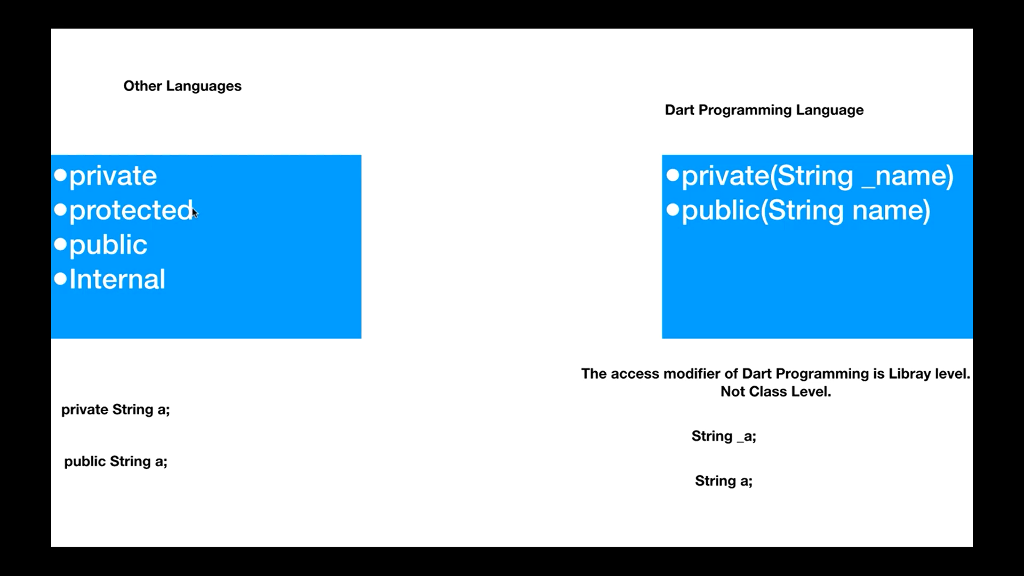

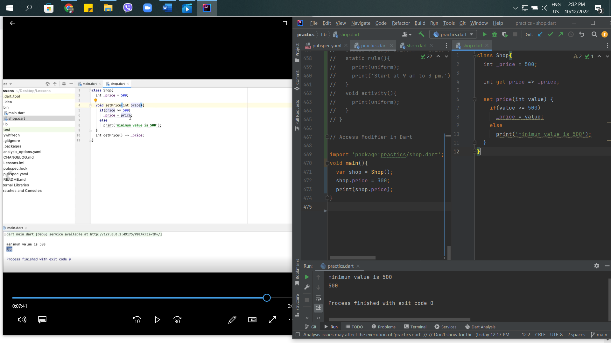

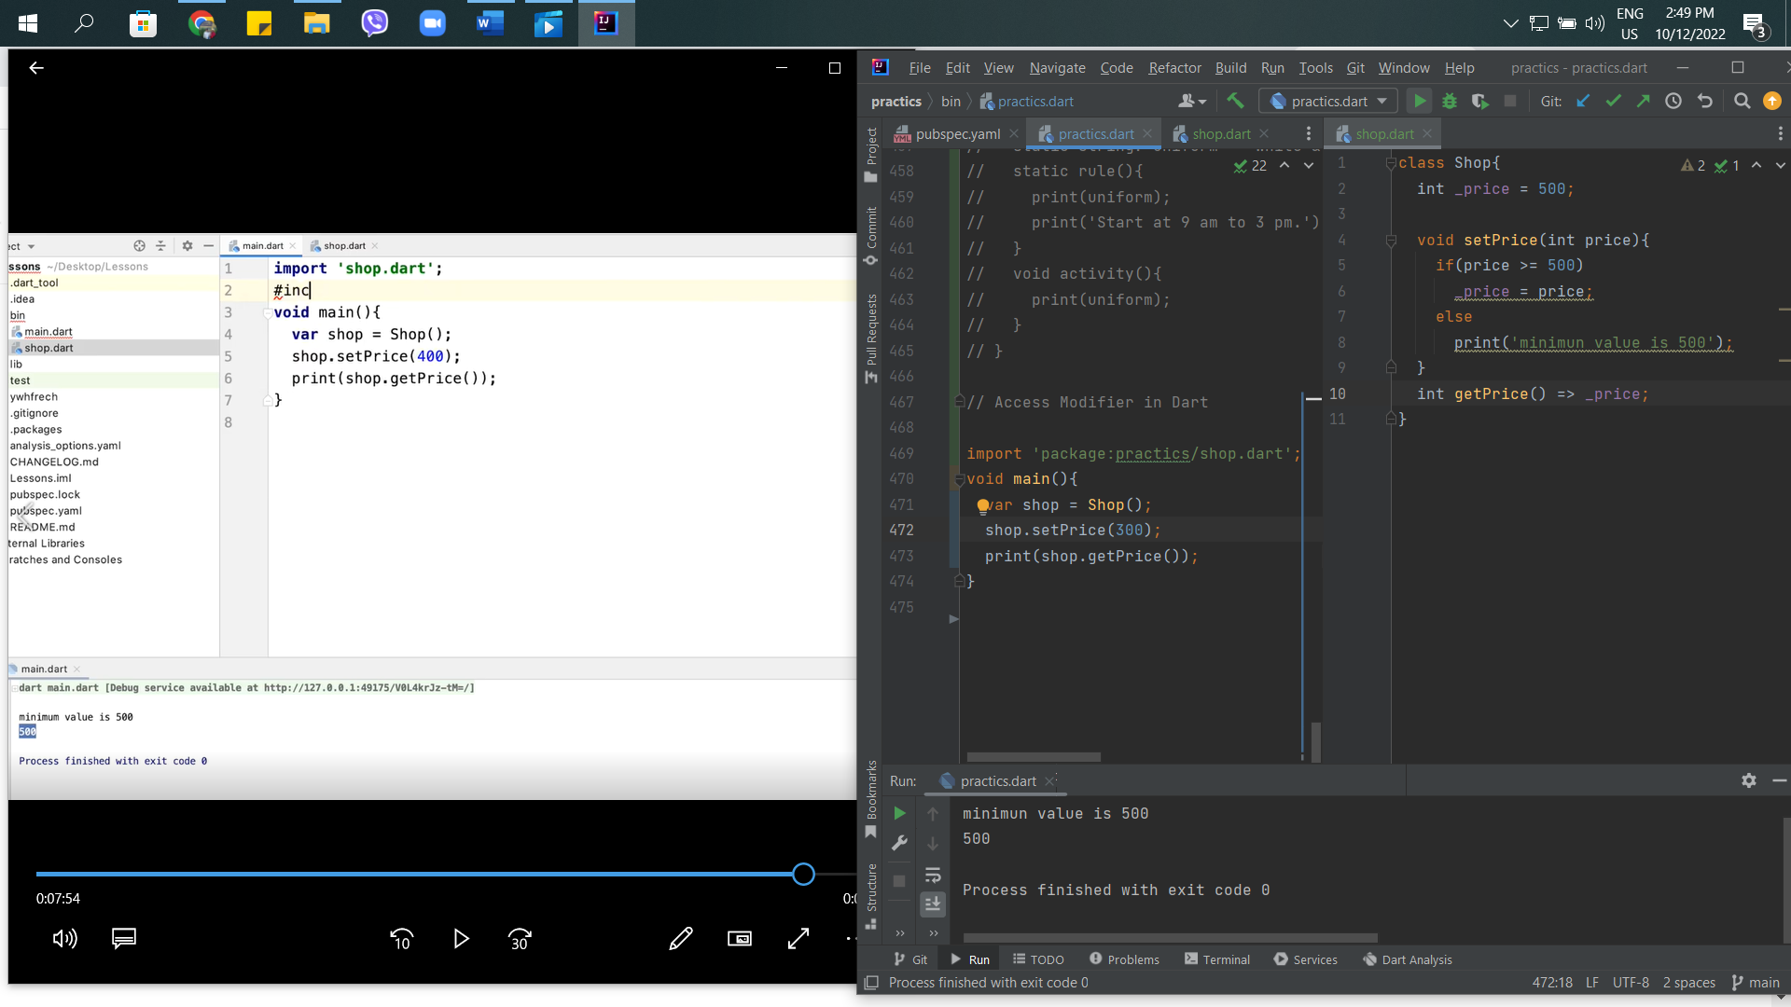

38th - Abstract Class in Dart

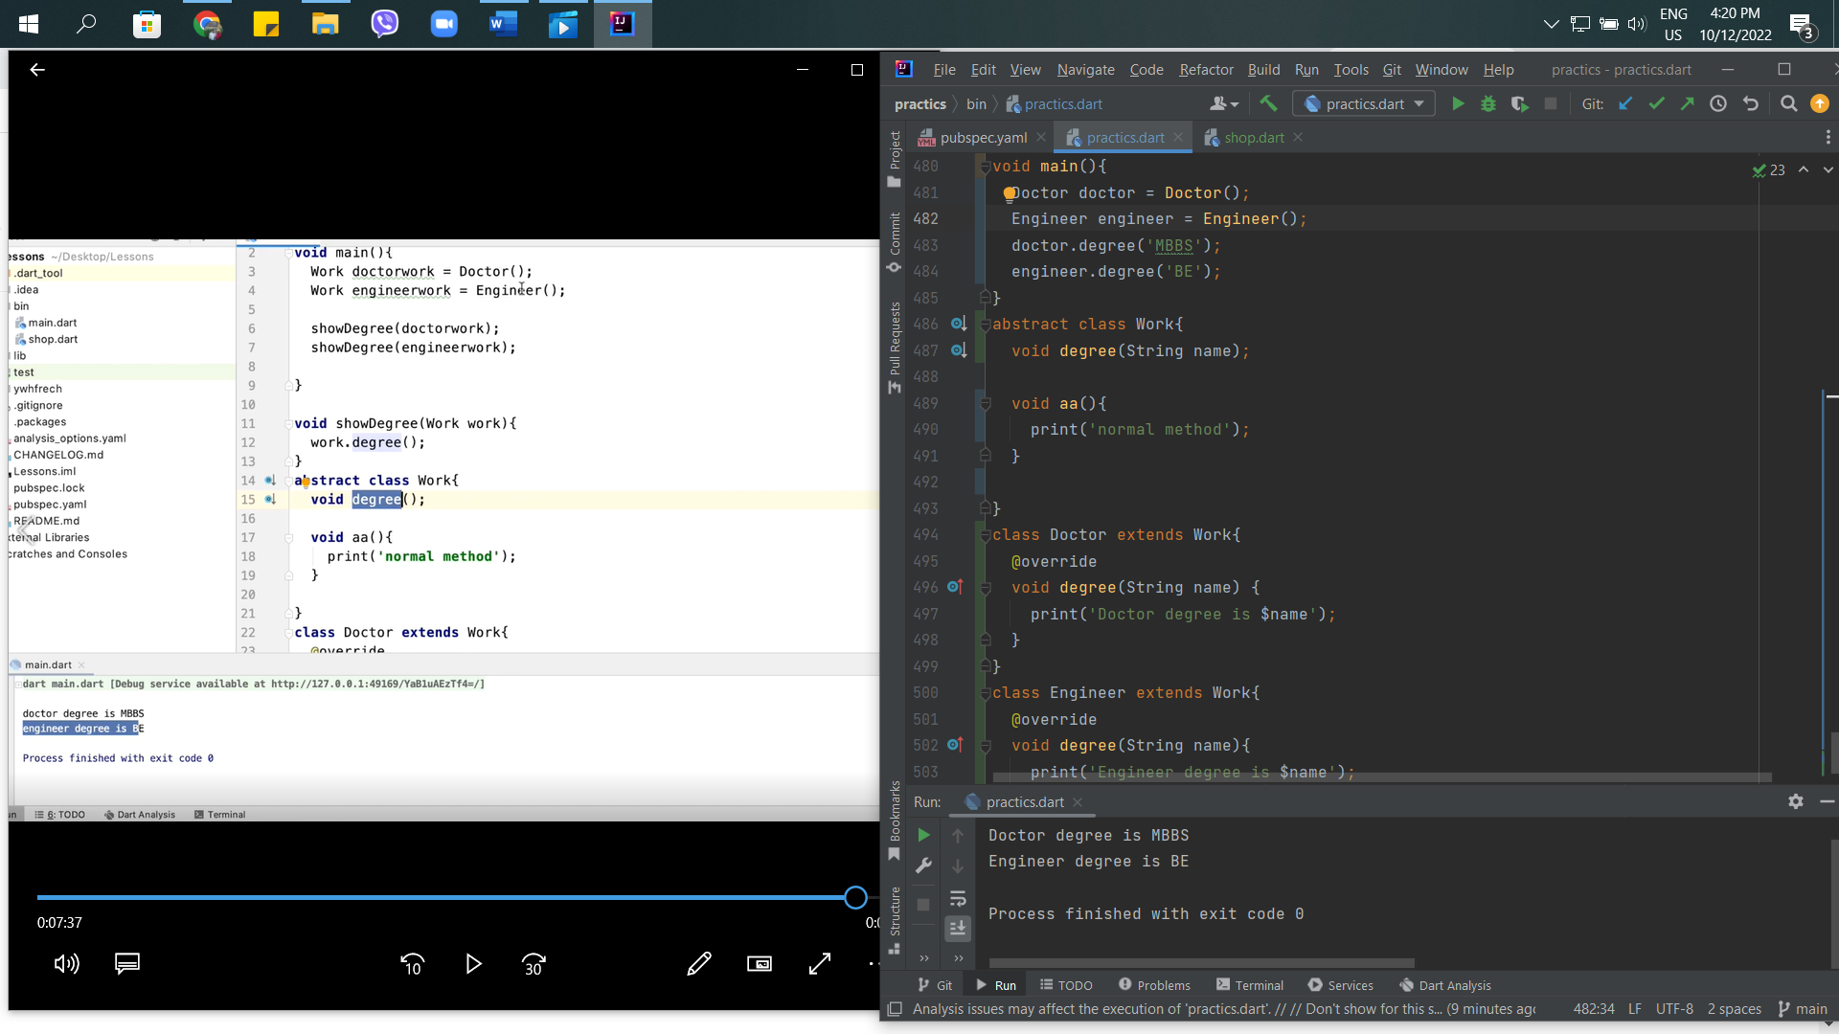

39th – Interface in Dart

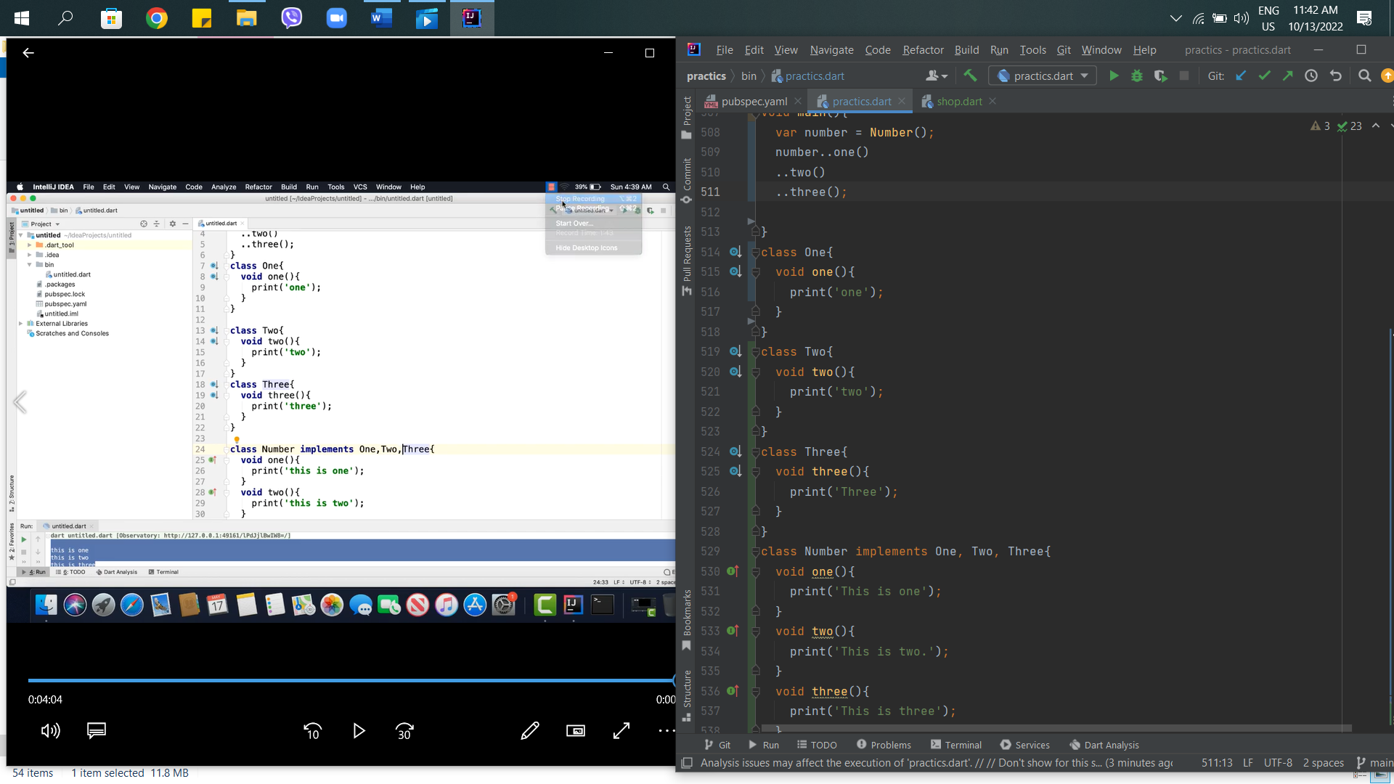

40th – Mixin In Dart

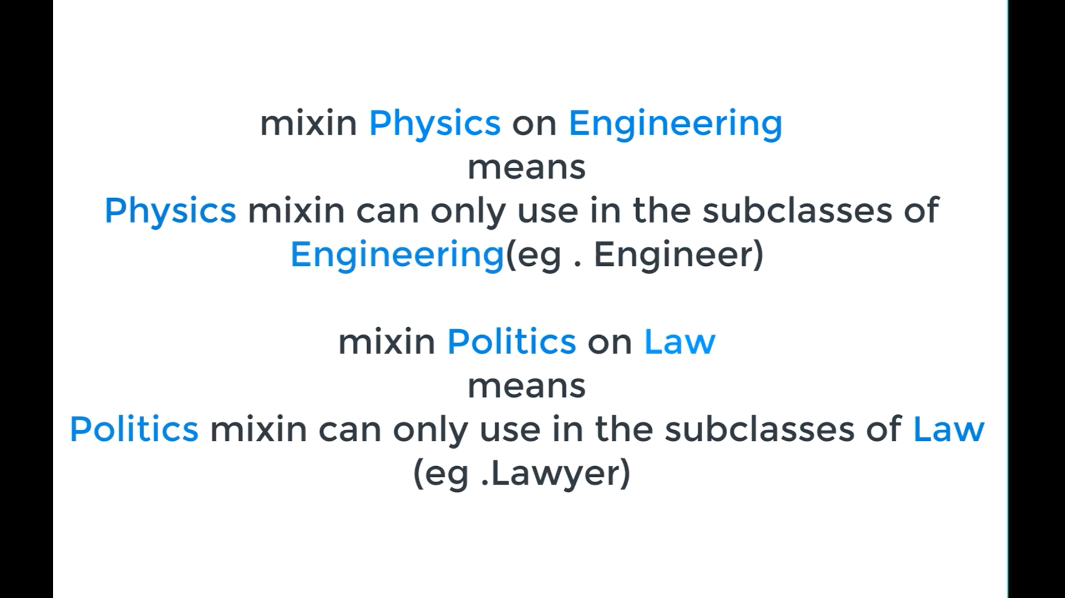

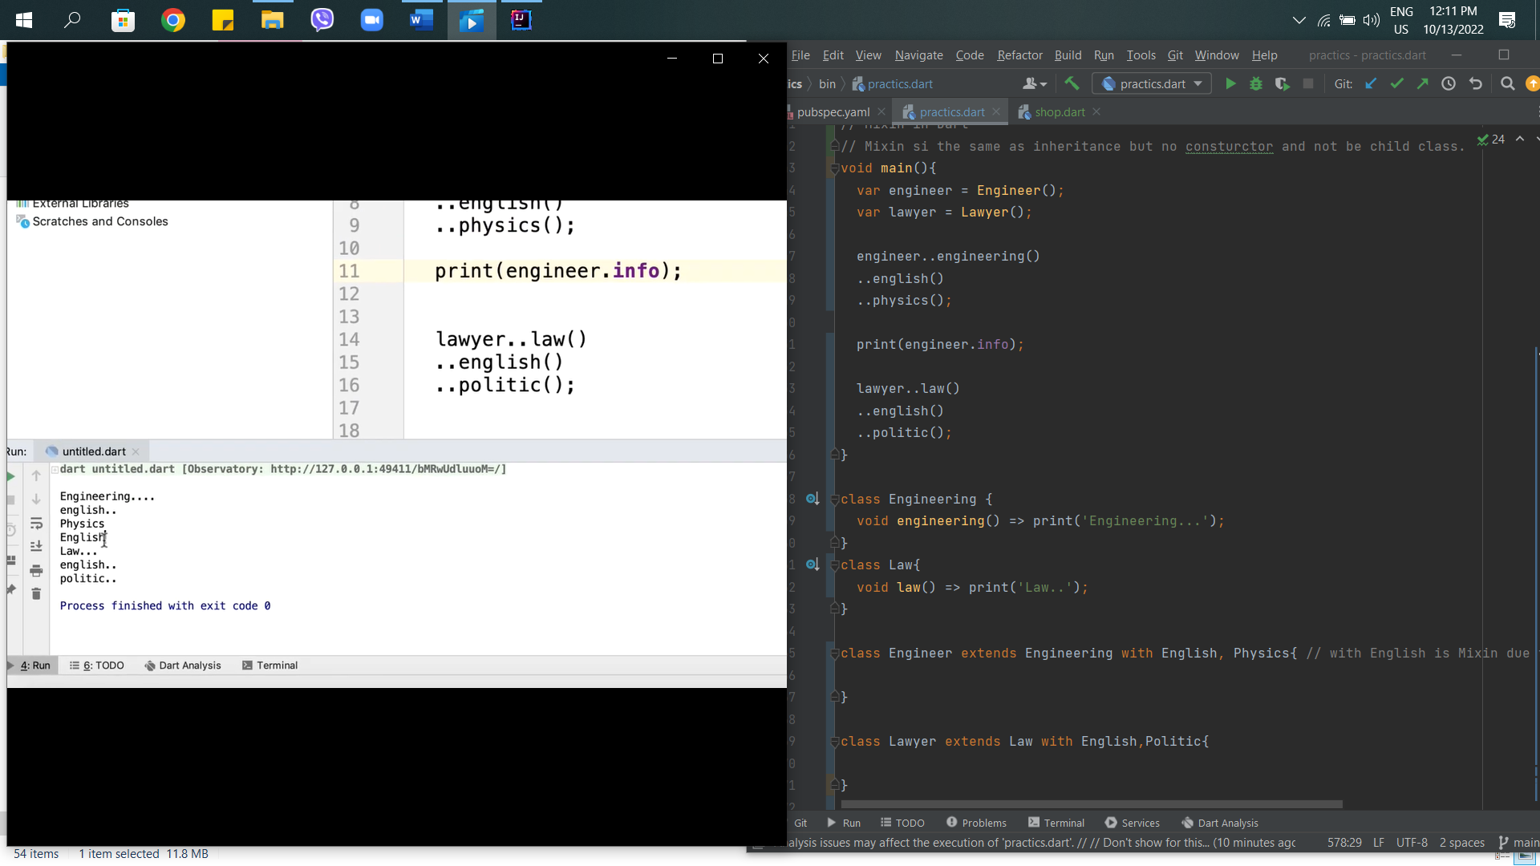

41st – Const & Final in Dart

Constant and final are not allowed to reassign and compile time const.

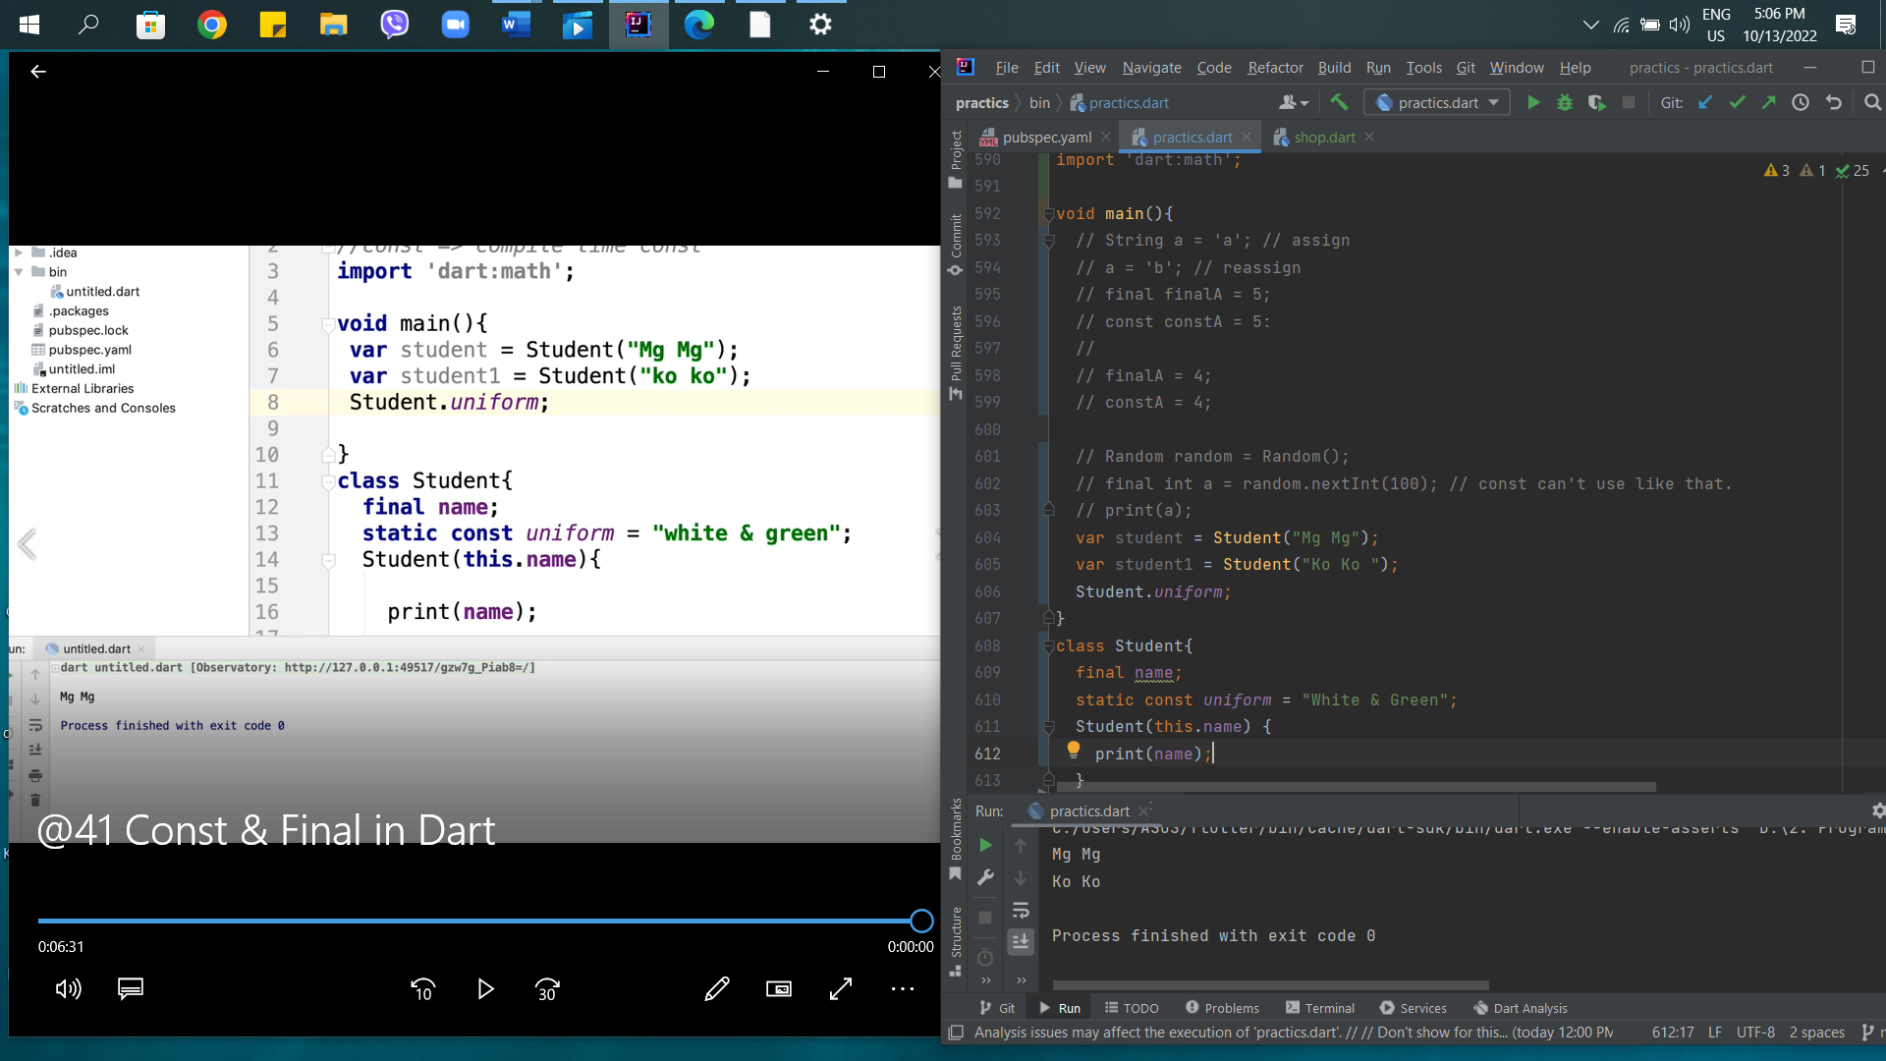

42nd – Extension Method in Dart

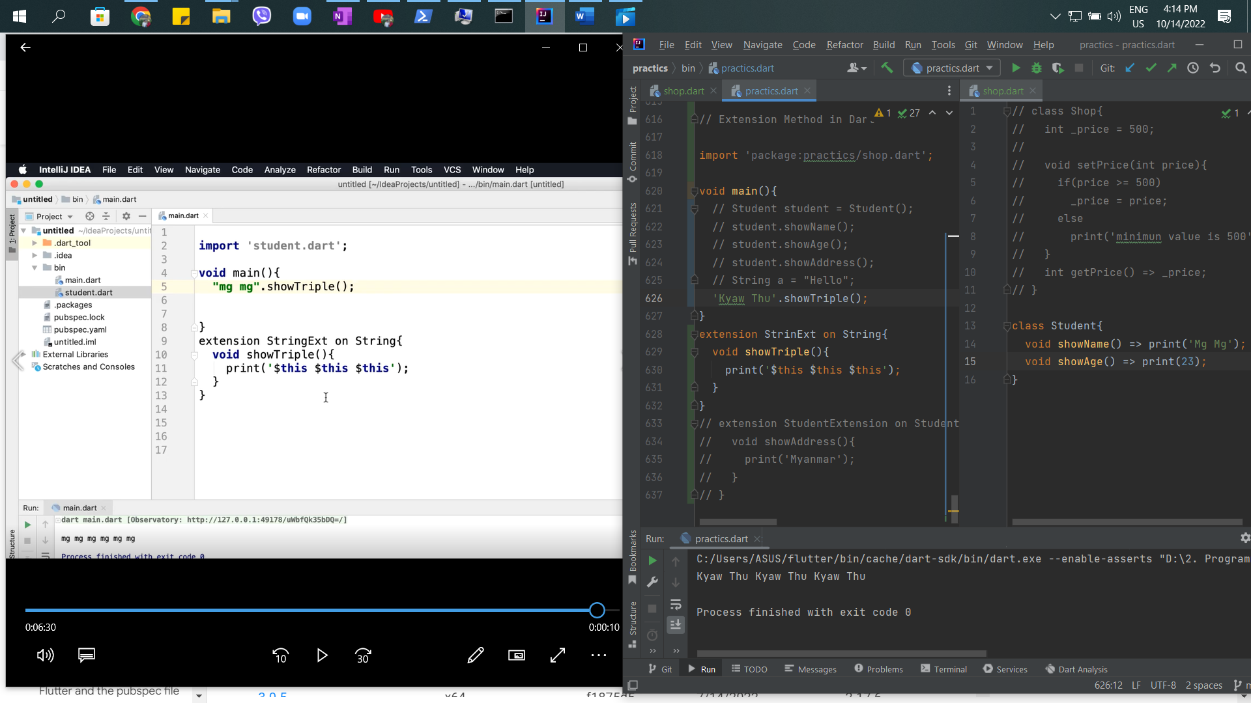

43rd – Asynchronous Programming in Dart

Asynchronous Programming

What is –

1. Isolate
2. Event Loop

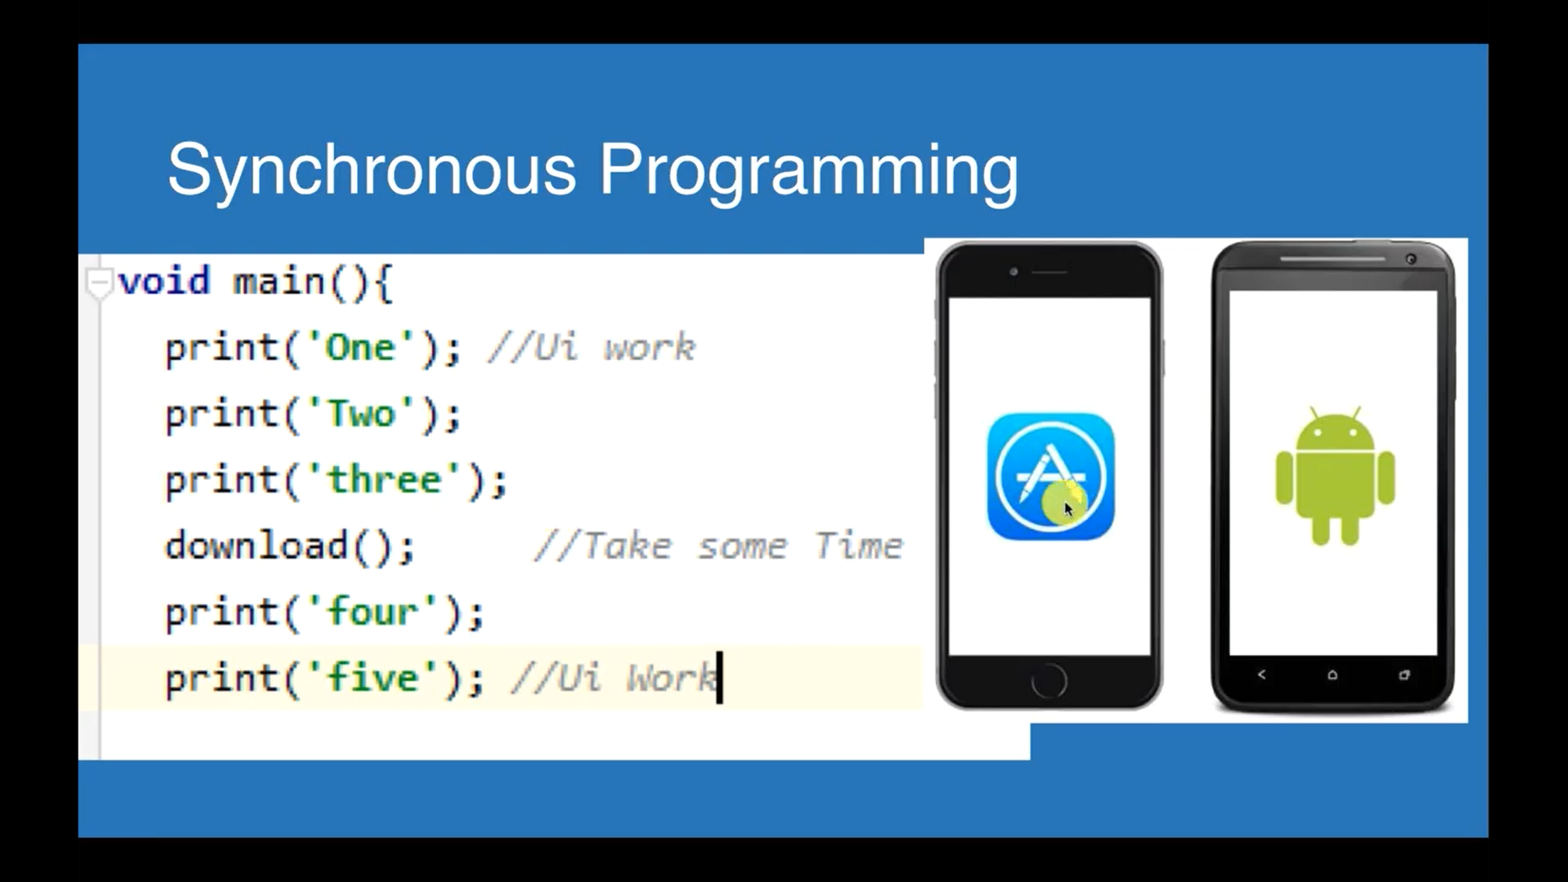

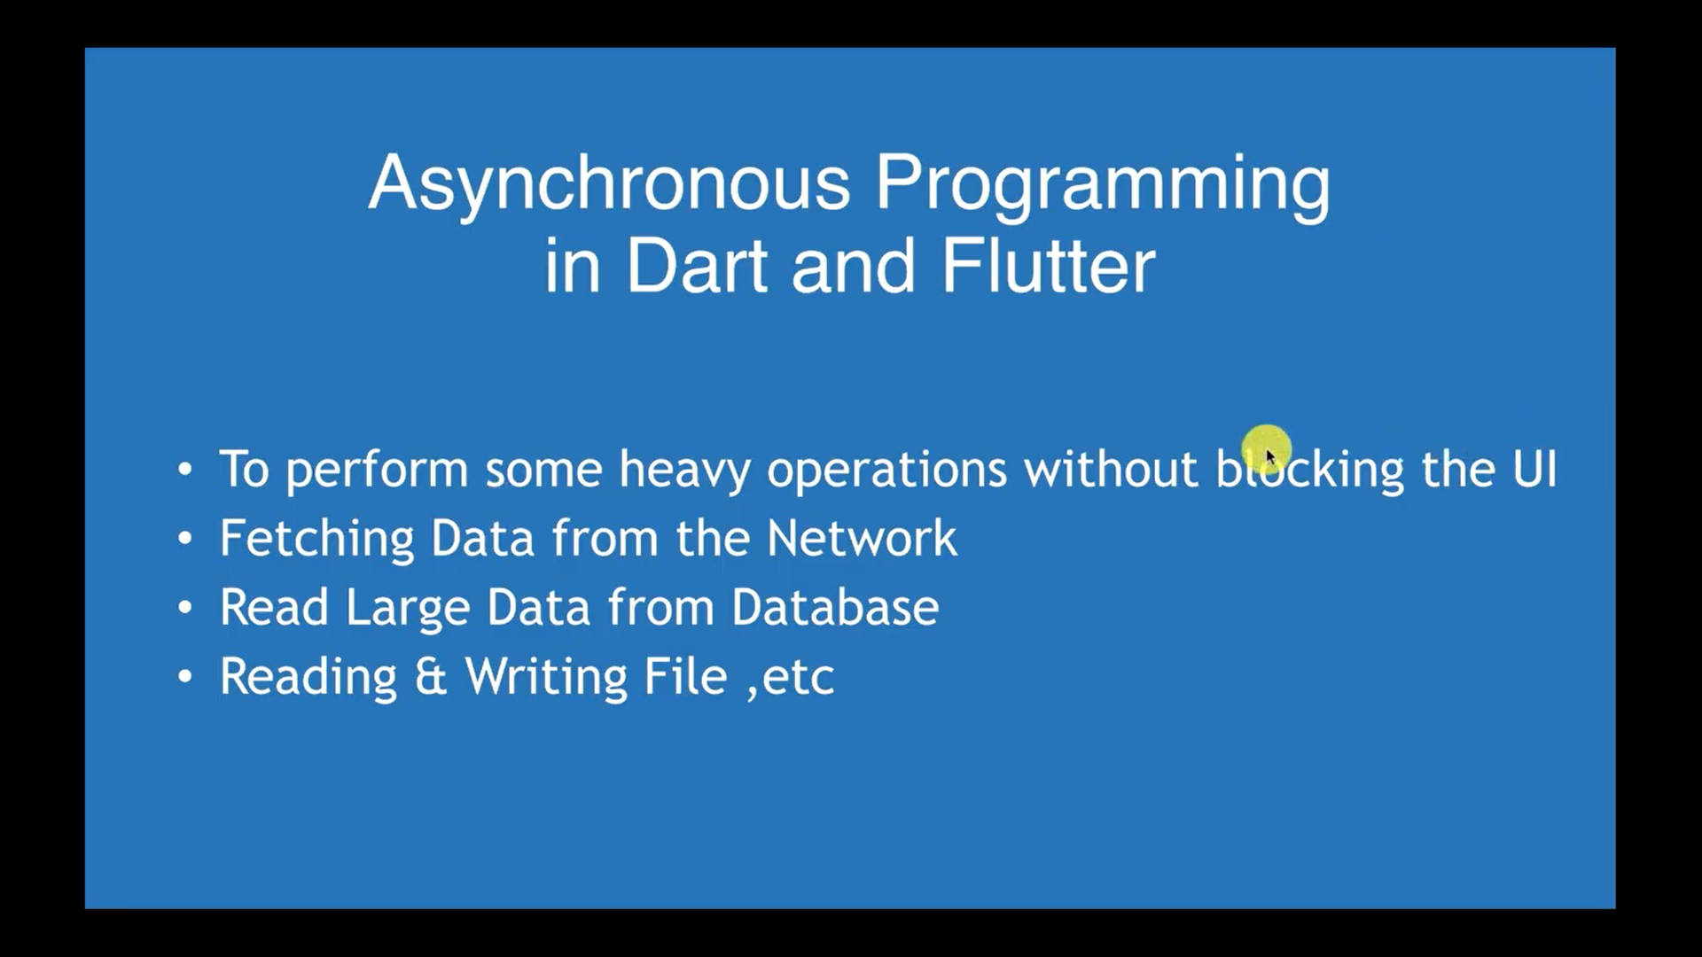

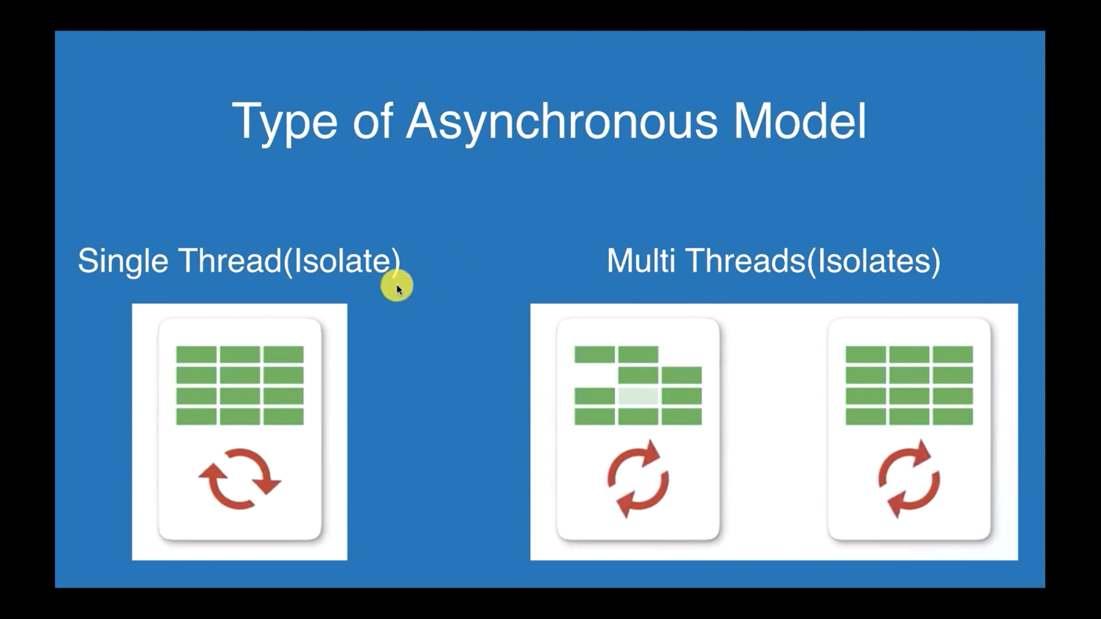

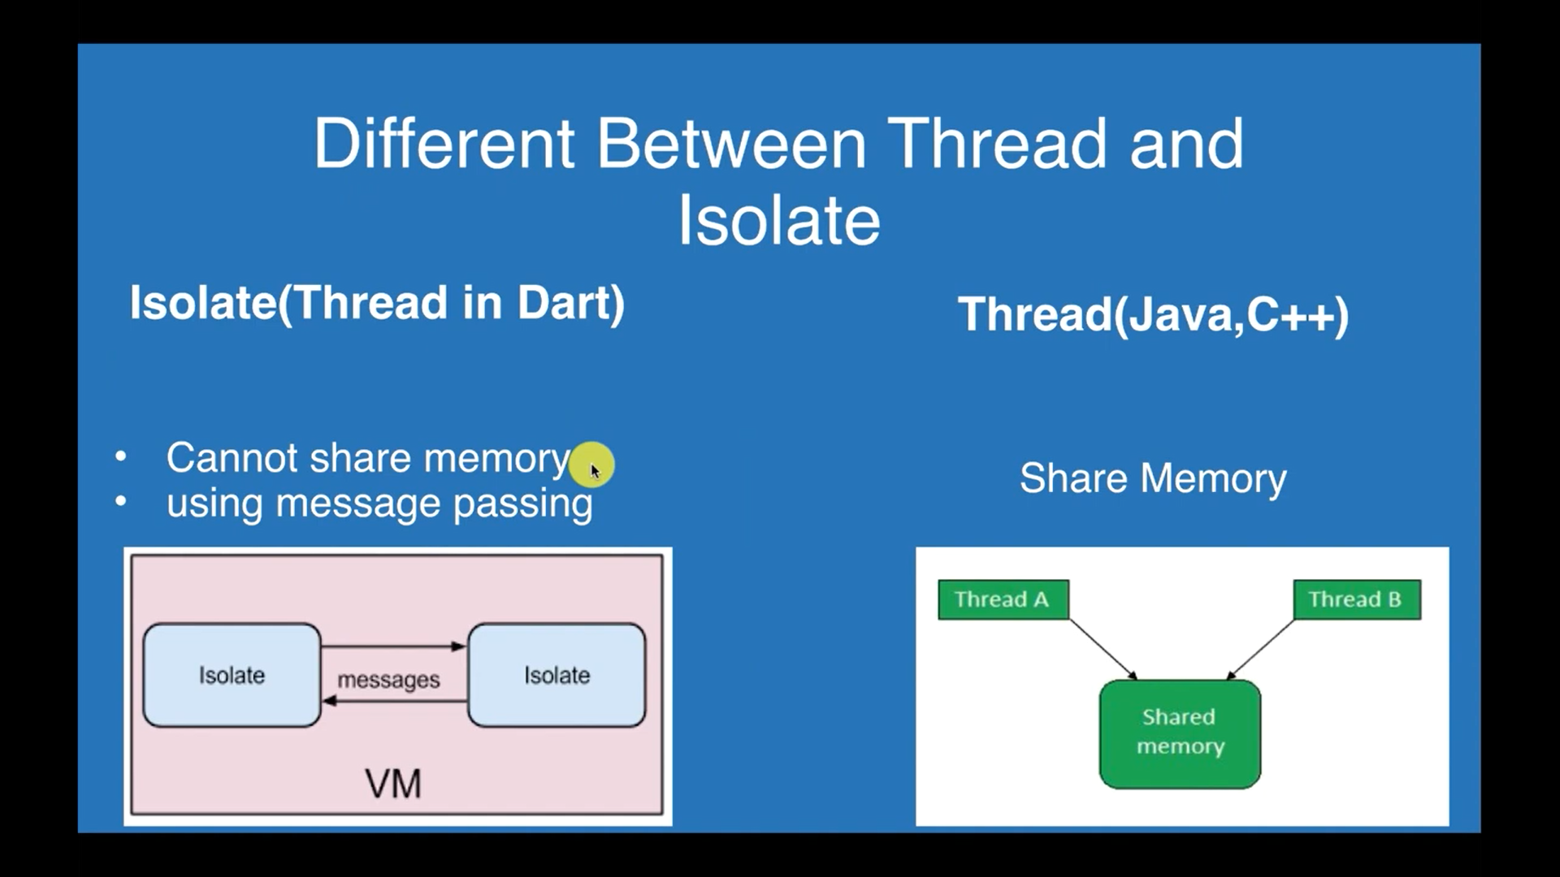

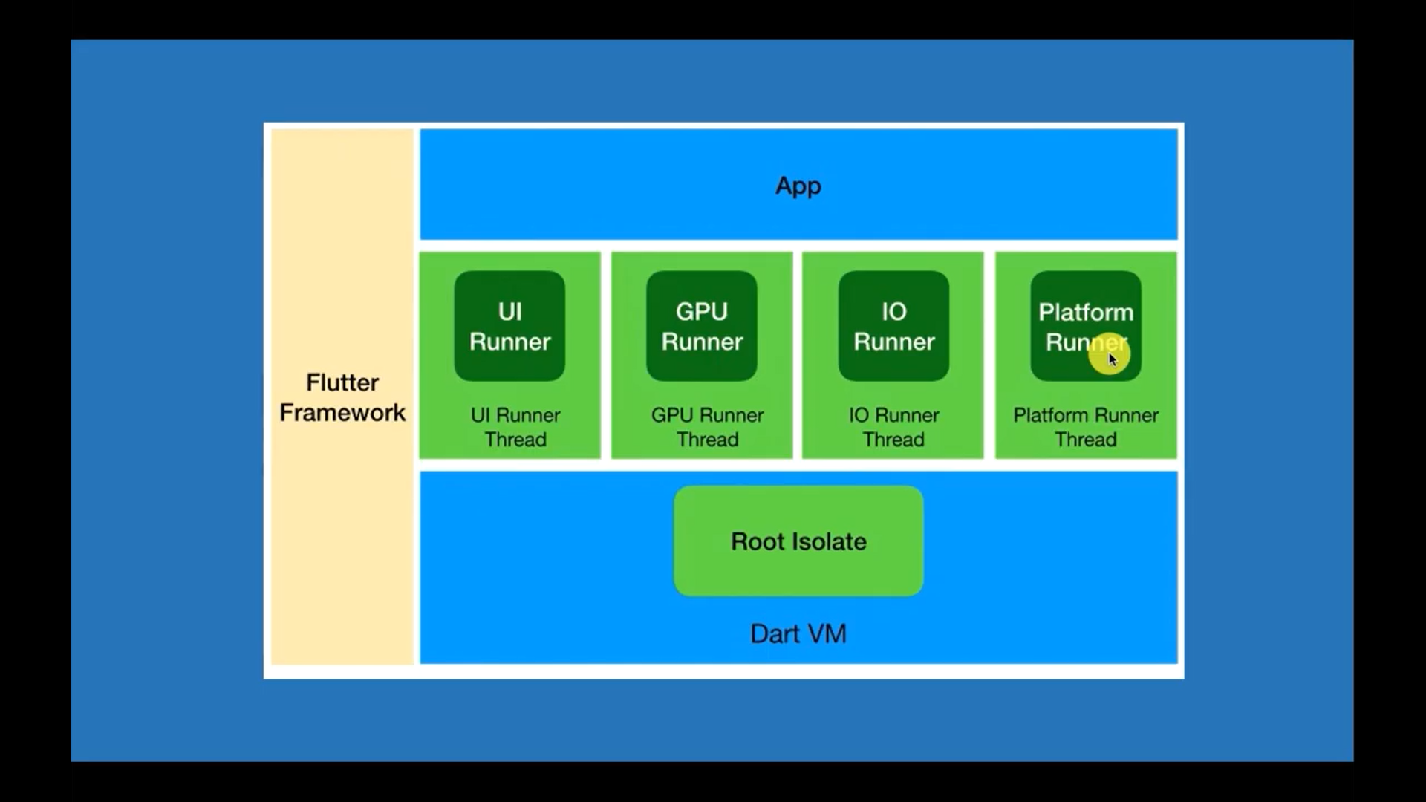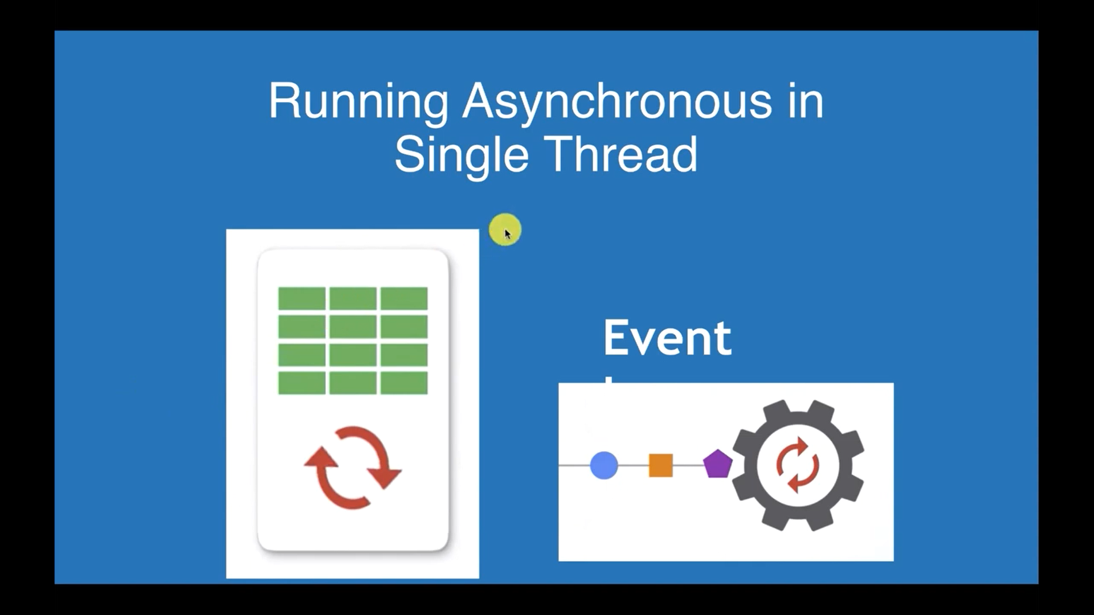

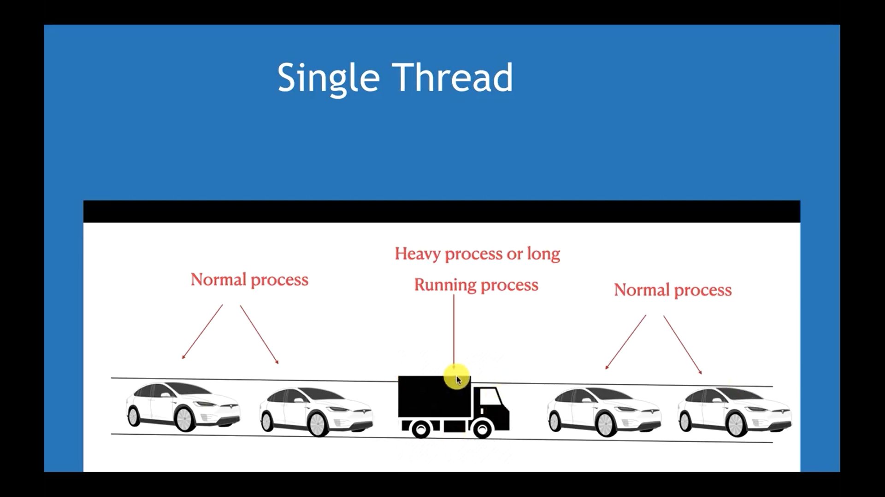

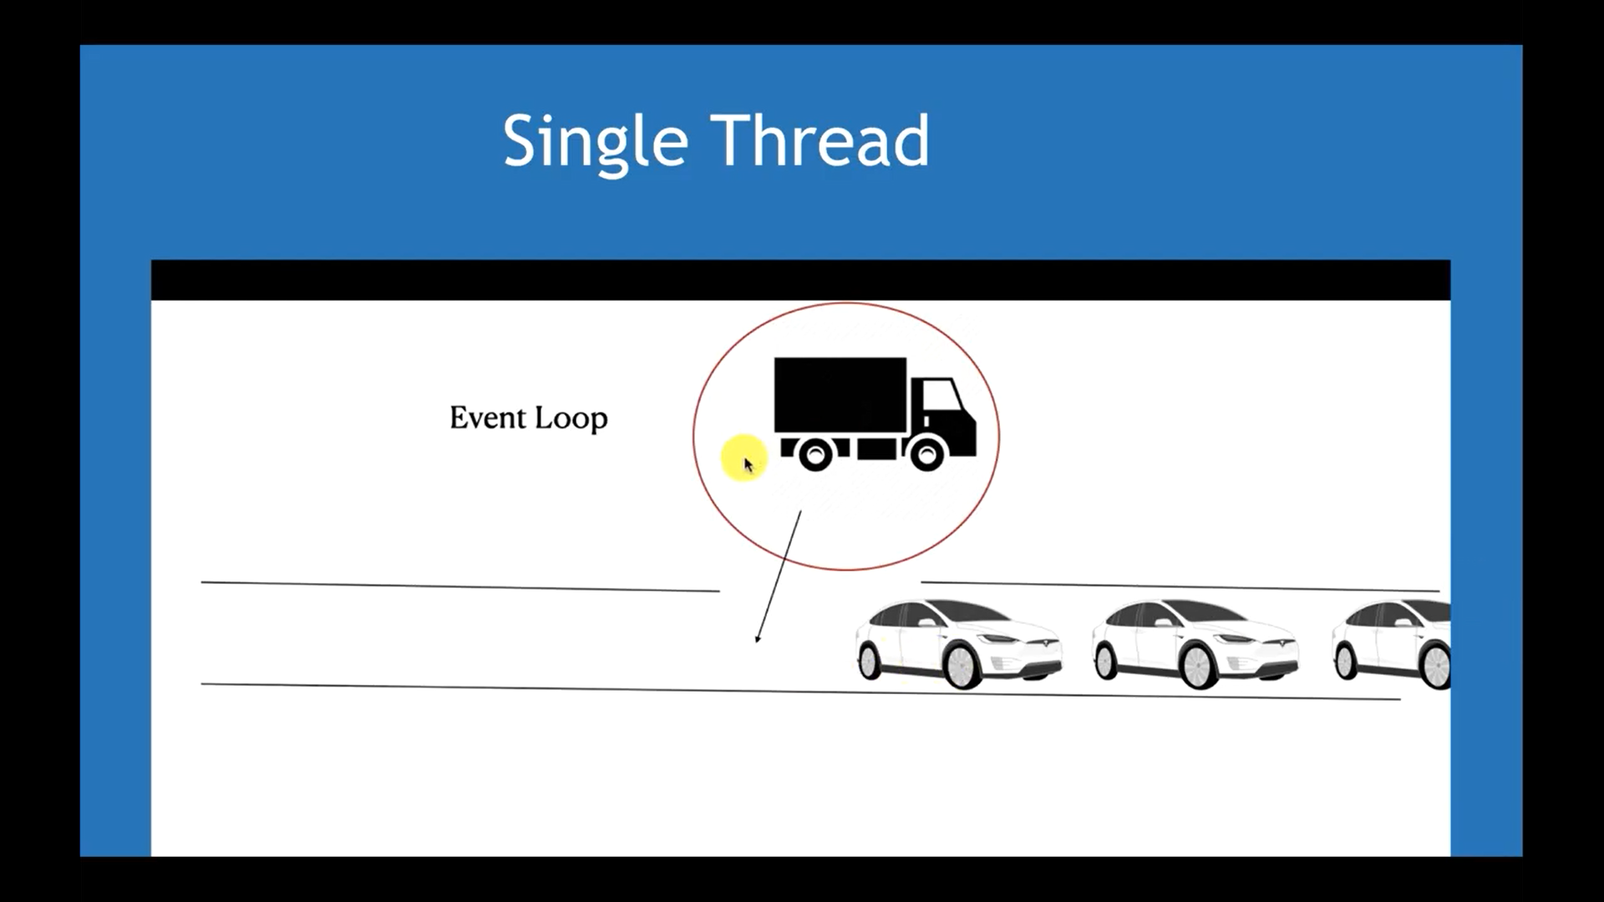

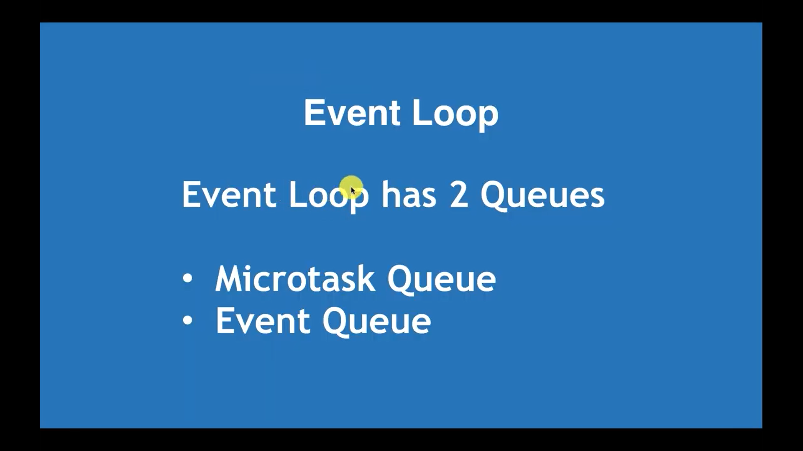

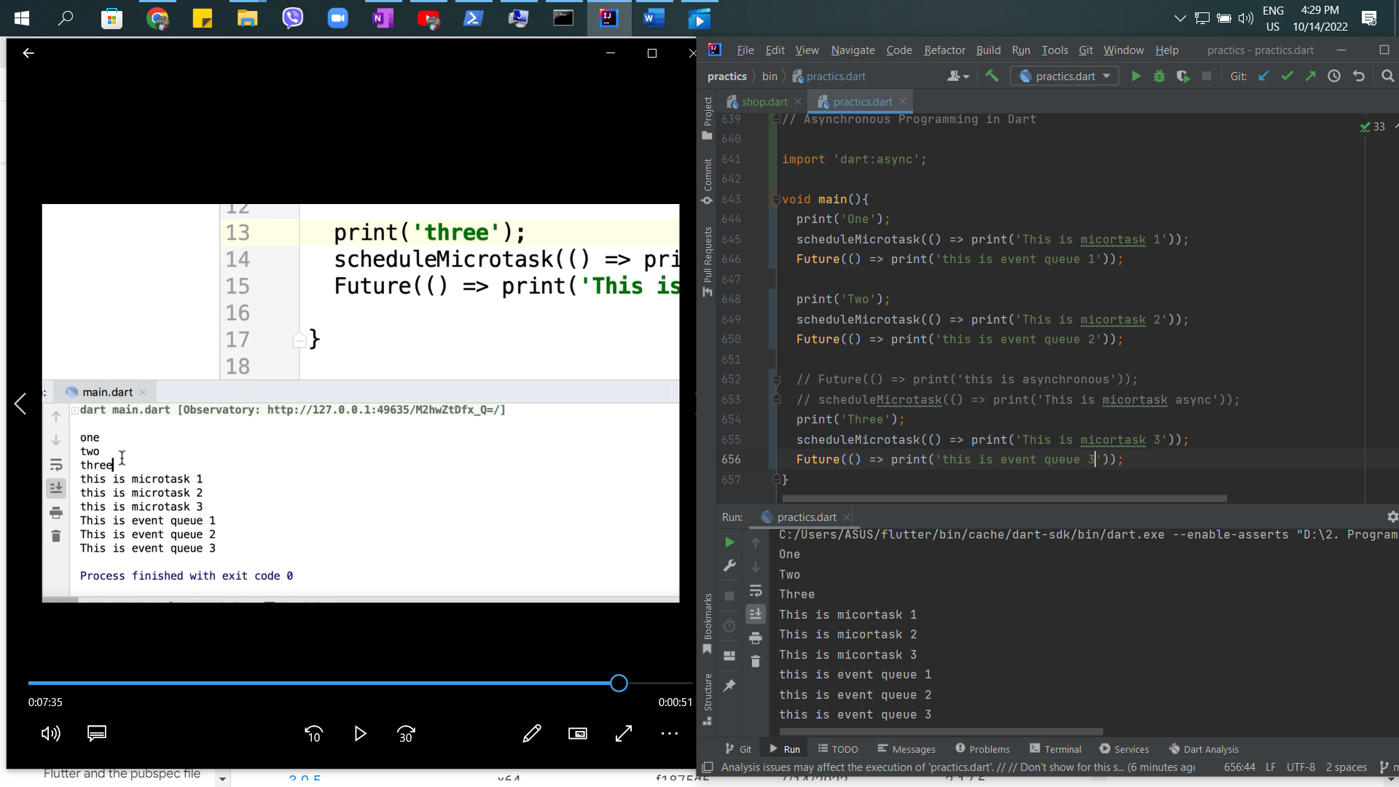

44th – Future Async and await in Dart

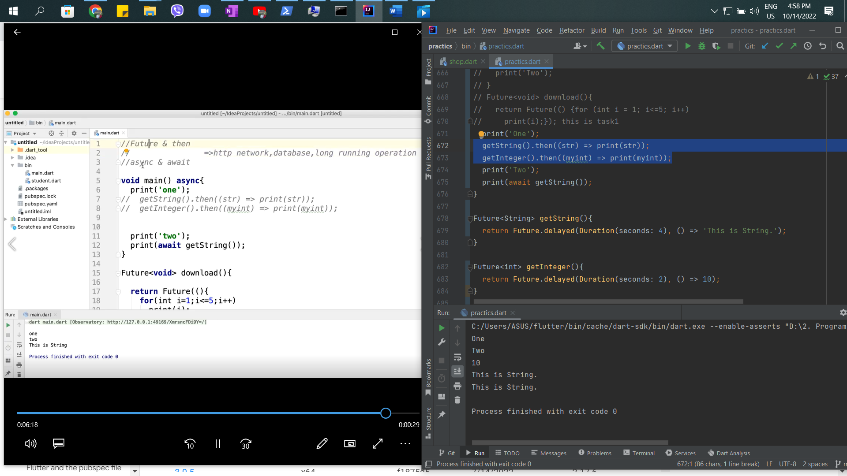

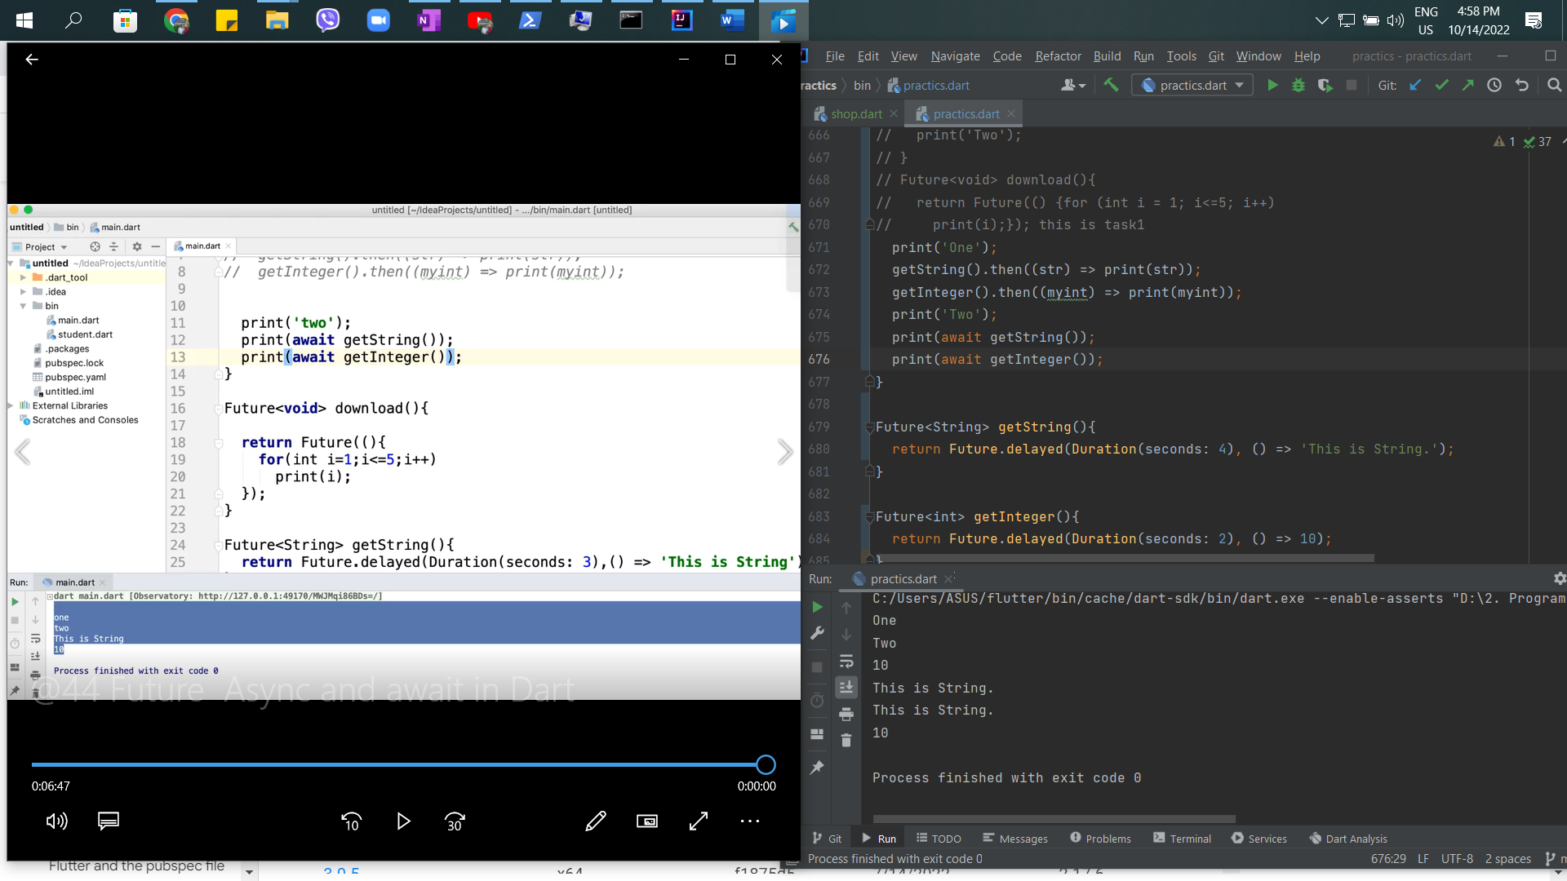

45th – Callback and Error Handling with Async and Await in Dart

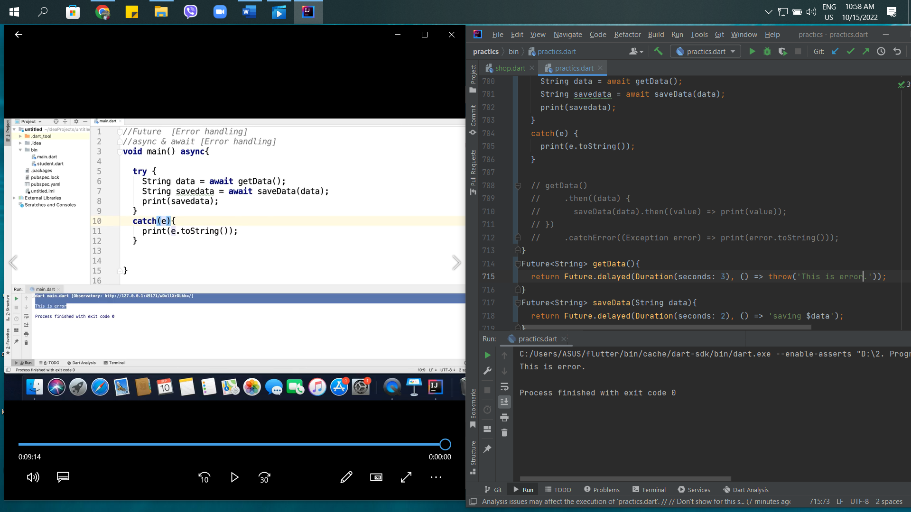

46th – Stream Introduction in Dart Programming

Stream is Reactive Programming.

Future = Single Data

Stream = Asynchronous Sequence of Data for Block Pattern.

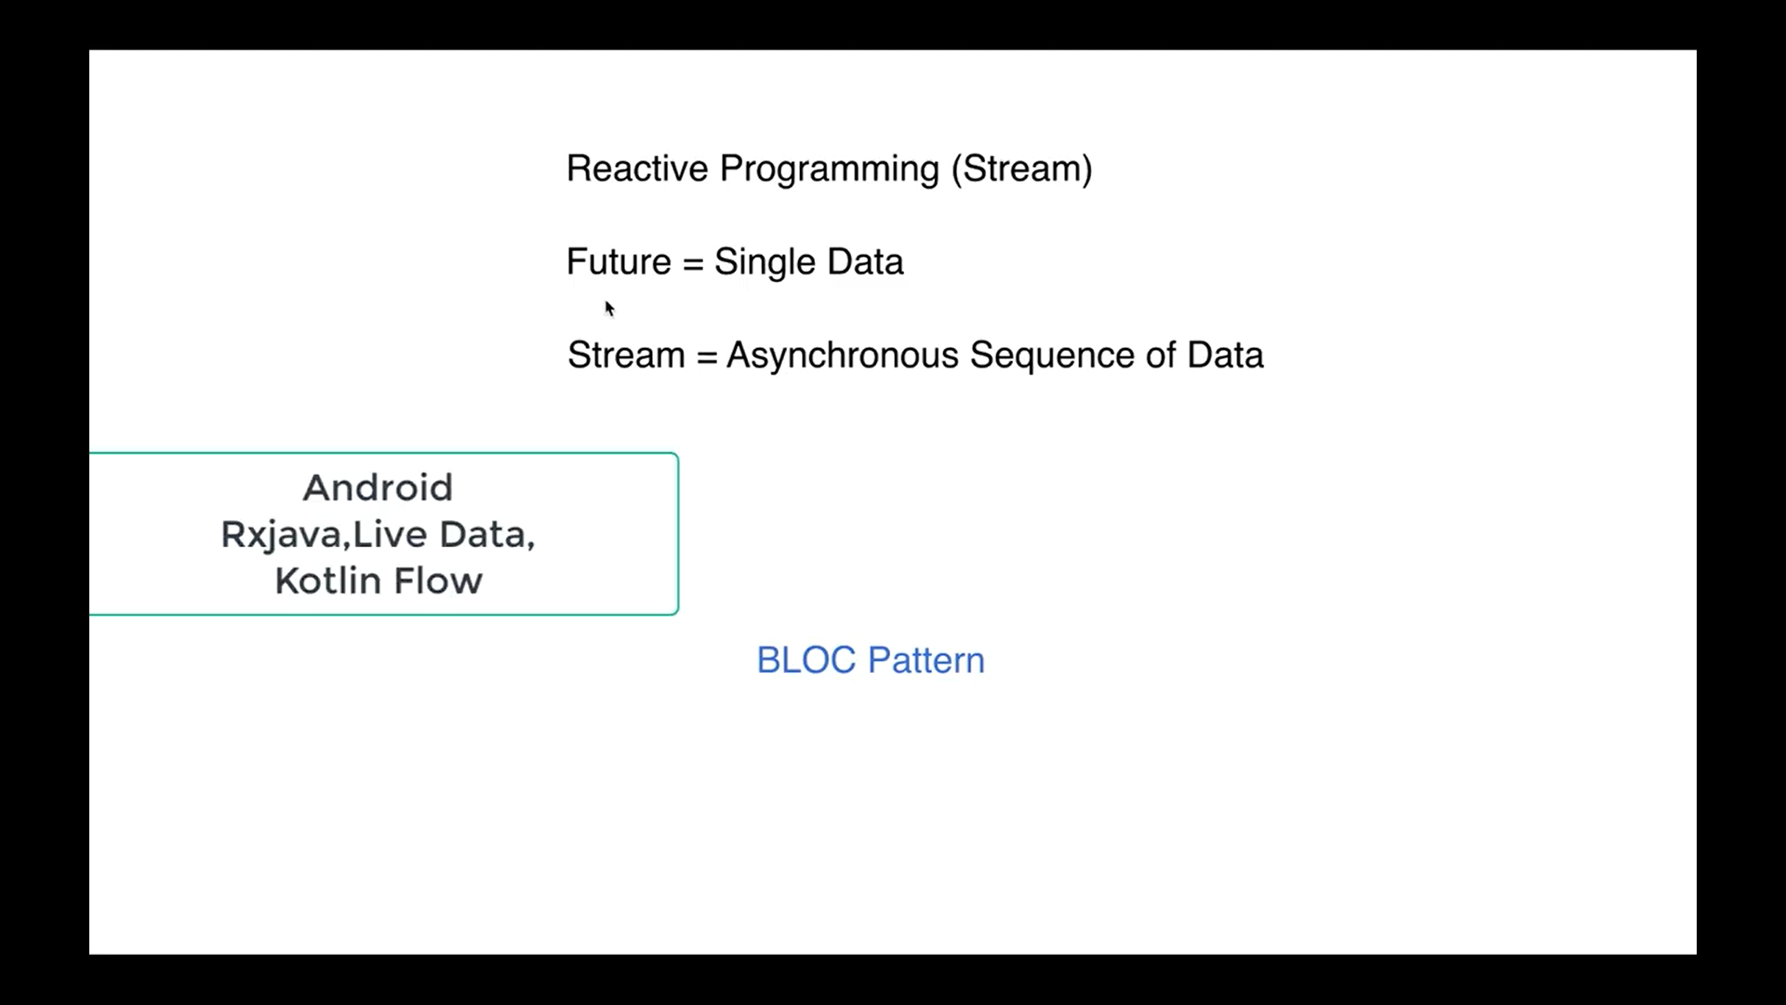

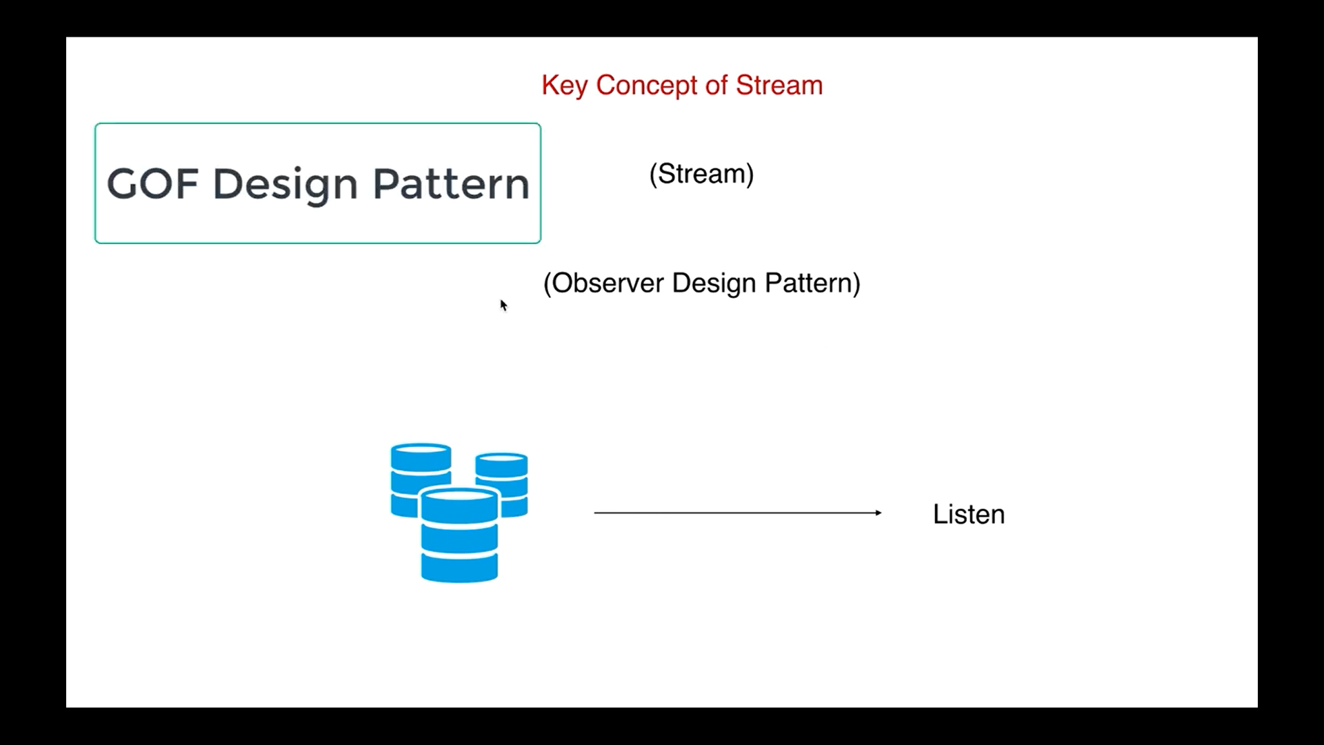

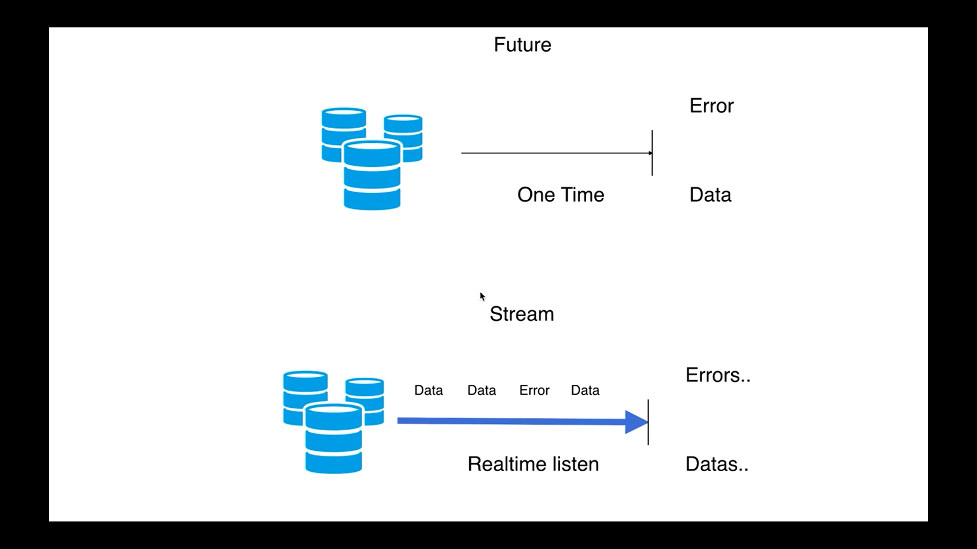 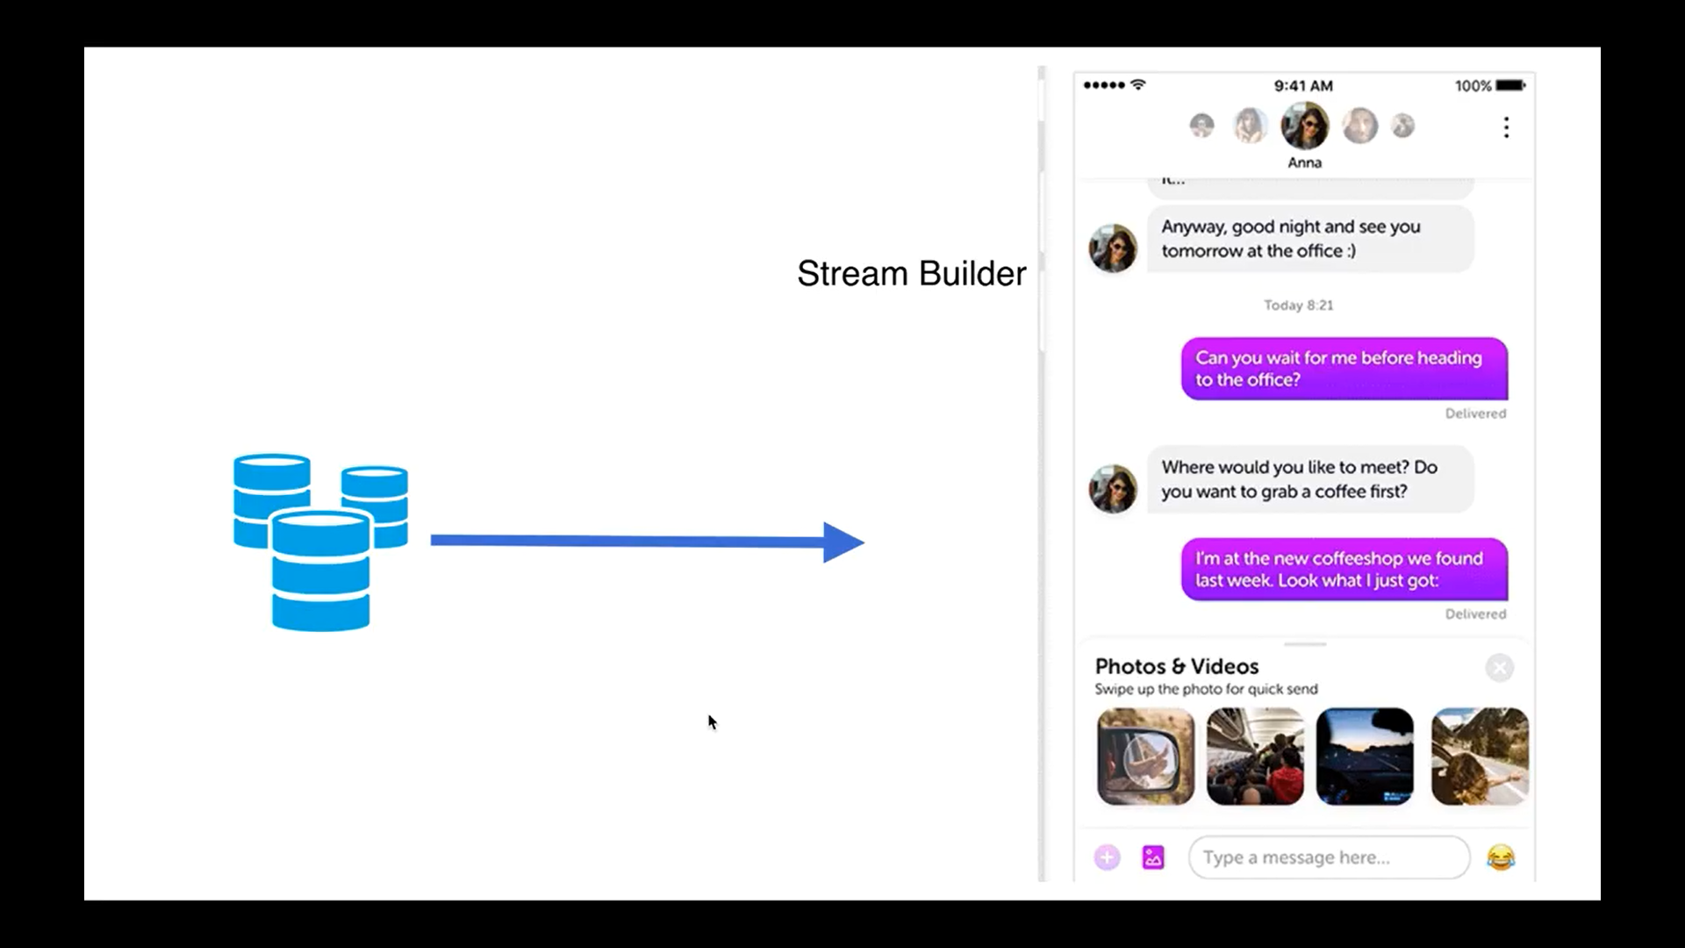

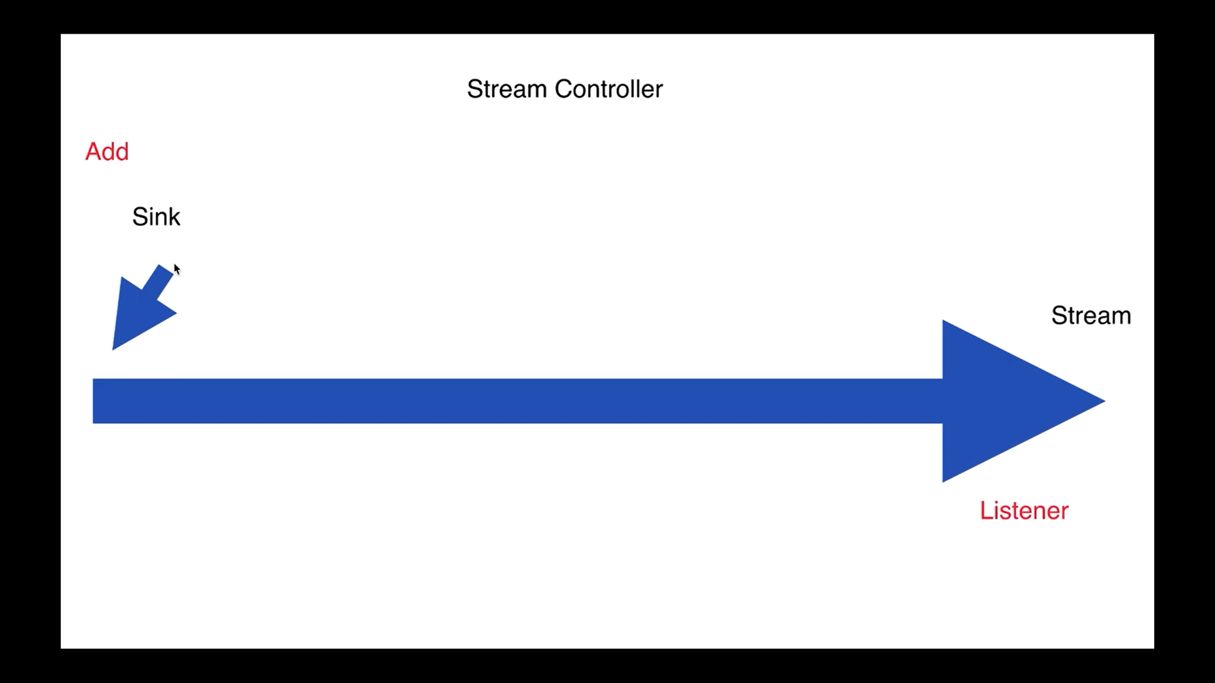 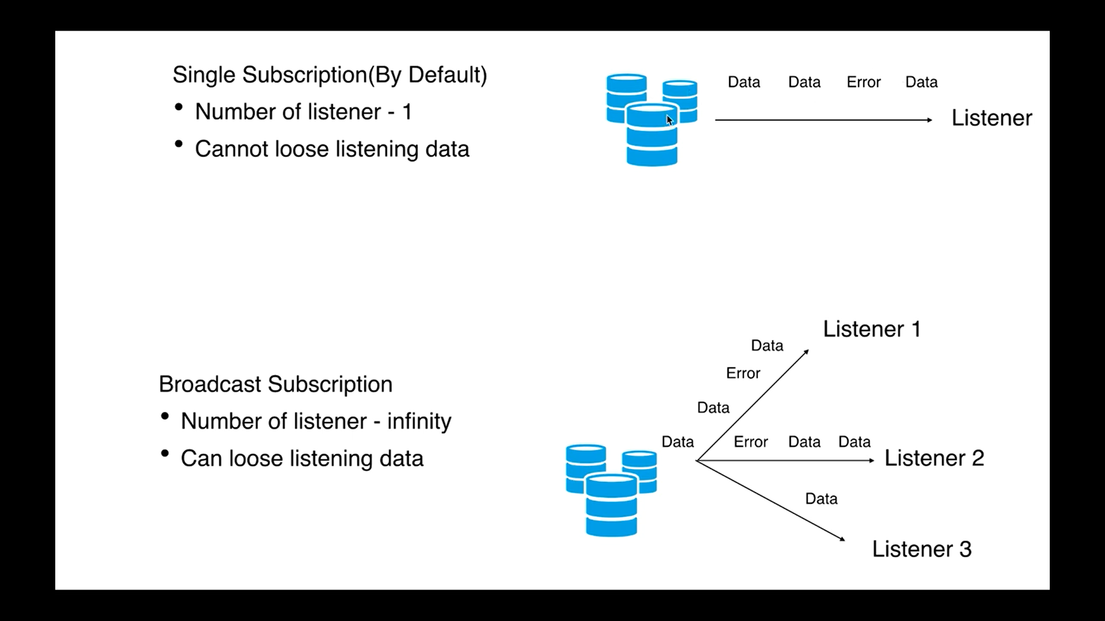

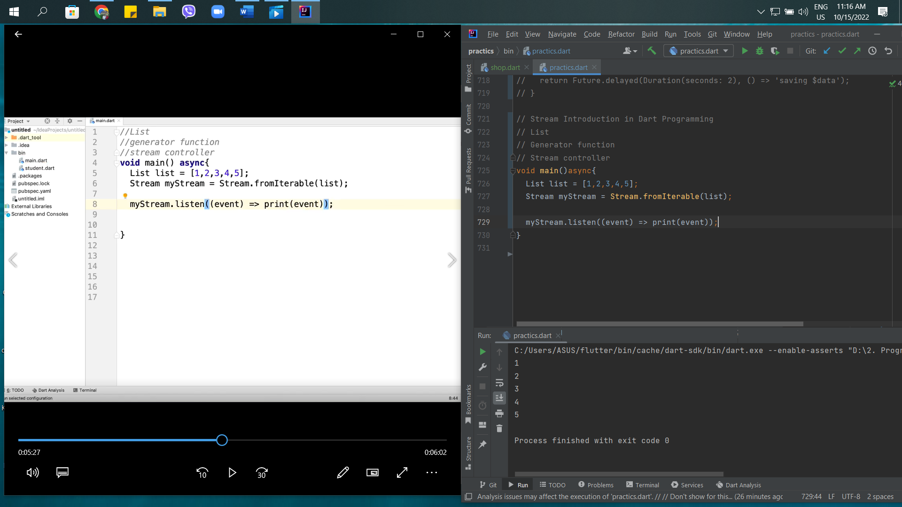

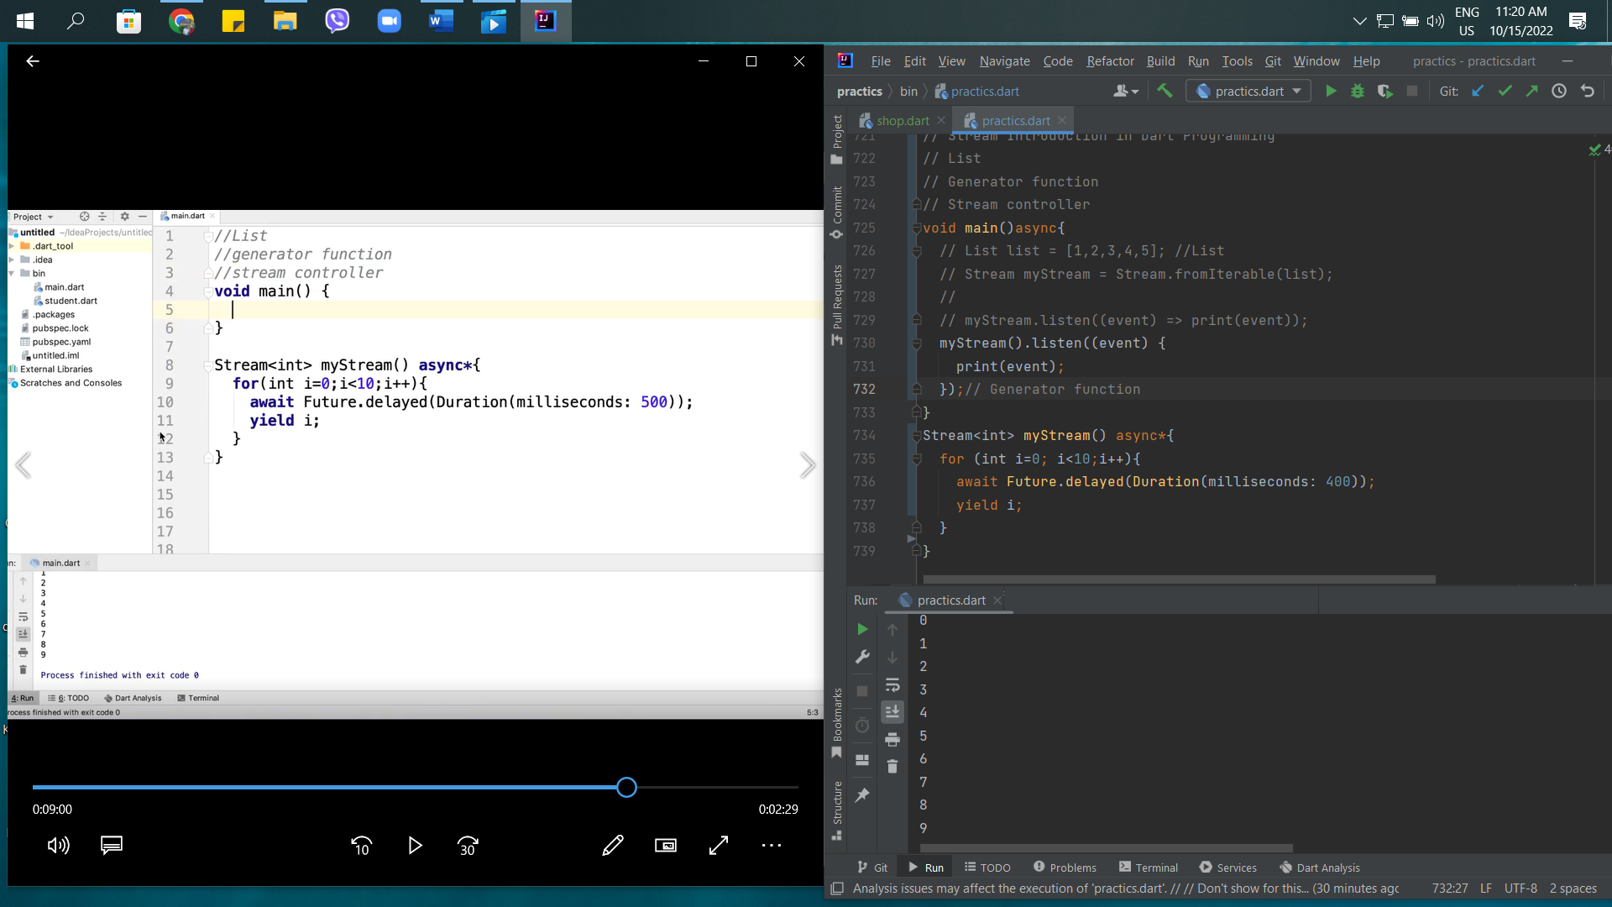

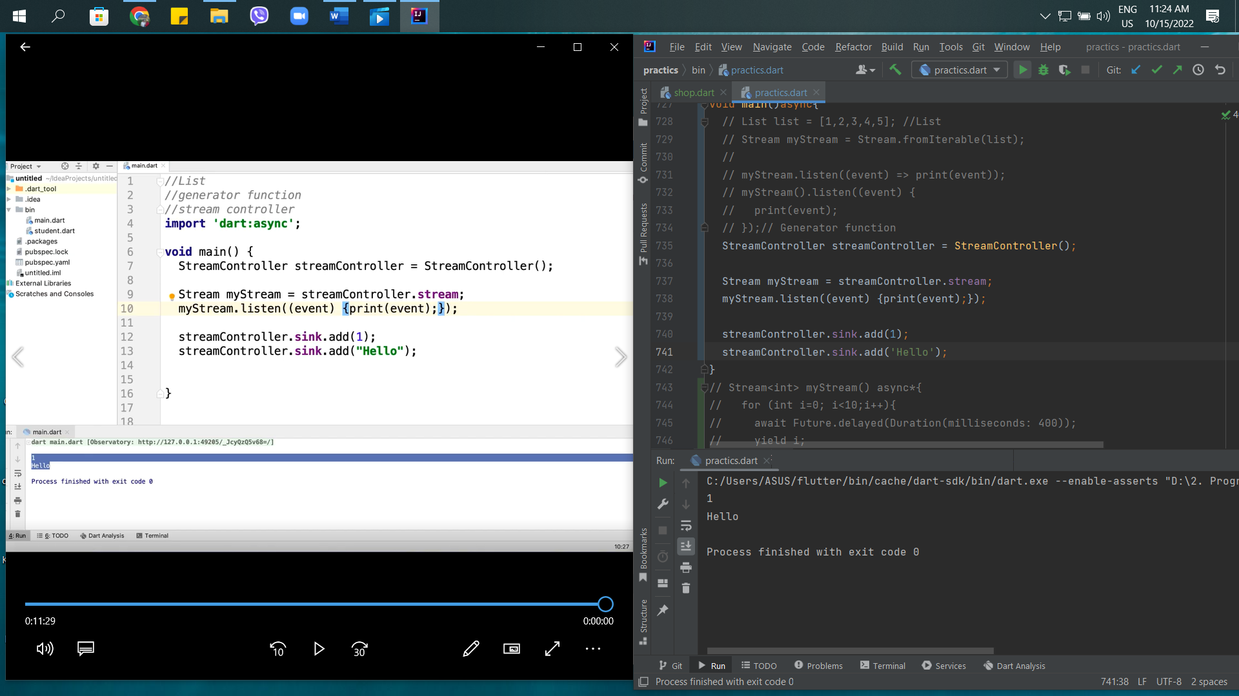

47th – Stream Subscription in Dart

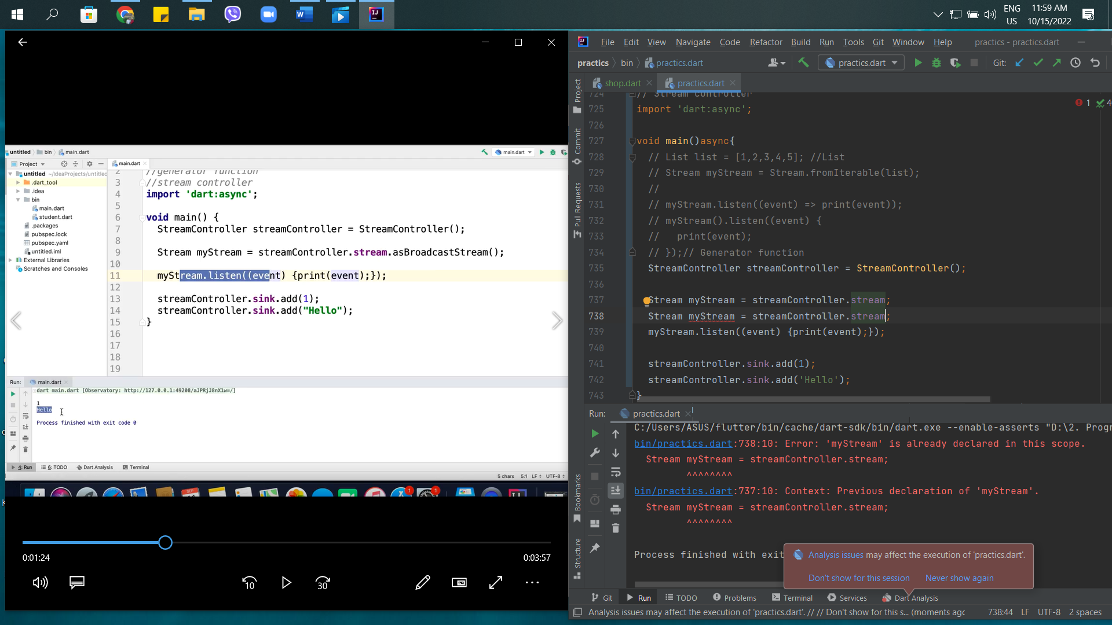

Single Stream can listen one time. If you want to listen more than one time, you need to write BroadcastStream.

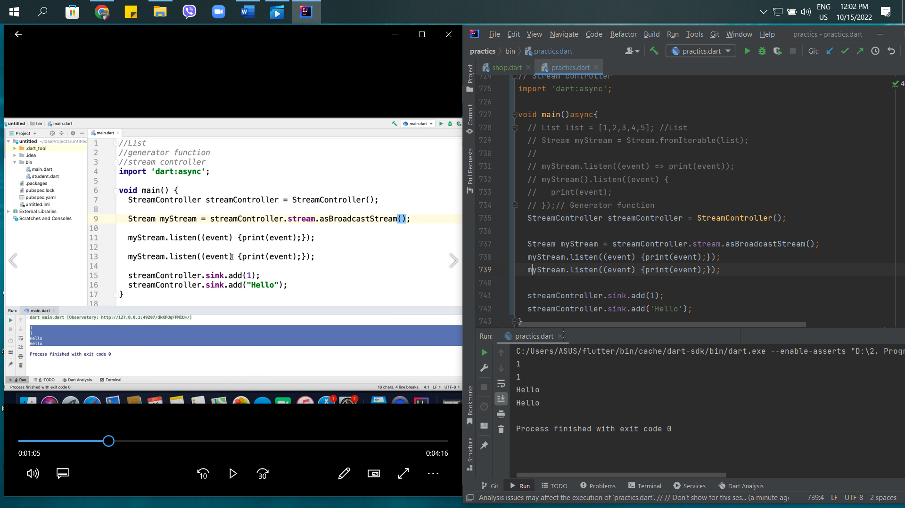

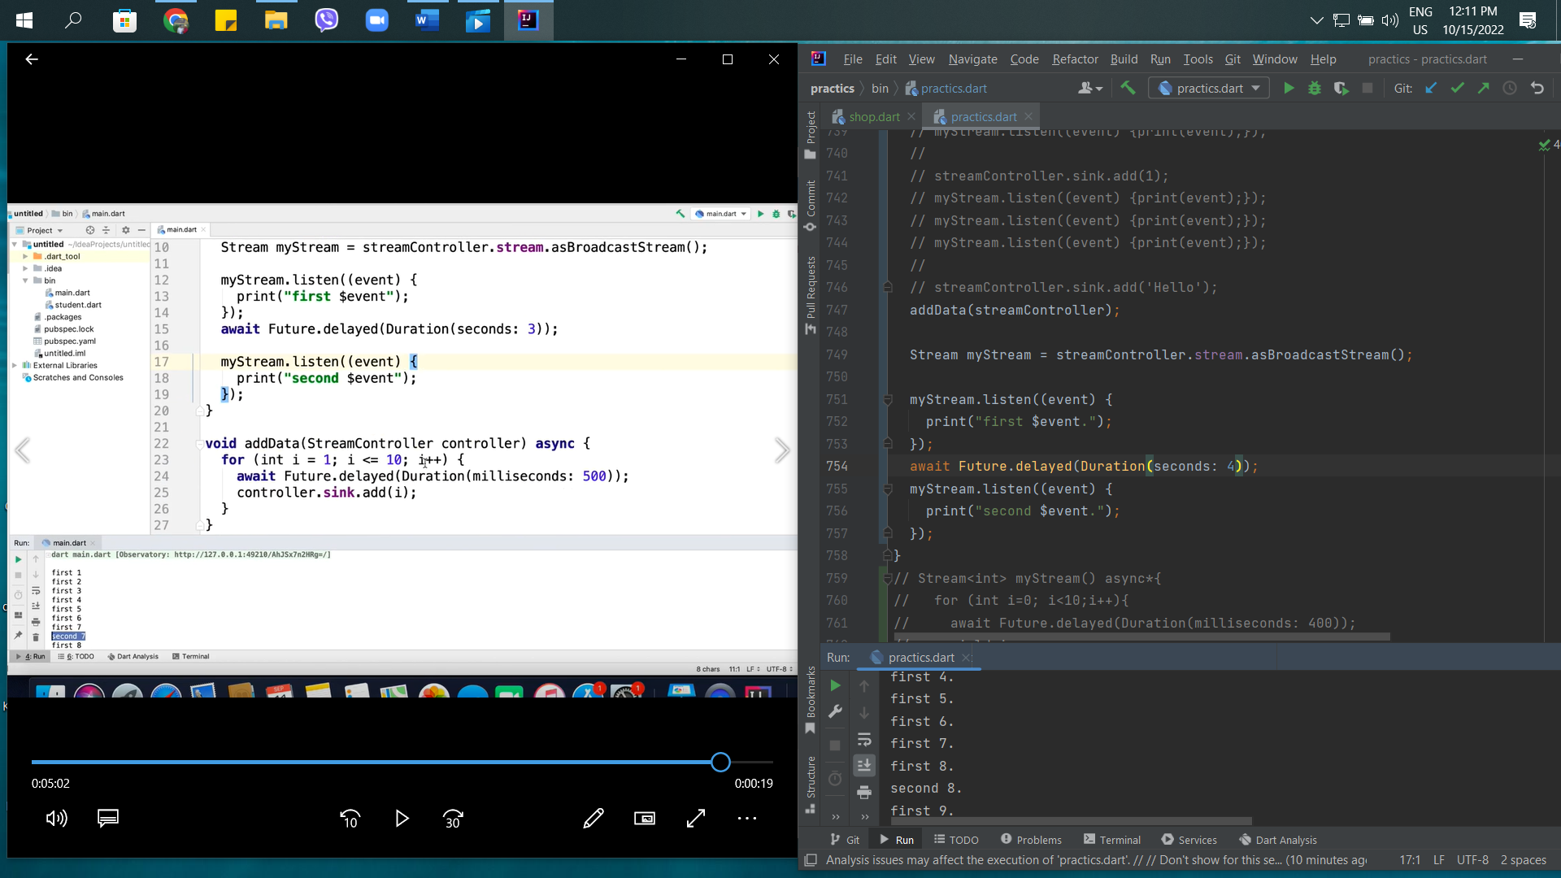

47th – Error Handing in Dart

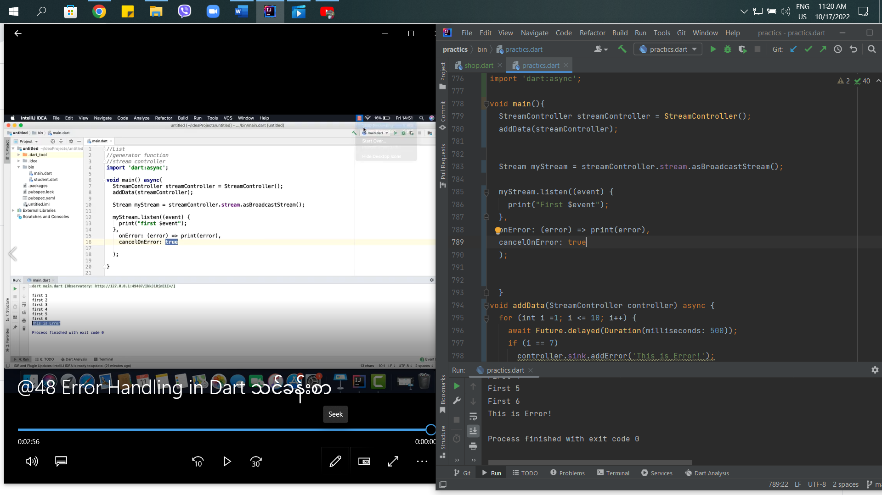

49th – Stream Transformer in Dart

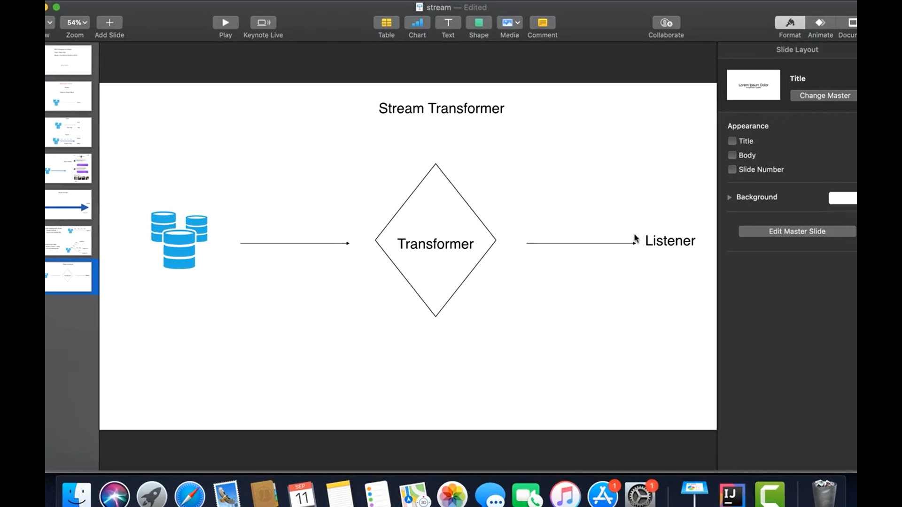

There are 2 class in Stream. These are

* Stream Transformer
* Operator

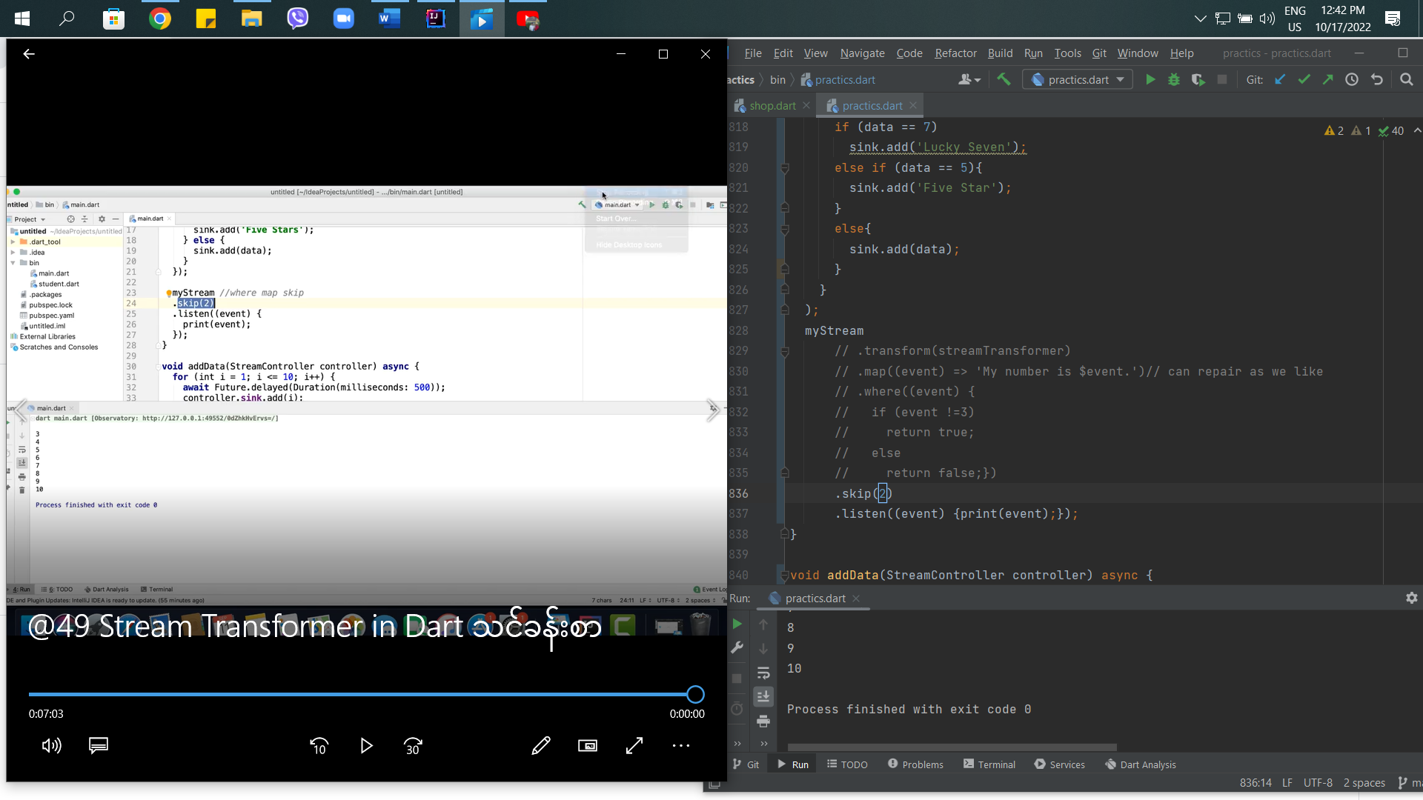

50th – Null-Safety in Dart

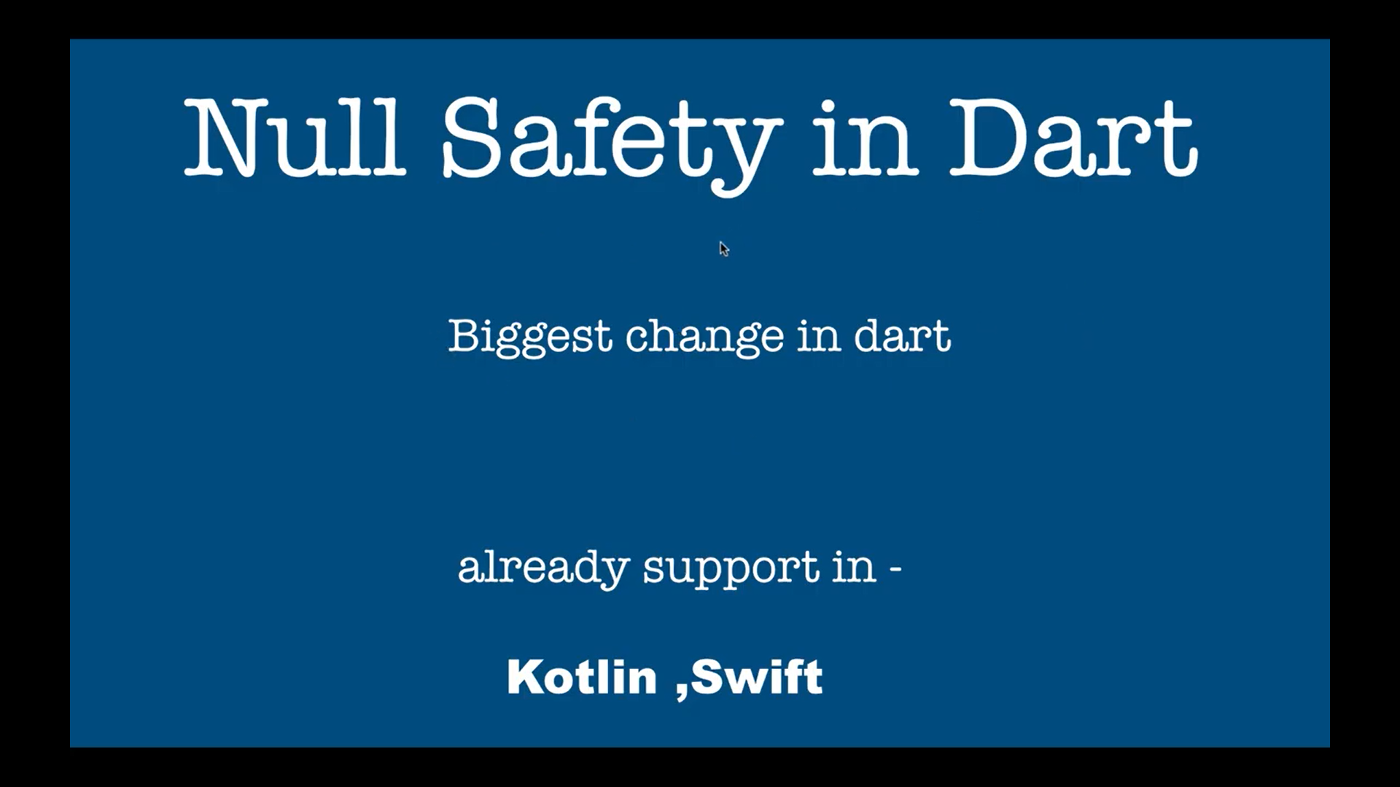

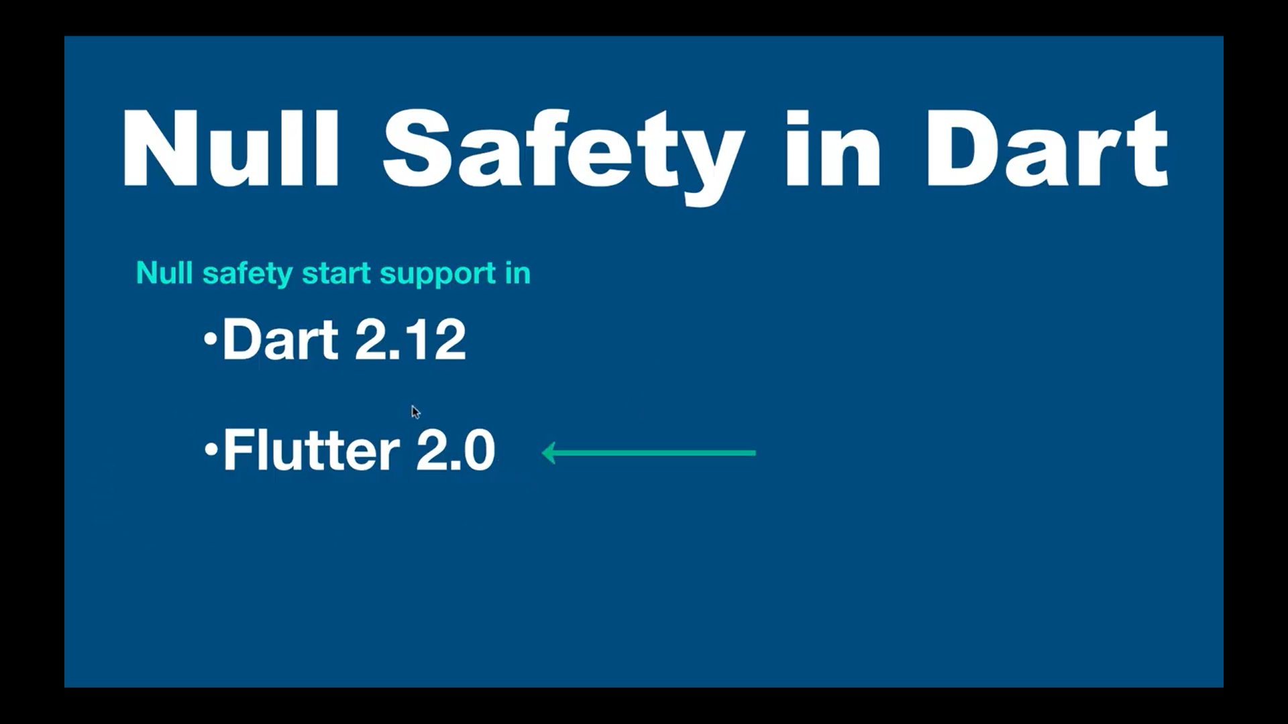

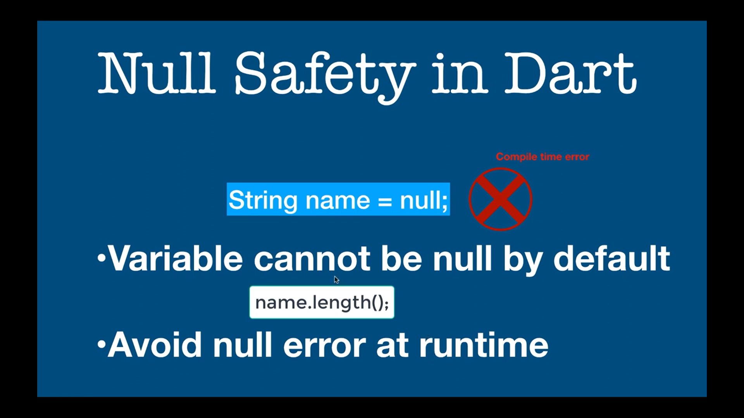

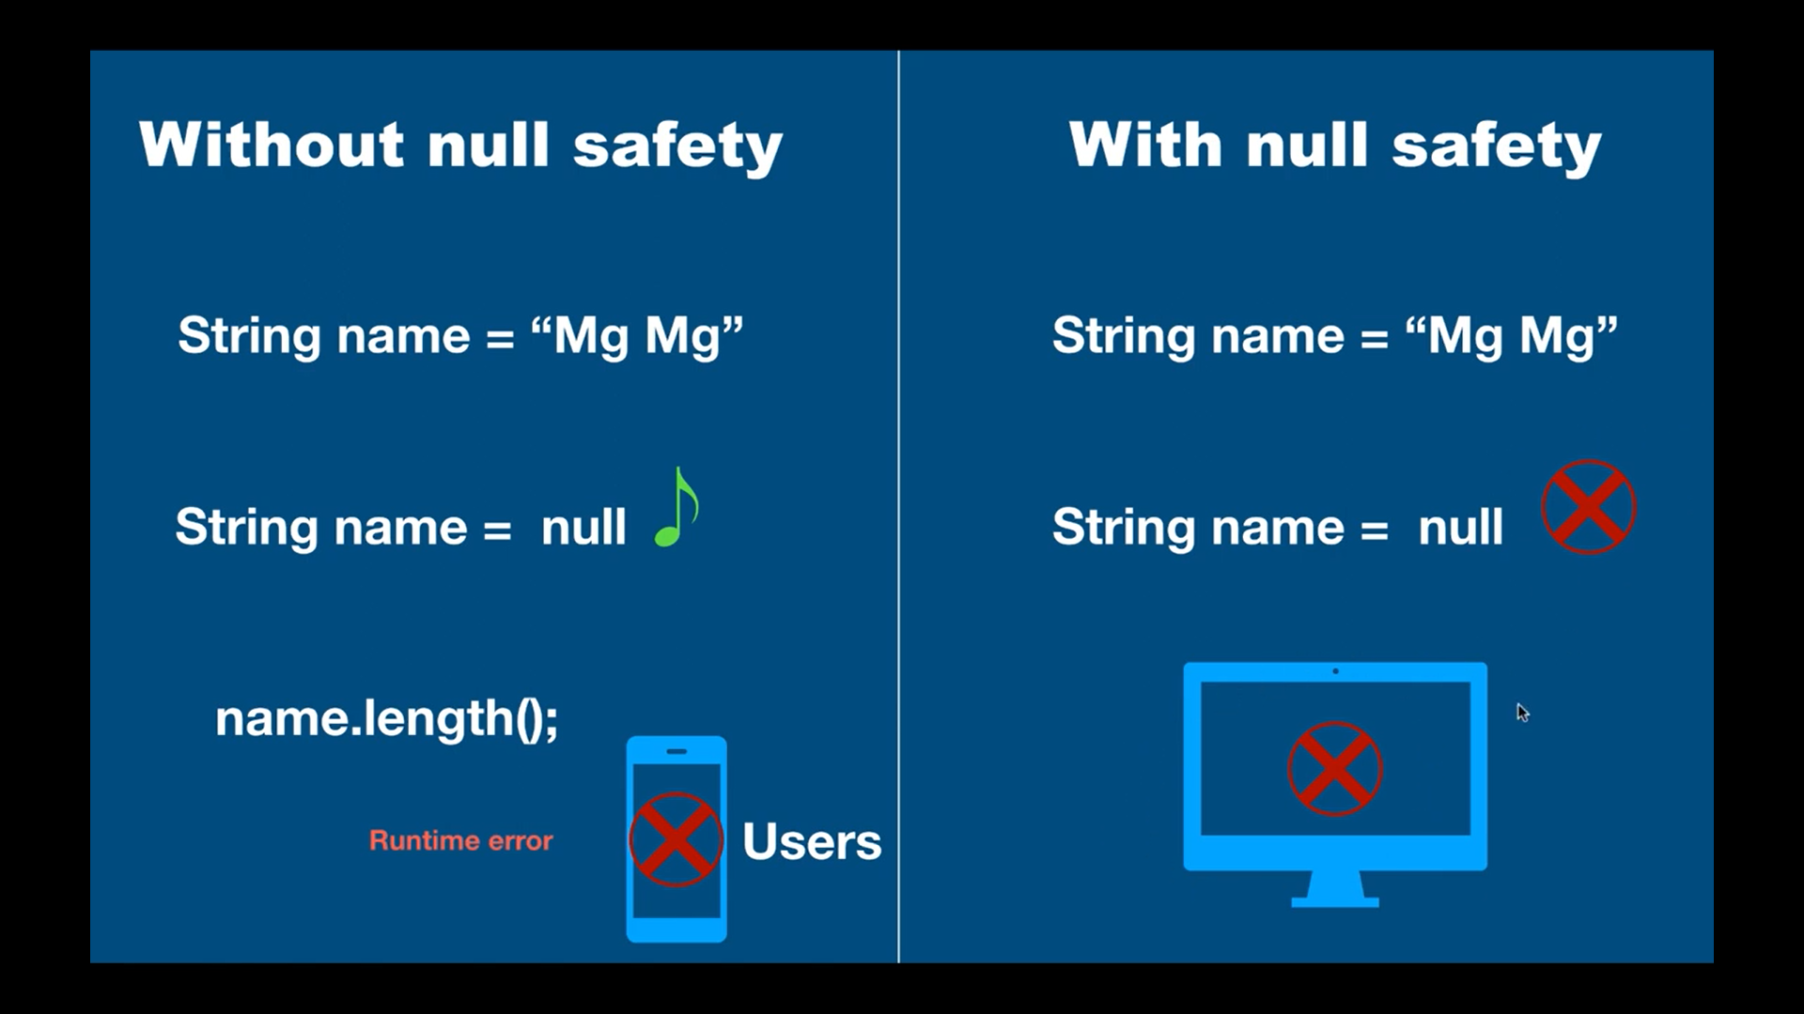

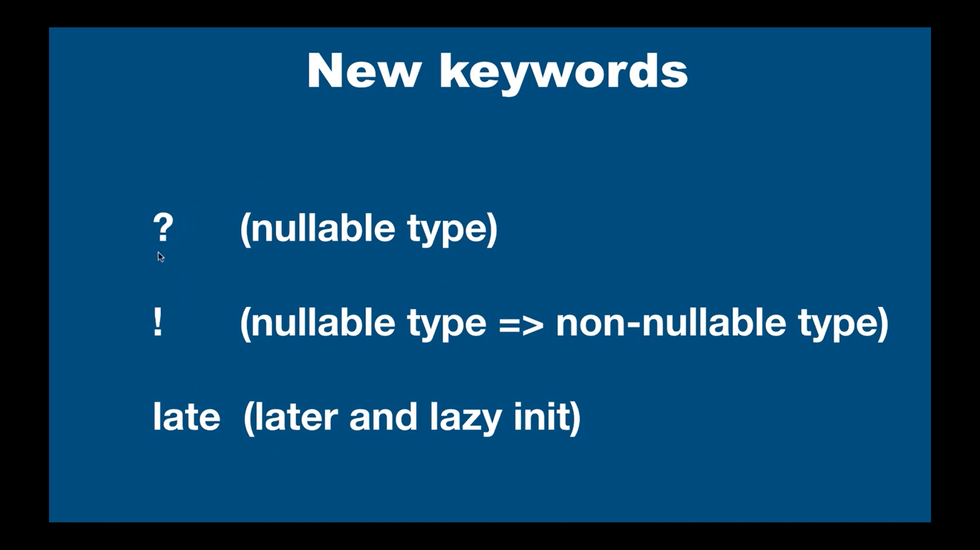

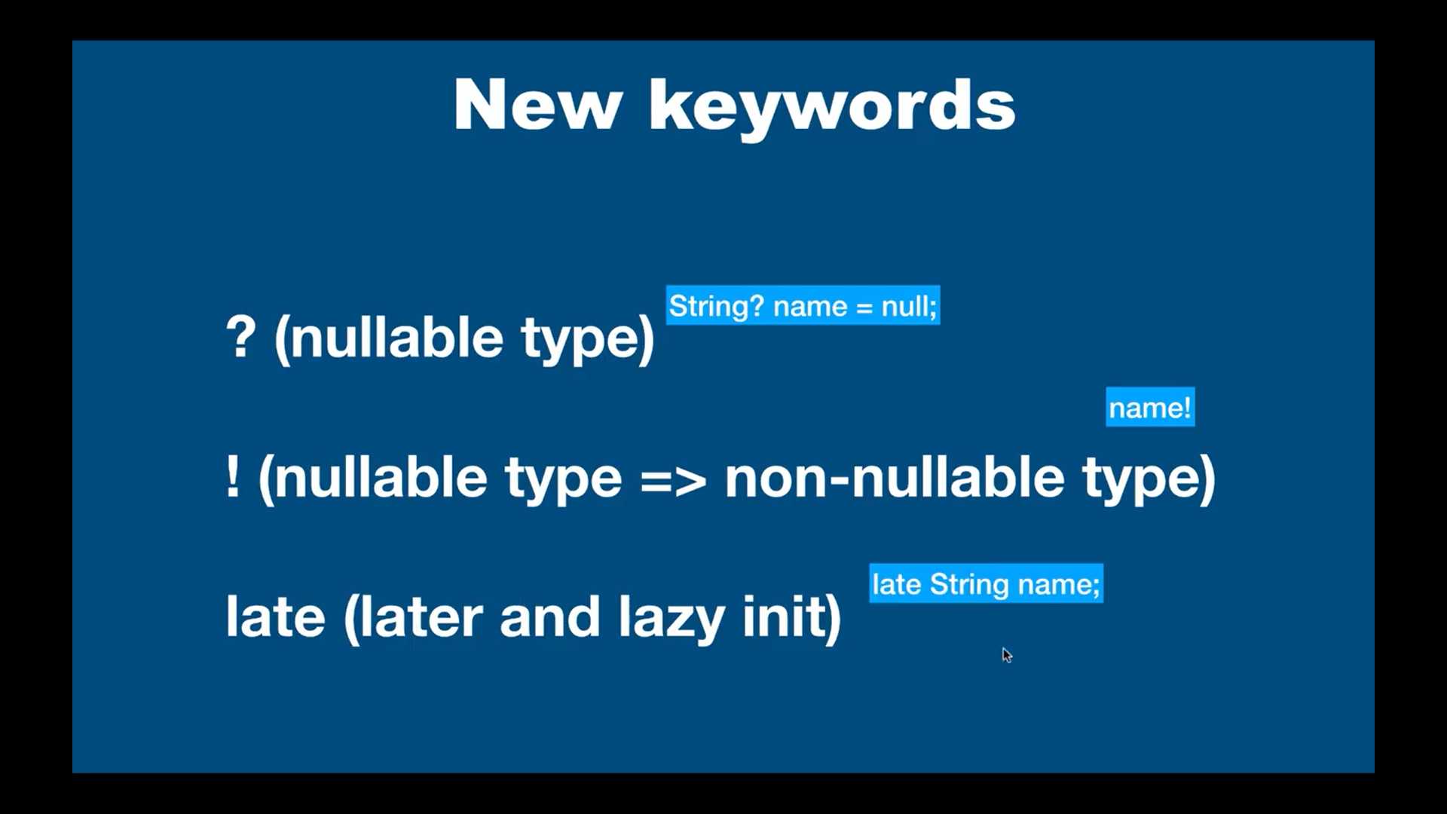

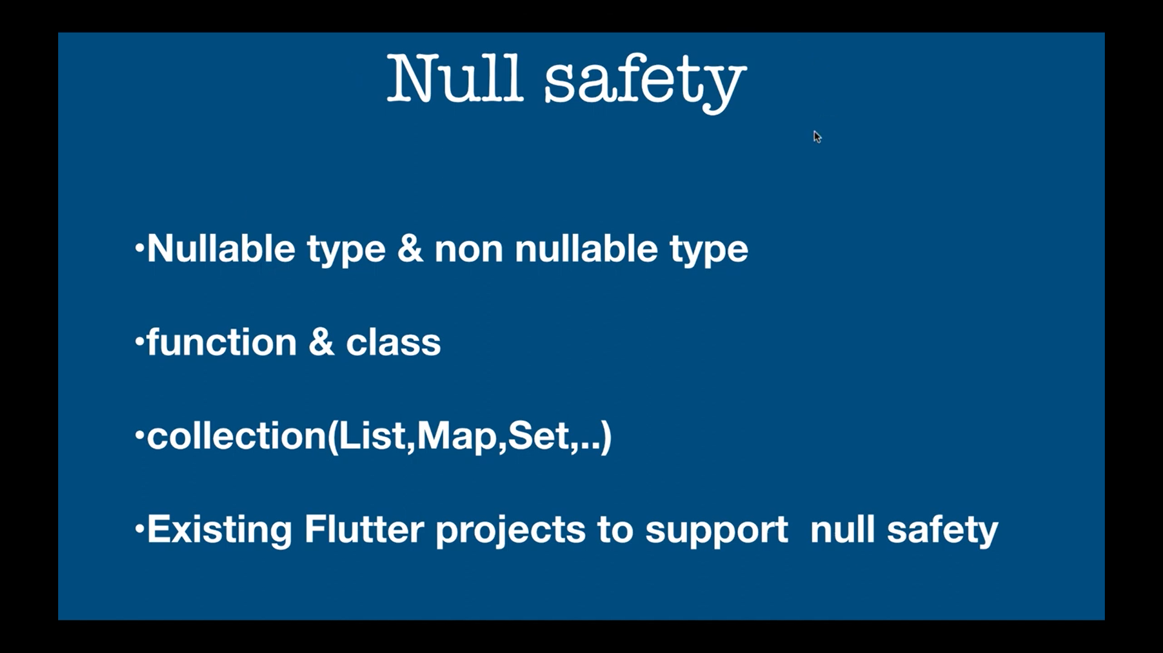

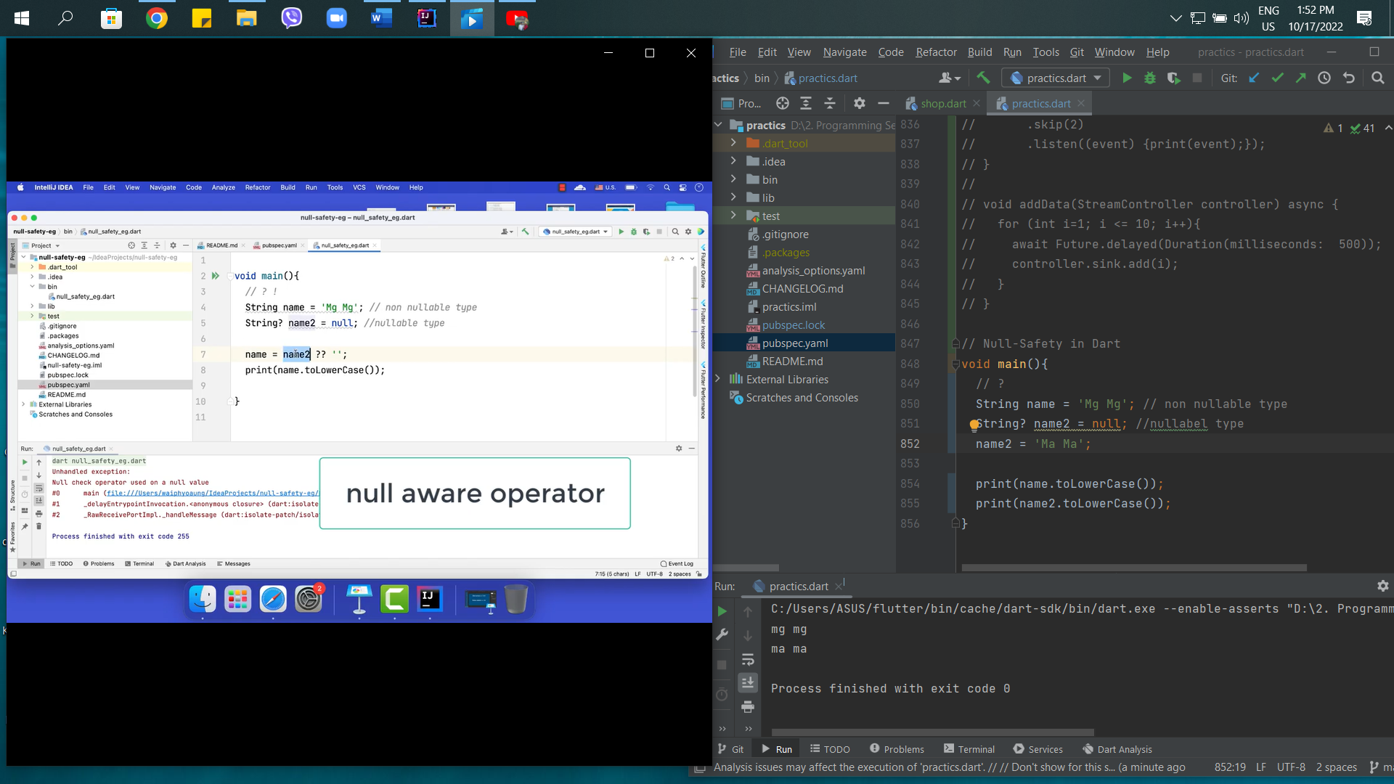

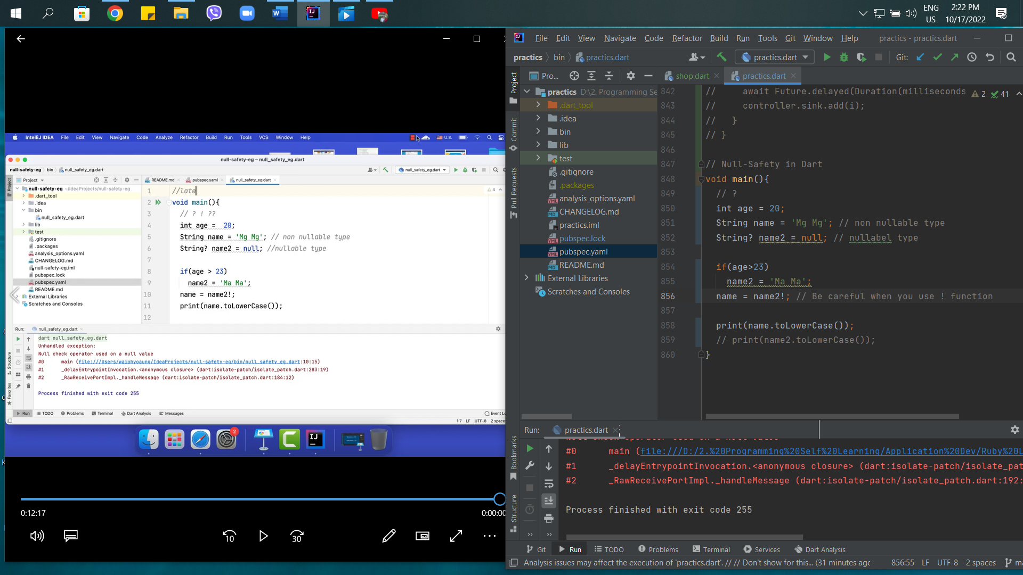

51st – Null Safety Part-2

* Function & class
* Late
* Collection

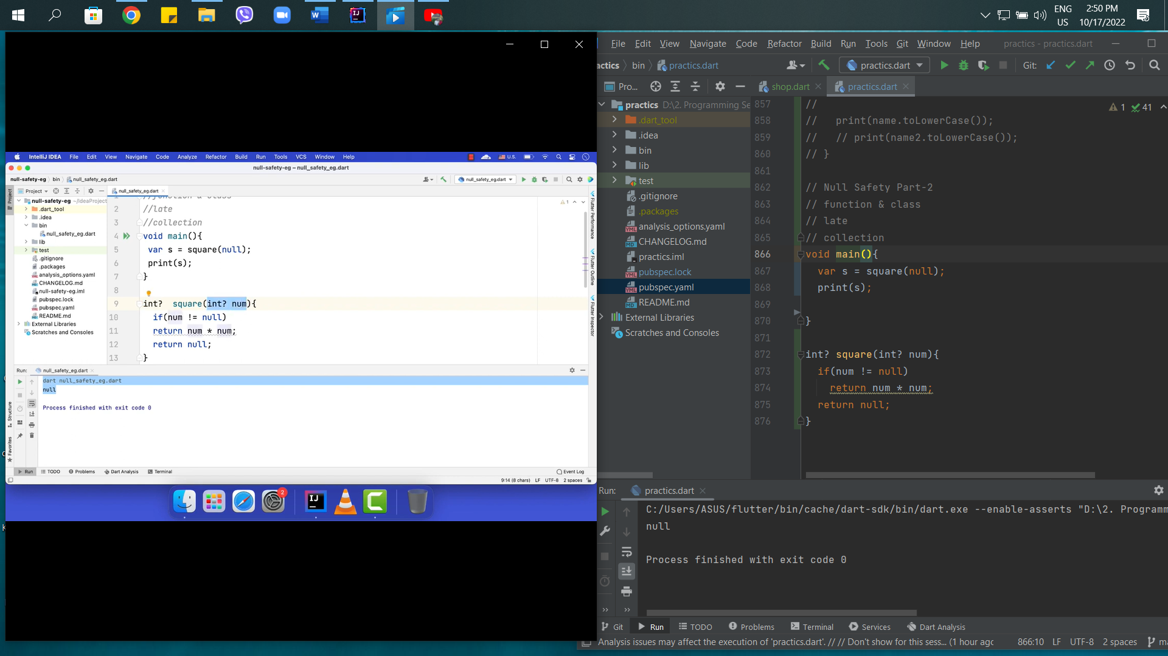

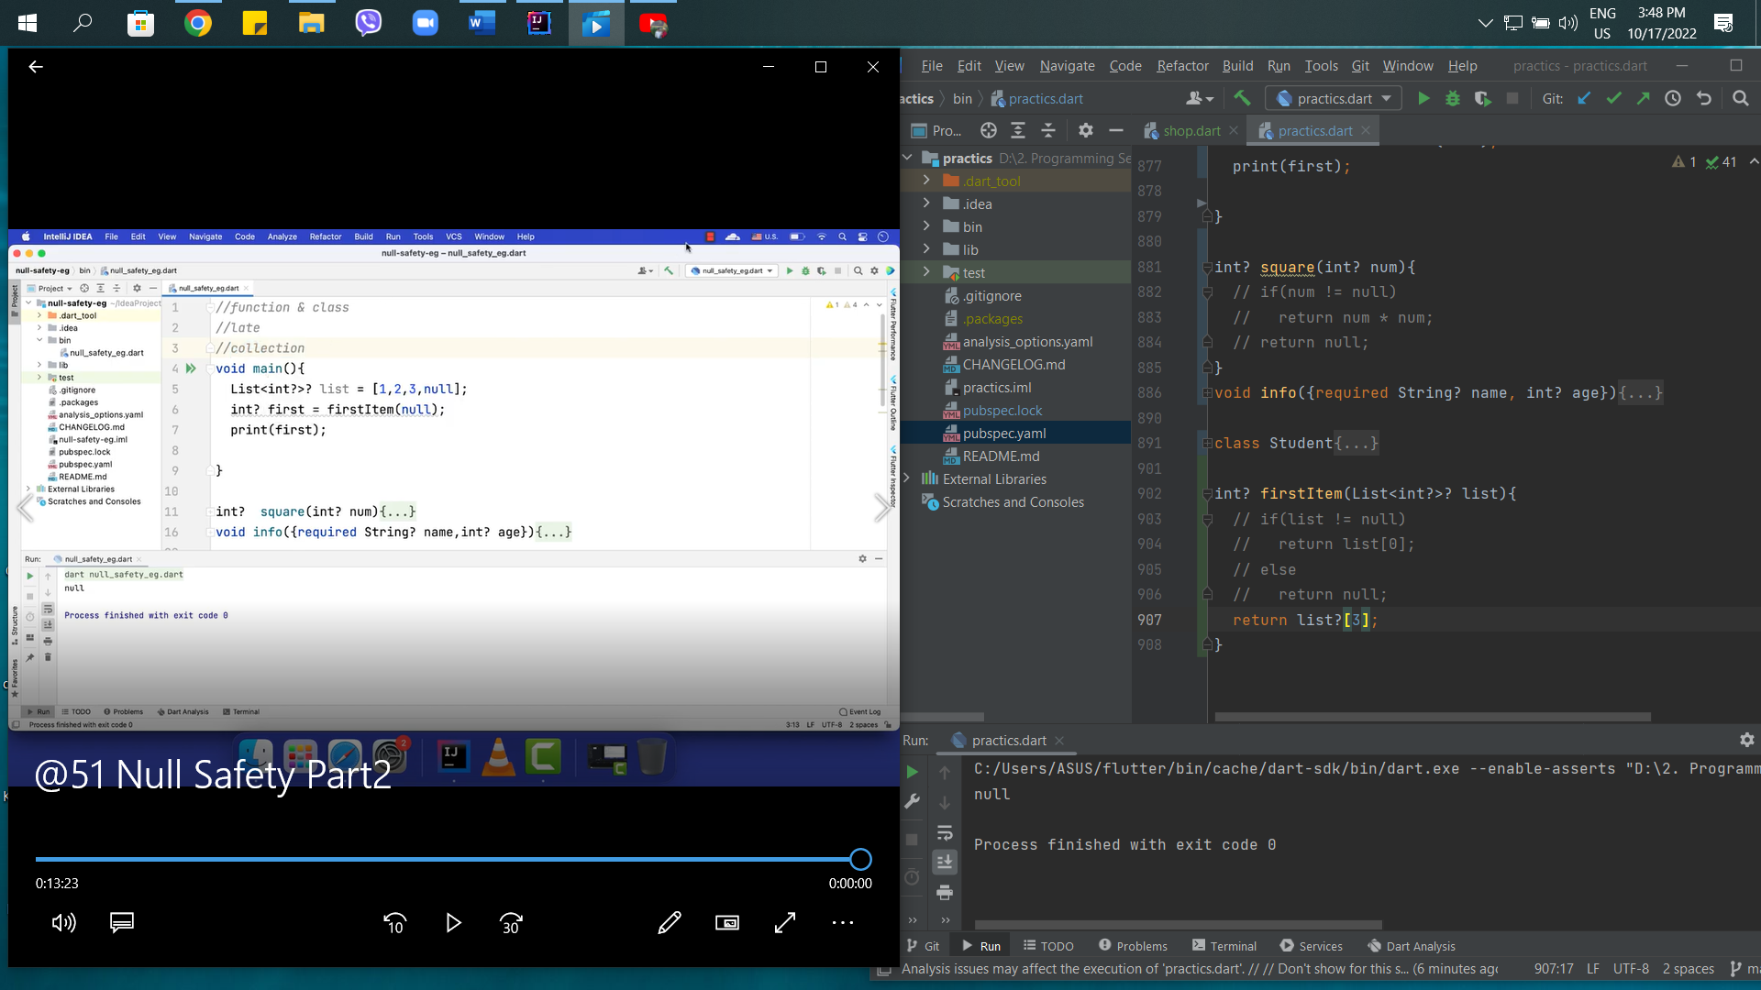

52nd – Type alias in Dart

